2020-05-27

Guide
The Religious Literacy Toolbox



SMC-Faith in development welcomes you to: Guide to the toolbox for religious literacy
SMC Faith in Development describes religious literacy as: An understanding that beliefs and religious actors play a significant role in shaping society, and our ability to relate to and work with these ideas and actors. (From SMC’s Policy on Religious Literacy)
The Toolbox for Religious Literacy consists of a PowerPoint presentation packed with resources for presentations and group exercises, together with this guide to using the PowerPoint resource.
It is designed to support any organisation that wishes to deepen its understanding of its own identity in relation to religion, as well as its understanding of the roles and various identities of religious actors encountered in specific contexts.
SMC hopes that this toolbox will help you and your organization to develop greater religious literacy and thereby strengthen your ability to reach your objectives in a world where a majority of people identify with some form of religious belief. The toolbox is a rich resource. It can be used in a workshop lasting from an hour up to four or five days, or in several workshops over time, depending on how extensive a process you wish to initiate and the objectives of the learning process.
This guide provides an introduction and overview to assist facilitators who wish to use the toolbox to plan and deliver a workshop or facilitate a process.
More resources on religious literacy, along with contact information, can be found on SMC’s website: www.smc.global.

Structure of the toolbox
The toolbox has three parts or streams.
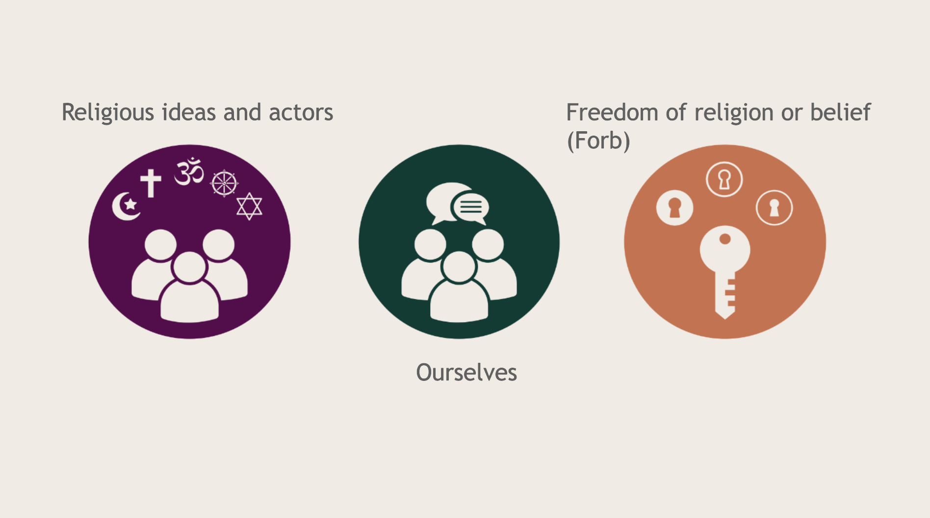
- Religious ideas and actors – describing the actors we are to cooperate with and the religious reality we live in, but might not always understand
- Ourselves – reflecting on our own identity in relation to religion
- Freedom of religion or belief – looking at the possible limitations or possibilities set by the presence or lack of this basic human right, both in terms of culture and legal frameworks.

These three parts or streams are looked at on three different levels.
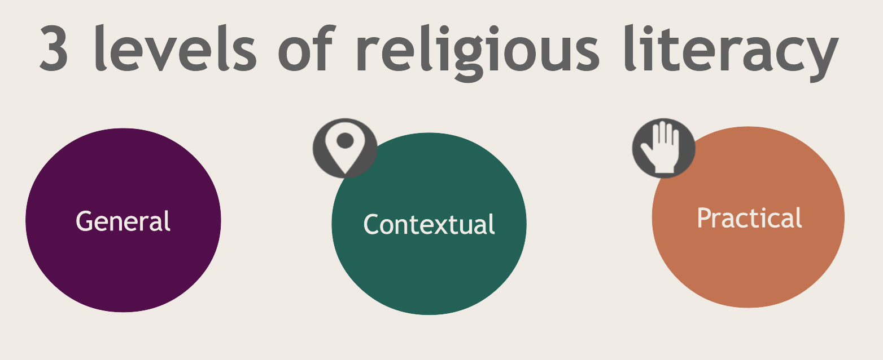

- General religious literacy – Develop knowledge and reflection about the role of religion in rights-based development and the motivation driving our own organisation.
- Contextual religious literacy – Strengthen context- and actor-analysis through increased religious literacy.
- Practical religious literacy – Identify relevant strategies in relation to religion and religious actors to reach relevant development goals.

How to use the toolbox
Consider the process in three stages. The PowerPoint-based Toolbox is designed to help you move through these three stages. However, you may choose to work with just one step or select parts from each. The three steps are:
- A general orientation – an introduction to the issues at stake.
- Contextual reflection – exploring the context you work in. This includes practical tools for assessing your environment in relation to the role of religion, religious actors, your own organisation or community, and the level of Freedom of Religion or Belief (FoRB).
- Strategic development – a presentation of strategies collected from SMC’s experience, along with suggestions for further planning and learning.

Before you begin
Know your target group or participants and set clear objectives for the workshop. Will it be a short introduction to the topic, an extensive training aimed at preparing for a new project or programme, or a long-term process that you and your team revisit over time to map and explore new learning priorities?
The process is designed to be participatory, and its outcome depends on participants’ willingness to share and discuss.
Familiarise yourself with the Toolbox. Instructions for facilitators are included in the notes for each slide. You may find that some slides are repetitive or unnecessary for your process – feel free to omit them.

Practical hints
- Some slides are marked as possible handouts for participants. These handouts can be found in the final pages of this guide.

- The Toolbox does not include energisers or group dynamic exercises. Remember to plan plenty of these, allowing ample time for exercises and discussions. A suggested timetable is provided on page 13.

- It is helpful to assign at least one colleague to document the process.

- Consider participant’s seating arrangements. If several organisations are present, mixed groups may be useful in the first part of the process, but participants from the same organisation should sit together during the final, practical section.

- Be aware that discussing the role of religious actors and issues related to FoRB can be sensitive in some contexts and may even have severe security implications. Consider this in advance. In certain contexts, it may be better to use alternative terminology when addressing FoRB issues. This may affect which slides can be shown publicly, as some explicitly reference FoRB.

Overview of the content

Introduction and presentation of SMC (Slides 1–5)
Slides 1–5 introduce SMC Faith in Development and its member organisations. For more information, please visit www.smc.global.
You may omit this section if it is not relevant, but please ensure that credit is given to SMC for producing the Toolbox.

Presentation of the toolbox (Slides 6–12)
Slides 6–12 provide an overview of the Toolbox and the process you are about to begin. Use these slides carefully to help participants understand the structure of the process, but do not linger here too long. Avoid starting the process itself while introducing the overview.
If you wish to give a general introduction to the role of religion and religious actors in development, you can use slides 13–40, possibly adding one exercise (for example, actor mapping) as an illustration.

First level: General religious literacy (Slides 13-40)

Religious ideas and actors (Slides 13-40)
Slide 14 introduces the role of narratives as a particular aspect of religion and their influence on human decision-making. This serves as a foundation for understanding religious literacy and the reasoning behind religion’s role in societal change.
Slides 15–17 introduce the concept of bilingualism as the ability to speak both a faith-based language and one rooted in universal human rights. This is distinct from religious literacy, and it is important to understand the difference.
Slide 18 bridges the discussion on bilingualism to the challenges of speaking about religion objectively, or from an outsider’s perspective. It invites reflection on whether it is possible to separate oneself from being a believer to become an observer.
Slides 19–27 provide examples of how religion can be defined or understood. Be aware that statistics on religion varies a lot depending on the definition of religion being used. The point is not the exact numbers but the insight that the majority of the world's population defines themselves within a religious context.
Slide 28 explains how SMC understands religious literacy on the three levels used within the toolbox:
General religious literacy
Contextual religious literacy
Practical religious literacy

Slides 29–37 present examples illustrating why religious literacy is important.
Slide 38 focuses on religion’s role in social and political change, showing examples of how understanding a group’s underlying theology is essential to grasping its socio-political strategy.
Slide 39 raises questions about the relationship between religion and gender.
Slide 40 presents examples of the more problematic aspects of religion.
Slide 41 encourages discussion about the instrumentalization of religious actors from the perspective of back donors.

Looking at Yourself – General Religious Literacy (Slides 42–54)
Slides 44–45 present examples of typologies of faith-based organisations, helping you to gain a deeper understanding of your own identity.
Slides 46–52 offer exercises to identify your organisation’s identity using a triangulation approach: declared, experienced, and attributed identity.
Slide 53 introduces a conversation with a slightly different perspective on organisational identity, focusing on the stories or anecdotes used to build a shared narrative within the organisation.
Slide 54 explores the advantages and challenges of having multi-faith staff in a faith-based organisation.

Freedom of Religion or Belief (Slides 55–62)
Slides 55–62 focus on FoRB at the level of general religious literacy. The context in which you are working, where levels of FoRB can vary greatly between countries or settings, will influence how openly religion can be discussed during training. Please consider this in advance.
Further resources can be found at www.forb-learning.org.
Slide 63 concludes this section and invites participants to summarise their learning so far.

Second level: Contextual Religious Literacy (Slides 64–90)
At this level, you move beyond the general concepts and begin analysing the specific context in which you work or plan to work. This involves concretely identifying and seeking to understand the religious actors operating within that context.
If your participants represent different organizations, it might be beneficial to sit in organizational groups, discussing a common context.
Slides 66–69 focus on three key questions that you may or may not have addressed previously. The following section of the Toolbox will help you explore these questions more deeply:
- What religious actors and ideas are at work in our context?
- How well do we understand these religious actors, and how can we learn more about them?
- Does the context allow us to ask questions about religion and belief?
Slides 70–71 address the identification of religious actors. It is essential to identify both the context and the religious actors within it as concretely and specifically as possible, and to do so at the level most relevant to your work — for example, at the community level. This will help you stay focused.
Slides 72–73 serve as reminders to always consider the FoRB situation.
Slide 74 (Process Check) encourages you to review progress and reflect on how far you have come in this iterative process of building religious literacy.

Religious Actors and Yourself in Context (Slides 75–90)
Slides 75–82 contain practical exercises for analysing and mapping the various actors in your context and understanding your relationship with them. The results of these exercises will guide you in choosing strategies and developing practical religious literacy.
If time is limited, focus on mapping no more than three actors to keep the exercise manageable.
Slides 75-76 Actor Mapping:
These slides encourage you to be as practical as possible — even drawing a physical map of your working area. Identify the religious actors present in your context, as well as other actors for whom religion may be a relevant factor. The first slides give an instruction and the second follows with an example.
Slides 77-78 Actor analysis. These exercises can be printed as handouts and shared with the working groups. The first slides give an instruction and the second follows with an example.

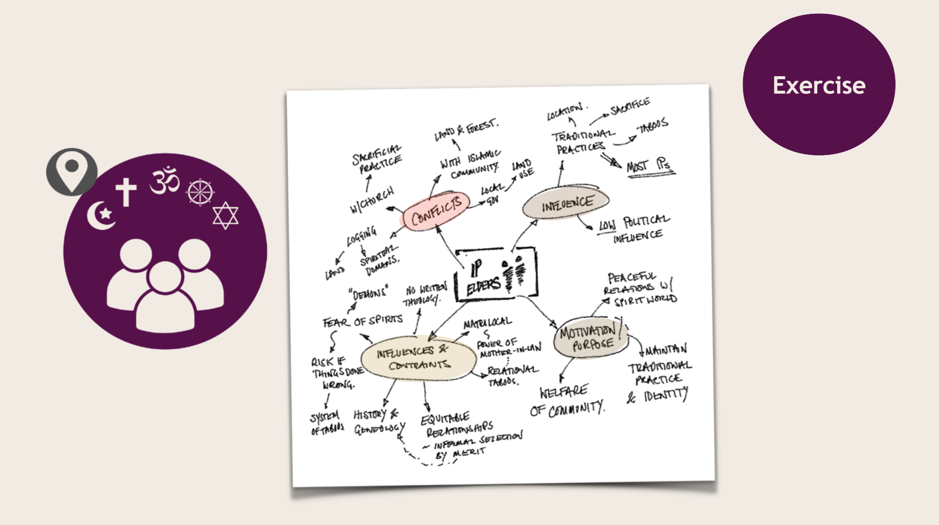
Slides 79–80 Force-Field Analysis:
An example of how to map the often complex forces that support or hinder your goals. The first slides give an instruction and the second follows with an example.
Slides 81–82 Self-Reflection:
These slides help you to look again at your own role in the context and how others perceive you. Slide 82 should be accompanied by a handout with a form for participants to fill in (see handouts at the end of this guide).
Slide 83 Process Check:
Encourages reflection on progress and understanding so far.
Slides 84–89 Contextual Assessment Tools:
These slides include reflections and practical tools to help you analyse barriers and opportunities in your context, and to determine the actions you need to take.
Ensure that the right materials are available, such as handouts, paper, and pens. Slides 87 and 88 should be accompanied by handouts containing discussion questions and forms to complete (see the handouts at the end of this guide).

Third level: Practical Religious Literacy (Slides 90–101)
At this level, you begin planning your future work and deciding which strategies to adopt, based on the insights and analysis gained from the previous stages.
Slides 90–92 These slides introduce the third level and provide a moment to review where you are in the overall process. Use this opportunity to ensure that participants share a common understanding of the findings so far, before moving on to strategy development. Are there still unsolved issues or discussions that needs to be taken further in earlier stages of the process?
Slides 93–99 present six different strategies for interacting with religious actors. Examples from SMC’s work illustrating each strategy found in the notes under each slide. This is the part of the process when you move from learning into planning.
Print these six slides and either post them on the walls around the room or place them on tables for participants to refer to during discussions. The strategies are based on experiences from SMC’s work.
As a facilitator, you may wish to add examples from your own experience to illustrate each strategy. Participants may also contribute their own examples or identify additional strategies relevant to their contexts.
Slides 100-101 are exercise dealing with the strategies.
Slides 102-104 guide participants through the final exercises, focusing on planning future actions. Encourage them to be as concrete as possible and to set clear, achievable goals for their continued work.
Allow time for evaluation and reflection. This is an important step to consolidate learning, celebrate progress, and identify areas for ongoing development.
If you have further questions or remarks, please contact info@smc.global

Handouts
The following pages contain printable handouts for some of the exercises.

Suggested outline of a week-long workshop

DAY 1: Connecting, Introduction and general religious literacy | DAY 2:  Religious Actors | DAY 3:  Strategies & tools | DAY 4:  Going Forward
9:30-10:30  Why are we here?  Introductions and connections  - Presentation SMC  - Religious Literacy  - Intro to process | 8:15-10:00  Recap Day 1  Intro Day 2  - Who are we? Are we religious?  - The identity of our organisation | 8:15-10:00  Recap Day 2  Intro Day 3  Continue: FoRB/Actor analysis | 08:30-10:30  Recap Day 3  Intro Day 4  What next? Action plans  Learning questions?  Q’s for follow-up trip
10:30-11:00 Break | 10:00-10:30 Break | 10:00-10:30 Break | 10:30-11:00 Break
11:00-12:30  Religion and Development  General Religious Literacy  The importance of the narrative. | 10:30-12:00  Continue: Who are we? Are we religious?  The identity of our organisation | 10:30-12:00  How can we engage with Religious Actors | 11:00-13:00  Sharing plans  Recap from learning week  Closing and Evaluation
12:30-14:00 Lunch | 12:00-13:30 Lunch | 12:00-13:30 Lunch | 13:00 Lunch
14:00-15:15  Continued | 13:30-15:00  Actor analysis in context | 13:30-15:00  Strategies & tools
15:15-15:45 Break | 15:00-15:30 Break | 15:00-15:30 Break
15:45-17:15  General Religious Literacy  FoRB | 15:30-16:30  Continue: Actor analysis in context | 15:30-16:30  Implementing strategies & tools
17:15-17:30  End-of day reflection | 16:30-17:00  Reflection time | 16:30-17:00  Reflection time
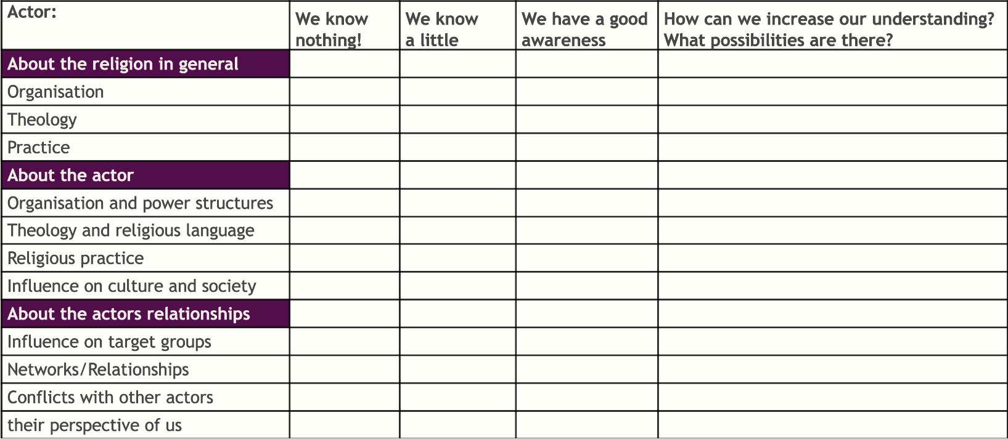

Map Out Actors in Relation to Us and the Project Goals

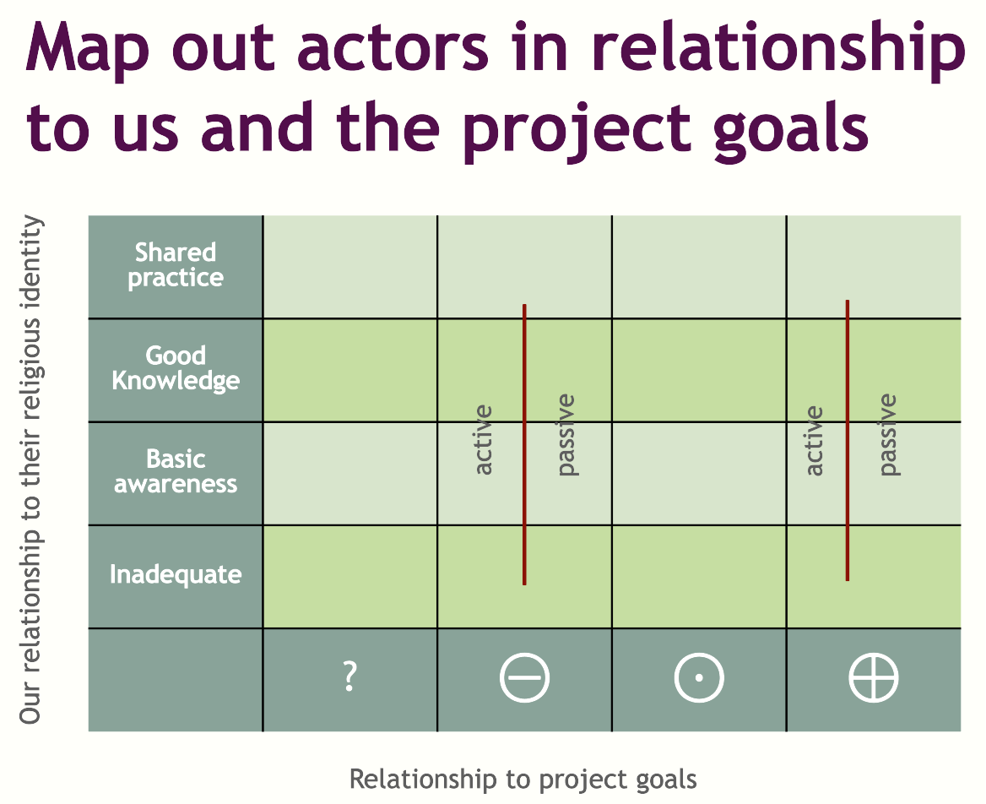

Questions for the four-field analysis chart
Some questions to get you thinking…
- What are our unique opportunities to engage with this actor?
- Does their theology relate to our project goals in ways which we could appeal to? How?
- Do we have the ability to use a shared religious language to communicate about the project goal? What religious terms could we use?
- Would this actor provide access to new networks? How would we be able work with them?
- Do we have shared religious practices that strengthens our relationship?

… what questions do we have about our relationships with these actors that we need to learn more about?
Based on who we are, and who they are, what barriers might we face?
- Where might this religious actor actively resist working with us? Why?
- Does their theology conflict with any of our project goals, or with us as an organisation? How?
- If the FORB context does not allow us to speak freely, how will we manage this?

What risks do we face in referring to religion or cooperating with this actor?
- Whom might we risk excluding?
- What conflicts could be escalated?

