1 jeks ieish
udkj wjYH;d - udkj ysñlï
- udkj j.lSï

Ôú; iQmh

udkj wjYH;d ldâm;a
ug wjYHhs'''  ksoyi' | ug wjYHhs'''  iudkd;au;djh'  fjkiafldg i,lkak tmdæ
ug wjYHhs'''  Ôj;aj isákak' | ug wjYHhs'''  jy,aNdjfhka ksoyia ùug'
ug wjYHhs'''  jOysxidfjka  wdrlaId ùug' | ug wjYHhs'''  wkkH;djhla ;sîug'
ug wjYHhs'''  kS;sh u.ska ug iudkj yd  idOdrKj i,lkq ,eîug' | ug wjYHhs'''  ug jerÈ f,i i,lkq  ,nk úg wdrlaIdj'
ug wjYHhs'''  w;a;fkdau;sl w;awvx.=jg  .ekSï j,ska iy hqla;s  iy.; fkdjk  o`vqqjï j,ska wdrlaIdj' | ug wjYHhs'''  kvq úNd. idOdrKj yd  m%isoaêfha mj;ajkq ,eîug'
ug wjYHhs'''  jerÈlre nj Tmamq jk  ;=re ks¾fodaIS f,i  i,lkq ,eîug' | ug wjYHhs'''  fm!oa.,sl;ajh  iy .re;ajh'
ug wjYHhs'''  ksoyfia .uka ìuka  hdug bvfokq ,eîug' | 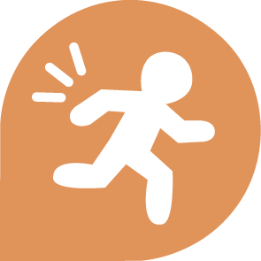  ug wjYHhs'''  wk;=frka fíÍ m,dhdu  i|yd bv fokq ,eîug'
ug wjYHhs'''  mqrjeisNdjh' | ug wjYHhs'''  uu leu;s kï újdy ù  orejka ,eîu i|yd  bvfokq ,eîug'
ug wjYHhs'''  mjqf,a msßñkag yd  ldka;djkag tlu  whs;sjdislï ;sîug' | ug wjYHhs'''  uf.a foaj,a whs;s lr.kak'
ug wjYHhs'''  iajdëkj is;Su i|yd  bvfokq ,eîug' | ug wjYHhs'''  uf.a wd.ula$úYajdi  ;sîug yd ms<sme§u  i|yd bvfokq ,eîug'
ug wjYHhs'''  uf.a yDo idlaIshg  wkqj uf.a wd.u$úYajdi  fjkia lsÍu i|yd  bv fokq ,eîug' | ug wjYHhs'''  u; ±Íug iy tajd  wka wh iu. fnod  .ekSu i|yd  bvfokq ,eîug'
ug wjYHhs'''  f;dr;=re fj;  m%fõY ùug' | ug wjYHhs'''  ñksiqka yuqùug" Tjqka iu.  tl;= ùug iy lKavdhï  ixúOdkh lsÍug'
ug wjYHhs'''  Pkaoh m%ldY  lsÍfï whs;sh' | ug wjYHhs'''  ksjyklaa'
ug wjYHhs'''  fi!LH /ljrKh' | ug wjYHhs'''  úfkdao ùug iy  uf.a is;=ú,s iy  woyia m%ldY lsÍug'
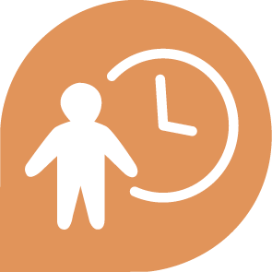  ug wjYHhs'''  jev lsÍug yd  idOdrK jegqma  ,nd .ekSug' | ug wjYHhs'''  úfõlh iy  úfkdaoh'
ug wjYHhs'''  wdydr' | ug wjYHhs'''  wOHdmkh'
ug wjYHhs'''  úoHdfõ m%;s,dN N=la;s ú£ug' | ug wjYHhs'''  iduldó"  úêu;a iudchla'
ug wjYHhs'''  wka whj  /ln,d .ekSug' | ug wjYHhs'''
ug wjYHhs''' | ug wjYHhs'''
ug wjYHhs''' | ug wjYHhs'''
ug wjYHhs''' | ug wjYHhs'''

