1 jeks ieish
udkj wjYH;d - udkj ysñlï
- udkj j.lSï

udkj ysñlï .e,ßh

fmdaiag¾
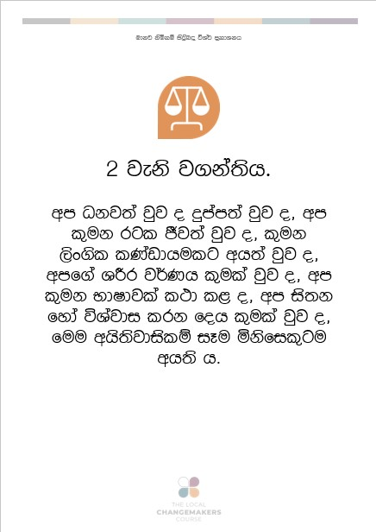
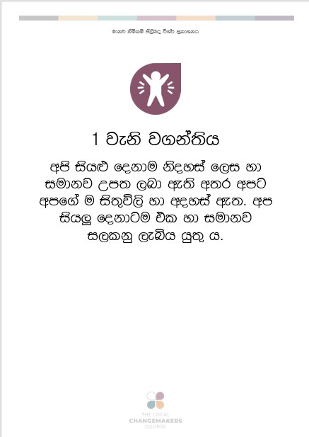

1 jeks j.ka;sh

wms ish¨ fokdu ksoyia f,i yd iudkj Wm; ,nd we;s w;r wmg wmf.a u is;=ú,s yd woyia we;' wms ish¨‍ fokdg u tl yd iudkj i,lkq ,eìh hq;= h'

2 jeks j.ka;sh'
wms Okj;a jqj o" ÿmam;a jqj o" wms l=uk rgl Ôj;a jqj o" l=uk ,sx.sl lKavdhulg wh;a jqj o" wmf.a YÍr j¾Kh l=ula jqj o" wms l=uk NdIdjla l:d l< o" wms is;k fyda úYajdi lrk foh l=ula jqj o" fuu whs;sjdislï iEu ñksfil=g u wh;s h'

3 jeks j.ka;sh'
wms ieug Ôú;aùfï whs;sh iy ksoyfia yd iqrlaIs;j Ôj;aùug whs;sh we;'

4 jeks j.ka;sh'
wmj jyf,l= njg m;a lsÍug lsisfjl=g whs;shla ke;s w;r" wmg fjk;a lsisfjl= wmf.a jyf,l= njg m;a lr.; fkdyel'

5 jeks j.ka;sh'
wmg ßoùug fyda jO ysxid lsÍug fyda wmg l=ßre f,i ie,lSug lsisfjl=g whs;shla ke;'

6 jeks j.ka;sh'
kS;sfhka wmj mqoa.,fhl= f,i ms<s.kq ,eîug wm ieug whs;shla we;'

7 jeks j.ka;sh'
kS;sh iEu flfkl=gu tl yd iudk h' th wms ish¨ fokdg idOdrK f,i ie,lsh hq;= w;r" fjkia fldg i,lkq ,eîfuka wmj wdrlaId l< hq;= h'

8 jeks j.ka;sh'
kS;sh úiska wmf.a whs;sjdislï wdrlaId l< hq;= w;r" hful= wmf.a whs;sjdislï W,a,x>kh lrk úg kS;sh wmg Wmldr l< hq;=h'

9 jeks j.ka;sh'
idOdrK fya;=jla fkdue;sj wmj w;awvx.=jg .ekSug fyda isr.; lsÍug fyda wmj wfma rfgka fkrmd ±óug lsisfjl=g whs;shla ke;'

10 jeks j.ka;sh'
kS;sh lv l< njg hful=g fpdaokd lrkafka kï" tu mqoa.,hdg idOdrK yd m%isoaO kvq úNd.hla i|yd whs;sh we;'
11 jeks j.ka;sh'
hfula hï fohla l< njg Tmamq jk ;=re Tjqkag ta i|yd fodia fkdmejßh hq;= h' wms krl fohla l<d hehs ñksiqka mjikafka kï" th i;H fkdjk nj Tmamq lsÍug wmg whs;shla we;' wms fkdl< fohla fjkqfjka fyda wms isÿ l< kS;shg mgyeks fkdjk fohla fjkqfjka fyda lsisfjla wmg o`vqqjï fkdl< hq;= h'

12 jeks j.ka;sh'
wmf.a fyd| kug ydks lsÍug lsisfjla W;aidy fkdl< hq;= h' b;d idOdrK fya;=jla fkdue;sj wmf.a ksjig meñŒug" wmf.a ,sms újD; lr ne,Sug fyda wmg fyda wfmf.a mjq,g lror lsÍug lsisfjl=g whs;shla ke;'

13 jeks j.ka;sh'
wmf.a rg ;=< wmg wjYH ;eklg hdug iy wms leu;s mßos úfoaY rgj,g .uka lsÍug wm ieug whs;shla we;'

14 jeks j.ka;sh'
wfma rfÜ§ wm jOysxidjg ,laùfï wjodkula ;sfí kï" wdrlaIdj i|yd fjk;a rglg hdug wm ieug whs;shla we;'

15 jeks j.ka;sh'
wm ieu hï rglg wh;a ùug" tkï mqrjeisNdjhg wm ieug whs;shla we;'

16 jeks j.ka;sh'
iEu jeäysá wfhl=g u újdy ùug yd Tjqkag wjYH kï mjq,la idod .ekSug whs;sh we;'
lsisfjl=g újdyùu i|yd n, fkdl< hq;= h' újdy ù isák úg;a" fjka ù isák úg;a msßñkag yd ldka;djkag tl yd iudk whs;sjdislï we;'

17 jeks j.ka;sh'
iEu flfkl=g u foaj,a whs;s lr .ekSug fyda tajd fnod .ekSug whs;sh we;' lsisfjl= idOdrK fya;=jla fkdue;sj wmf.a foaj,a wfmka ,nd fkd.; hq;= h'

18 jeks j.ka;sh'
iajdëkj is;Sug iy wmf.a yDoh idlaIshg wkqj lghq;= lsÍug" úYajdi ±Íug iy wd.ula ;sîug wm ieug whs;shla we;'
;ksju fyda fjk;a mqoa.,hska iu. iy m%isoaêfha fyda fm!oa.,slj wmf.a úYajdi weoySug wm ieug whs;shla we;'
;ukag wjYH kï ;ukaf.a úYajdi iy wd.u fjkia lsÍug iEu flfkl=g u whs;shla we;'
19 jeks j.ka;sh'
fmd;a m;a fyda wka;¾cd,h jeks ´kEu l%uhla yryd f;dr;=re fj; m%fõY ù hï hï foa ms<sn| ;SrK .ekSug;a" wmf.a u; iy woyia ±Íug iy m%ldY lsÍug;a" l=uk fyda ia:dkhl Ôj;a jkakd jQ wka mqoa.,hska iu. tu u; iy woyia fnod .ekSug;a wms ish¨ fokdg whs;sh ;sìh hq;= h'

20 jeks j.ka;sh'
wmf.a ñ;=rka yuqùug iy iduldój wmf.a whs;sjdislï wdrlaId lsÍu i|yd tlaj jev lsÍu we;=¿j tlg tlaj lghq;= lrk lKavdhï ks¾udKh lr .ekSug wm ieug whs;shla we;'
wmg hï lKavdhulg ne£ug wjYH fkdfõ kï wmj tu lKavdhug n,y;aldrfhka n|jd .ekSu lsisfjl=g l< fkdyels h'
21 jeks j.ka;sh'
ue;sjrK i|yd bosßm;a ùug;a" uyck fiajhg iïnkaO ùug;a wm ieug whs;sh we;' l,ska l,g mj;ajk ue;sjrK j,oS foaYmd,k kdhlhskag Pkaoh ,nd oSug iEu jeäysáhl=g u whs;sh we;' m%ldY lrk Pkao ish,a, tl yd iudk jk w;r tAjd ryis.;j m%ldY l< hq;= fõ'
22 jeks j.ka;sh'
wms ish¨ fokdg u ksjila ;sîug" Ôj;a ùug m%udKj;a uqo,la ,eîug iy wm wikSm jqjfyd;a ffjoH m%;sldr ,nd .ekSug whs;sh we;' ix.S;h" l,dj" Ys,am yd l%Svdj ;=<ska úfkdao ùug iy wmf.a woyia yd ye`.Sï m%ldY lsÍug iy wmf.a l=i,;d fhdod .ekSug wm ieug wjia:dj ,nd Èh hq;= h'
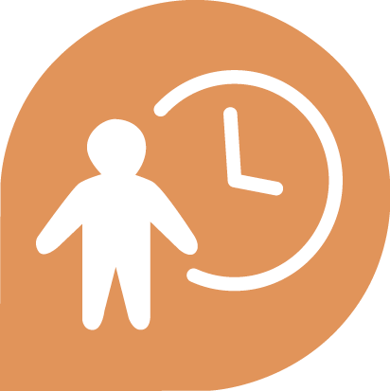
23 jeks j.ka;sh'
iEu jeäysáfhl=g u /lshdjla lsÍug" ;ukaf.a jev i|yd idOdrK jegqmla ,nd .ekSug iy jD;a;Sh iñ;shlg ne£ug whs;shla we;'

24 jeks j.ka;sh'
wms ish¨ fokdg u /lshdfjka úfõl .ekSug iy ksial,xlj isàug whs;shla we;'
25 jeks j.ka;sh'
m%udKj;a wdydr" we÷ï me<÷ï" ksjdi yd fi!LH /ljrKh iys; f.!rjkSh Ôú;hlg wm ieug whs;shla we;' uõjreka iy <uhska" /lshdjla fkdue;s mqoa.,hska" iy jhia.;‍ yd wdndO iys; mqoa.,hska hk ish¨ fokdg Wmldr ,eîug whs;shla we;'
26 jeks j.ka;sh'
wm ieug wOHdmkhla ,eîug whs;sh we;' m%d:ñl wOHdmkh fkdñ,fha ,eìh hq;=h' wmg jD;a;shla bf.k .ekSug fyda wmf.a ish¨‍ l=i,;d m%fhdackhg .ekSug yels úh hq;= h'
27 jeks j.ka;sh'
wmf.a ixialD;shg iy úoHdj yd ±kqu u.ska iudchg f.fkk hym;a foa N=la;s ú£ug wm ieug u whs;shla we;'

28 jeks j.ka;sh'
wmf.a whs;sjdislï iy ksoyi N=la;s ú£ug yels jk mßÈ úêu;a" iduldó iudchl yd f,dalhl Ôj;a ùug wmsg whs;shla we;'

29 jeks j.ka;sh'
wmsg wfkla mqoa.,hska flfrys hq;=lï ;sfnk w;r" wms Tjqkaf.a whs;sjdislï iy ksoyi wdrlaId l< hq;= h'

30 jeks j.ka;sh'
wfkl=;a mqoa.,hskaf.a whs;sjdislï iy ksoyi wysñ jk wdldrhg lghq;= lsÍug lsisÿ rdcHhlg fyda mqoa.,fhl=g wjir ke;'

