mkuÊT 1
- kdpjj; Njitfs; - kdpj cupikfs;
- kdpjg; nghWg;Gf;fs;

kdpj cupikfs; fhlÊrpafkÊ
RtnuhlÊbfsÊ

'

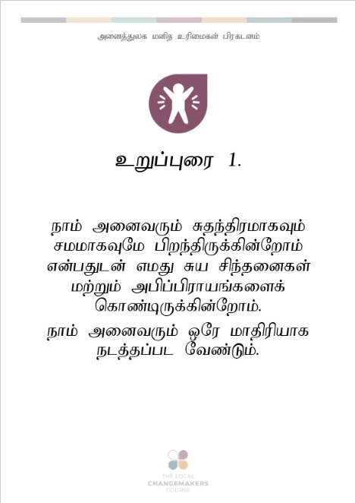

cWg;Giu 1.

ehk; midtUk; Rje;jpukhfTk; rkkhfTNk gpwe;jpUf;fpd;Nwhk; vd;gJld; vkJ Ra rpe;jidfs; kw;Wk; mgpg;gpuhaq;fisf; nfhz;bUf;fpd;Nwhk;.
ehk; midtUk; xNu khjpupahf elj;jg;gl Ntz;Lk;.

cWg;Giu 2.

ehk; nry;te;ju;fshapDk; ViofshapDk;> ve;j ehl;by; tho;e;jNghJk;> ehq;fs; vg; ghypdj;ijr; Nru;e;jtuhapDk; my;yJ ehq;fs; ve;epwj;ijr; Nru;;e;jtuhapDk;> ehq;fs; vk;nkhop NgrpDk;> ehq;fs; vjid rpe;jpj;jNghJk; my;yJ ek;gpaNghJk; mijnajidAk; nghUl;gLj;jhJ> ,t; cupikfs; xt;nthU kdpjg; gpwtpf;Fk; cupj;JilajhFk;.

cWg;Giu 3.

vk; midtUf;Fk; tho;tjw;fhd cupik cz;L vd;gJld; Rje;jpukhfTk; ghJfhg;ghfTk; thOk; cupik cz;L.

cWg;Giu 4.

vk;ik mbikahf;Ftjw;fhd vtUfÊFkÊ cupik ,y;iy vd;gJld; ehKk; NtW vtiuAk; mbikahf;f KbahJ.

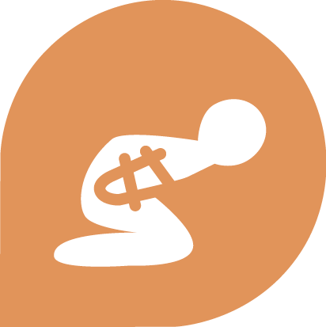
cWg;Giu 5.

ve;jnthU egUf;Fk; vk;ik fhag;gLj;Jtjw;Nfh my;yJ rpj;jputij nra;tjw;Nfh my;yJ nfh^ukhf elj;Jtjw;Nfh ve;jnthU cupikAk; ,y;iy.

cWg;Giu 6.

rl;lj;jpd; Kd;dpiyapy; egnuhUtuhf mq;fPfupf;fg;gLtjw;fhd cupik vk; midtUf;Fk; cz;L.

cWg;Giu 7.

rl;lk; midtUf;Fk; xNukhjpupahdJ. mJ ek; midtiuAk; ePjpahf elj;j Ntz;Lnkd;gJld; vk;ik ghugl;rj;jpypUe;J ghJfhf;f Ntz;Lk;.

cWg;Giu 8.

rl;lk; vkJ cupikfisg; ghJfhf;f Ntz;Lnkd;gJld; vtNuDk; vkJ cupikfis kPWfpd;wNghJ cjt Ntz;Lk;.

cWg;Giu 9.

jFe;j fhuzkpd;wp vk;ik ifJ nra;tjw;Nfh my;yJ rpiwapy; itg;gjw;Nfh my;yJ vkJ ehl;bypUe;J mDg;Gtjw;Nfh ve;jnthU egUf;Fk; cupik ,y;iy.

cWg;Giu 10.

vtNuDnkhUtu; rl;lj;ij kPwpaikf;fhf Fw;wk; rhl;lg;gl;lhy;> mtu;fSf;F ePjpahd kw;Wk; gfpuq;f tpsf;fnkhd;wpw;fhd cupik cz;L.
cWg;Giu 11.

ve;jnthU egUk; Fwpg;gpl;l tplaj;ij mtu;jhd; nra;jhu; vd;gJ ep&gpf;fg;gLfpd;wtiuapy;> mjid nra;jikf;fhf Fw;wr;Rkj;jYf;F Mshff; $lhJ. ehq;fs; VjhtJ nfl;lJ nra;Jtpl;Nlhnkd kf;fs; $wpdhy;> mJ cz;ikay;y vd ep&gpg;gjw;fhd cupik vkf;F cz;L. ehq;fs; nra;ahjnthd;Wf;fhf my;yJ ehq;fs; nra;Ak;NghJ rl;lj;jpw;F vjpuhdjhf ,y;yhj xd;wpw;fhf ve;jnthU egUk; vk;ikj; jz;bf;ff;$lhJ.

cWg;Giu 12.

ve;jnthU egUk; vq;fsJ ew;ngaUf;F CW tpistpf;f Kaw;rpf;ff;$lhJ. ve;jnthU egUf;Fk; ey;y fhuznkJTkpd;wp vq;fs; tPl;bw;Fs; tUtjw;F> vq;fsJ fbjq;fisj; jpwg;gjw;F> my;yJ vq;fis my;yJ vq;fs; FLk;gj;ijj; njhy;iy nra;tjw;F cupik ,y;iy.

cWg;Giu 13.

vq;fsJ nrhe;j ehl;by; ehq;fs; Nghf tpUk;Gfpd;w ,lq;fSf;F nry;tjw;F kw;Wk; vq;fs; tpUg;gj;jpw;fika ntspehLfSf;F gpuahzk; nra;tjw;F ek; midtUf;Fk; cupik cz;L.

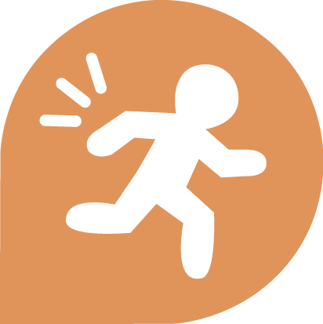
cWg;Giu 14.

vkJ nrhe;j ehl;by; ehk; Jd;GWj;jy;fSf;F Mshfpd;w mghak; cs;sNghJ> ghJfhg;gpw;fhf NtnwhU ehl;bw;F nry;tjw;fhd cupik vk; midtUf;Fk; cz;L.

cWg;Giu 15.

vk; midtUf;Fk; xU ehl;bw;F cupj;JilajhapUf;fpd;w – gpu[hTupikf;fhd cupik cz;L.

cWg;Giu 16.

taJte;j xt;nthUtUf;Fk;> mtu;fs; tpUk;gpd;> jpUkzk; nra;tjw;fhd kw;Wk; FLk;gnkhd;iwf; nfhz;bUg;gjw;fhd cupik cz;L. ve;jnthU egUk; jpUkzk; nra;tjw;F fl;lhag;gLj;jg;glf;$lhJ.
Mz;fs; kw;Wk; ngz;fs; jpUkzk; nra;fpd;wNghJ kw;Wk; mtu;fs; gpupfpd;wNghJ xNukhjpupahd cupikfisf; nfhz;Ls;shu;fs;.

cWg;Giu 17.

xt;nthUtUf;Fk; nghUl;fis nrhe;jq;nfhs;tjw;fhd kw;Wk; mtw;iwg; gfpu;tjw;fhd cupik cz;L. jFe;j fhuzkpd;wp ve;jnthU egUk; vk;kplkpUe;J nghUl;fis vLj;Jf; nfhs;sf;$lhJ.

cWg;Giu 18.

vk; midtUf;Fk; vq;fSf;fhf rpe;jpf;fpd;w cupik kw;Wk; vq;fsJ kdrhl;rpiag; gpd;gw;Wfpd;w cupik> ek;gpf;iffs; kw;Wk; kjnkhd;wpidf; nfhz;bUg;gjw;fhd cupik vd;gd cz;L. vk; midtUf;Fk; jdpahfNth my;yJ Vida egu;fSld; ,ize;Njh> gfpuq;fkhf kw;Wk; jdpg;gl;l ,lj;jpy; vq;fsJ ek;gpf;iffis eilKiwg;gLj;Jtjw;fhd cupik cz;L. xt;nthU egUf;Fk;> mtu;fSf;F tpUg;gkhapd; jq;fsJ ek;gpf;iffs; kw;Wk; kjj;jpid khw;wpf; nfhs;tjw;fhd cupik cz;L.
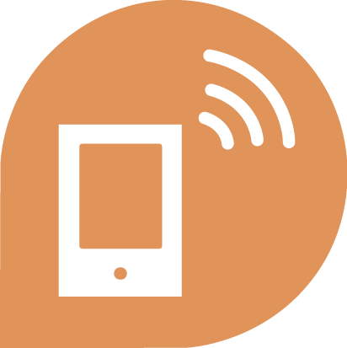
cWg;Giu 19.

vk; midtUf;Fk; jfty;fis mZFtjw;fhd kw;Wk; vq;fSila nrhe;j epidTfisf; nfhz;bUg;gjw;fhd> vq;fSila mgpg;gpuhaq;fs; kw;Wk; fUj;Jf;fisf; nfhz;bUg;gjw;fhd kw;Wk; ntspg;gLj;Jtjw;fhd kw;Wk; mtw;iw NtW egu;fSld;> mtu;fs; vq;F tho;fpd;wNghJk;> vq;fSf;F tpUg;gkhd ve;jnthU KiwapD}lhfTk;> cjhuzkhf Gj;jfq;fs; my;yJ ,izaj;jpD}lhfg; gfpu;e;Jf; nfhs;tjw;fhd cupik cz;L.

cWg;Giu 20.

vk; midtUf;Fk; vq;fSila ez;gu;fis re;jpg;gjw;fhd kw;Wk; vq;fSila cupikfis mikjpahd Kiwapy; ghJfhj;Jf; nfhs;tjw;fhf xd;whfg; gzpahw;Wjy; cs;slq;fyhf tplaq;fis xd;wpize;J nra;fpd;w FOf;fis cUthf;Ftjw;fhd cupik cz;L.
vq;fSf;F tpUg;gkpy;yhjNghJ> vq;fis FOnthd;wpDs; ,izg;gjw;F ahuhYk; KbahJ.
cWg;Giu 21.

Nju;jypy; epw;fTk;> nghJg;gzpapy; NruTk; ek; midtUf;Fk; xNu cupik cz;L. taJ te;j xt;nthUtUk;; NjuÊjyÊfspyÊ jq;fSila nrhe;jj; jiytu;fisj; njupT nra;tjw;F mDkjpf;fg;gl Ntz;Lk;. xt;nthUtUk; ,ufrpakhf mspf;fg;glj;jf;f thf;fpidf; nfhz;bUf;f Ntz;Lk;.

cWg;Giu 22.

vk; midtUf;Fk; tPnlhd;wpid nfhz;bUfÊf> tho;tjw;F NghJkhdg; gzj;jpidf; nfhz;bUfÊf kw;Wk; ehk; RftPdKWfpd;wNghJ kUj;Jt cjtpapidg; ngw;Wf;nfhs;tjw;fhd cupik cz;L. ehk; midtUk; mDgtpg;gjw;F kw;Wk; ,ir> fiy> iftpid> tpisahl;L Mfpatw;wpD}lhf vk;ik ntspg;gLj;Jtjw;F kw;Wk; vq;fSila jpwikfisg; gad;gLj;Jtjw;F mDkjpf;fg;gl Ntz;Lk;.

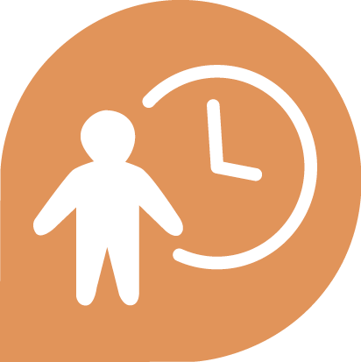
cWg;Giu 23.

xt;nthU taJ te;jtUf;Fk; njhopnyhd;Wf;fhd cupik> jq;fSila Ntiyf;Nfw;w epahakhd rk;gsj;jpidg; ngw;Wf;nfhs;tjw;fhd cupik kw;Wk; njhopw;rq;fnkhd;wpy; ,iztjw;fhd cupik cz;L.

cWg;Giu 24.

vk; midtUf;Fk; NtiyapypUe;J Xa;T ngWtjw;fhd kw;Wk; ,isg;ghWtjw;fhd cupik cz;L.

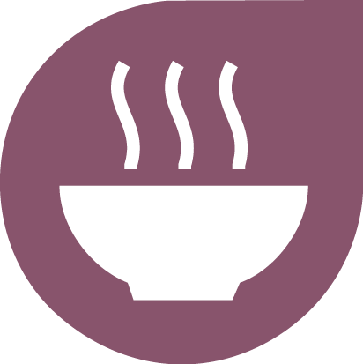
cWg;Giu 25.

NghJkhd czT> cil> tPL kw;Wk; Rfhjhug; guhkupg;Gldhd nfsutkhd tho;f;ifnahd;wpw;fhd cupik vk; midtUf;Fk; cz;L. jha;khu; kw;Wk; gps;isfs;> Ntiyaw;w egu;fs;> tajhd kw;Wk; ,ayhikfisAila egu;fSf;F cjtpf;fhd cupik cz;L.

cWg;Giu 26.

vk; midtUf;Fk; fy;tpf;fhd cupik cz;L. MukÊgfy;tp ,ytrkhdjhf ,Uf;f Ntz;Lk;. vk;khy; xU njhopiyf; fw;Wf; nfhs;sf;$bajhf my;yJ vkJ midj;J jpwikfisAk; gad;gLj;jf;$bajhf ,Uj;jy; Ntz;Lk;.

cWg;Giu 27.

vk; midtUf;Fk; vkJ nrhe;jf; fyhrhuj;jpw;fhd cupik kw;Wk; tpQ;Qhdk; kw;Wk; fw;wy; vd;gd r%fj;jpw;F nfhz;LtUfpd;w ey;y tplaq;fis mDgtpg;gjw;fhd cupik vd;gd cz;L.
cWg;Giu 28.

vkf;F xOq;fhd> mikjpahd r%fj;jpy; kw;Wk; cyfj;jpy; tho;tjw;fhd cupik cz;L. MfNt> ehk; vkJ cupikfs; kw;Wk; Rje;jpuq;fis mDgtpf;f KbAk;.

cWg;Giu 29.

Vida egu;fs; njhlu;ghf vkf;F xU flik cz;L vd;gJld; ehk; mtu;fspd; cupikfs; kw;Wk; Rje;jpuq;fisg; ghJfhf;f Ntz;Lk;.

cWg;Giu 30

ve;jnthU muRk; my;yJ egUk; Vida egu;fspd; cupikfs; kw;Wk; Rje;jpuq;fis ePf;Ffpd;wtifapy; nraw;gLtjw;F mDkjpf;fg;glf;$lhJ.

