1 jeks ieish

udkj wjYH;d - udkj ysñlï
- udkj j.lSï

bosßm;a lsÍu i|yd
l:k msgm;
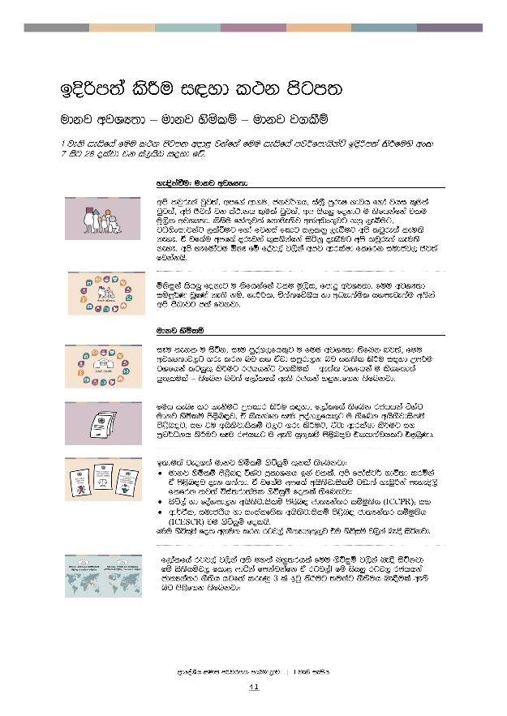
bÈßm;a lsÍu i|yd l:k msgm;
udkj wjYH;d – udkj ysñlï – udkj j.lSï
1 jeks ieisfha fuu l:k msgm; wod< jkafka fuu ieisfha mj¾fmdhskaÜ bosßm;a lsÍfuys wxl
7 isg 28 olajd jk ia,hsv i|yd fõ'
 | ye¢kaùu( udkj wjYH;d
 | wms ljqreka jqj;a" wmf.a wd.u" ckj¾.h" ia;%S mqreI Ndjh fyda jhi l=ula jqj;a" wms Ôj;a jk ia:dkh l=ula jqj;a" wm ish¨ fokdg u ;sfhkafka tlu uQ,sl wjYH;d' lsisu fya;=jla fkdue;sj w;awvx.=jg .kq ,eîug" jOysxidjkag ,laùug fyda fjkia fldg i,lkq ,eîug wms ljqre;a leu;s keye' ta jf.au wmf.a orejka l=i.skafka isákq oelSug wms ljqre;a leu;s keye' wms yefudagu ´kE fï foaj,a j,ska wmj wdrlaId flfrk iudcj, Ôj;a fjkakhs'
 | ñksiqka ish¨ fokdg u ;sfhkafka tlu uQ,sl" fmdÿ wjYH;d' fuu wjYH;d iïmQ¾K jqfKa ke;s kï" YdÍßl" Ñ;a;fõ.Sh yd wOHd;añl hymeje;au w;ska wms mSvdjg m;a fjkjd'
 | udkj ysñlï
 | iEu ;ekl u isák" iEu mqoa.,fhl=g u fuu wjYH;d ;sfnk nj;a" fuu wjYH;dj,g .re lrk nj iy tajd imqrd,k nj iy;sl lsÍu i|yd Wmßu jYfhka lghq;= lsÍug rchhkag j.lSula – we;a; jYfhka u lshf;d;a hq;=lula – ;sfnk nj;a f,dalfha we;s rchka y÷kdf.k ;sfnkjd'
 | fuh ienE lr .ekSug Wmldr lsÍu i|yd" f,dalfha ;sfnk rchhka úYaj udkj ysñlï ms<sn|j" ta lshkafk iEu mqoa.,fhl=g u ;sfnk whs;sjdislï ms<sn|j" iy tu whs;sjdislï j,g .re lsÍug" tajd wdrlaId lsÍug iy m%j¾Okh lsÍug iEu rchlg u we;s hq;=lï ms<sn|j tlÕ;ajhlg t<UqKd'
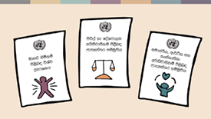 | b;du;a jeo.;a udkj ysñlï .súiqï ;=kla ;sfnkjd(  - udkj ysñlï ms<sn| úYaj m%ldYkh bka tlla' wms fmdaiag¾ Ndú;d lrñka ta ms<sn|j oek .;a;d' ta jf.au wmf.a whs;sjdislï jvd;a .eUqßka meyeÈ,s flfrk ;j;a úia;rd;aul .súiqï folla ;sfnkjd(  - isú,a yd foaYmd,k whs;sjdislï ms<sn| cd;Hka;r iïuq;sh (ICCPR)¦ iy  - wd¾Ól" iudchSh yd ixialD;sl whs;sjdislï ms<sn| cd;Hka;r iïuq;sh (ICESCR) tu .súiqï folhs'  fuu .súiqï fol wkqu; lrk rgj,a kS;Hdkql+,j tu .súiqï j,ska ne£ isákjd'
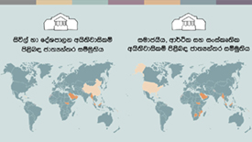 | f,dalfha rgj,a j,ska w;s uy;a nyq;rhla fuu .súiqï j,ska ne|S isákjd – fï is;shïj, fld< mdáka fmkajkafk ta rgj,aæ fï ish¨‍ rgj, rchhkaa cd;Hka;r kS;sh hgf;a lreKq 3 la bgq lsÍug ;ukag kS;suh ne|Sula we;s nj ms<sf.k ;sfnkjd(

- Tjqka idok kS;s j,oS iy ks,OdÍka .kakd l%shdud¾. j,oS udkj ysñlï j,g .re lsÍug' WodyrKhla f,i" fjkiafldg i,lk wdldrfha kS;s fkd;sìh hq;= w;r lsisfjl= jO ysxidj,g ,la fkdl< hq;=hs'
- rch úiska fyda fjk;a wfhl= úiska ;ukaf.a whs;sjdislï W,a,x>kh lrkq ,enQ úg iEu wfhl=g u hqla;sh bgq lr .; yels njg iy;sl lrñka udkj ysñlï wdrlaId lsÍug¦ iy
- iEu wfhl=g u ;ukaf.a whs;sjdislïj,g m%fõYh ,efnk nj iy;sl lsÍug Wmßu f,i lghq;= lrñka udkj ysñlï m%j¾Okh lsÍug' WodyrKHla f,i" iEu flfkl=g u fi!LH fiajd iy wOHdmkh i|yd m%fõYh we;s nj iy;sl lsÍug Wmßu jYfhka lghq;= l< hq;=hs' we;a; jYfhka u" iEu rchlg u tl yd iudk f,i iïm;a keye' tksid fuu iudc yd wd¾Ól whs;sjdislï ienE lsÍu l%u l%ufhka isÿjk l%shdj,shla'

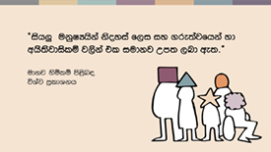 | iEu ñksfil=g u fuu whs;sjdislï tl yd iudkj we;s njg rchhka tlÕ ù ;sfnkjd' —ish¨‍ ukqIHhska ksoyia ukqIHhska f,i Wm; ,nk w;r Tjqka f.!rjh yd whs;sjdislï j,ska tl yd iudk fõ˜ hkqfjka udkj ysñlï ms<sn| úYaj m%ldYkfha m<uq jeks j.ka;sfha u i|yka fjkjd'
 | kuq;a" fndfyda rchhka fuu ne£ï bgq fkdlsÍu lK.dgqjg lreKla – fndfyda mqoa.,hskaf.a whs;sjdislï W,a,x>kh fjkjd' ldka;djka" .eyeKq <uhska" iq¿;r lKavdhï" wdndO iys; mqoa.,hska iy ixl%u‚lhska úfYaIfhka u whs;sjdislï W,a,x>khùï j,g f.dÿre fjkjd' f,dalfha iEu rgl u isÿjk W,a,x>khùulg fmdÿ WodyrKhla ;uhs ia;%S mqreI iudcNdjh mokï lr .;a ysxikh'
 | udkj ysñslï ms<sn| ú.%yh
 | rchhka whs;sjdislï W,a,x>kh lrk úg fyda whs;sjdislï W,a,x>kh lsÍï j,ska ck;dj wdrlaId lsÍug rchhka wfmdfydi;a jk úg meñK tu rchhkag o`vqjï lsÍu i|yd f.da,Sh fmd,sia n,ldhla keye' udkj ysñlï wkq.ukh lrkakg lshd rchhkag n, lsÍug tjeks cd;Hka;r fmd,sia n,ldhla fkdue;s kï" udkj ysñlï lshkafka" ienE n,hla ke;s" fjkila we;slsÍug ;sfnk M,odhS fuj,ulg jvd" lvodishl ,shejqKq jpk fm<la muKla fkdfjhso@
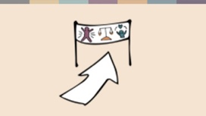 | tfia lSfuys hï i;H;djhla o ;sfhkjd – iuyr rchhkag n,mEï lsÍu b;d wmyiqhs' ta;a" udkj ysñlï W,a,x>kh lsÍï ms<sn|j cd;Hka;r yd foaYSh jYfhka isÿ flfrk úfõpk fndfyda rgj, Okd;aul fjkila we;s lsÍug fya;= ù ;sfnkjd' cd;Hka;r fmd,sia n,ldhla fkdue;sj jqj;a udkj ysñlï m%j¾Okh lrkakg yels fndfyda l%u ;sfnkjd'
ñksiqka udkj ysñlï úfõpkh lsÍug ;j;a fya;= lsysmhla ;sfnkjd' iuyr úg Tng o fujeks is;=ú,s we;sù ;sfnkjd fjkakg mq¿jks(
- iuyrúg udkj ysñlï lshkafka yßu ;dla‍I‚l fohla lshd Tng isf;kakg we;s – ta lshkafka udkj ysñlï Tng iïnkaOhla ;sìh yels fohla fkdj th kS;s{hskag iy foaYmd,k{hskag ud;Dldjla hehs Tng isf;kakg we;s'
- tfyu ke;akï" iuyrúg udkj ysñlï lshkafka Tnf.a ffoksl Ôú;hg fndfyda fihska ÿria: fohla lshd" ta lshkafka úYd, k.rj, m%N+ me,eka;shg wh;a mqoa.,hskag úuis,su;a úh yels fohla lshd Tng isf;kakg we;s'
- tfia;a ke;s kï" iuyrúg udkj ysñlï lshkafka f.da,Sh foaYmd,k l%Svdjl wdhqOhla f,i Tng fmfkkakg we;s' ta lshkafk iuyr rchka udkj ysñlï W,a,x>kh lrk w;r u l=yl f,i i;=rka úfõpkh lsÍug o udkj ysñlï Ndú;d lrkafka h lshd Tng isf;kakg we;s'
fyd|hs" udkj ysñlï lshkafka kS;sh iïnkaO fohla¦ foaYmd,k{hska kS;s yokjd¦ kS;s{hskag wêlrKh yryd udkj ysñlï fjkqfjka igka l< yelshs' tal we;a;" udkj ysñlï lshk fhÿu iuyr úg foaYmd,k wruqKq i|yd fhdod f.k wjNdú;d lrkjd' kuq;a udkj ysñlï lshkafka Bg jvd fndfyda mq¿,a fohlaæ
 | udkj ysñlï iy wms
wms oeka f;areï .;a wdldrhg" udkj ysñlï j,ska l:d lrkafka we;a; jYfhka u wmf.a tÈfkod Ôú;fha wmg we;s wjYH;d ms<sn|j hs¦ wfma mdif,a" f.dúmf<a" fiajd ia:dkfha" ksjfia iy wjg m%foaYfha isÿjk foa ms<sn|jhs¦ wms tlsfkldg ie,lsh hq;= wdldrh yd wmg i,lkq ,eíh hq;= wdldrh ms<sn|jhs¦ wmf.a Ôú; iïnkaOfhka n,h ;sfnk wh úiska" ta lshkafka bvï ysñhka" fiajd fhdaclhska" .=rejreka jeks wh ú;rla fkdfjhs wfma mjqf,a idudðlhska úiska mjd" iy we;a; jYfhka u" fmd,Sish" Widú" yuqodj iy rch jeks n,OdÍka úiska o wmj wmfhdackhg ,la lrkq ,eîfuka wmj wdrlaId lsÍu ms<sn|jhs'
iuyr úg wmg th fukafk fï úosyg fláfhka lsj yelshs( udkj ysñlï j,ska l:d lrkafka wm Ôj;a ùug leu;s wdldrfha iy wm tlaj jev lr f.dvkeÕSug leu;s wdldrfha iudch ms<sn|jhs'
wmf.aa m%cdjka ;=< udkj ysñlï ienE lr .ekSug kï" wms ish¨ fokd u bgq l< hq;= ld¾hNdrhla ;sfnkjd' fndfyda udkj ysñlï W,a,x>khùï isÿfjkafka idudkH ck;dj wka whf.a whs;sjdislï j,g .re fkdlrk ksidhs' WodyrKhla úosyg wms iuyr mqoa.,hskag wm yd iudk wh f,i fkdi,lk ksid' ta jdf.au ñksiqka tlsfkld fjkqfjka ke.S fkdisák ksid" foaj,a fjkia lsÍug W;aidy fkdlrk ksid iy wms fndfyda úg ksy`vj isák ksid rchhkag" jHdmdrj,g iy mqoa.,hskag udkj ysñlï W,a,x>kh lsÍï È.ska os.gu isÿq lrf.k hkakg yelsù ;sfnkjd'

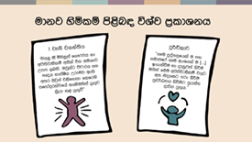 | wms wdKavq fkdfjhs – wms cd;Hka;r udkj ysñlï .súiqï w;aika lr,d keye¦ udkj ysñlï wkq.ukh lrk nj iy;sl lsÍug wmg kS;suh j.lSula keye' kuq;a wms ;¾ldkql+,j yd yDoh idlaIshg tlÕj ys;d ne¨fjd;a wms ish¨ fokd ukqIHhska' tu ksid wms tlsfkldg iodpdrd;aul hq;=lula ;sfnkjd' udkj ysñlï ms<sn| úYaj m%ldYkfha fufyu i|yka fjkjd(  —ish¨ u‍ ñksiqka f.!rjh yd whs;sjdislï w;ska tl iudkj Wm; ,nhs' Tjqkag úpdrh iy yDoh idlaIsh Wreuj we;s w;r Tjqka tlsfkld flfrys ifydaor;ajfha yeÕSulska hq;=j l%shd l< hq;= hs'˜  —''' iEu mqoa.,fhla u iy iudcfha iEu wxYhla u […] b.ekaùu yd oekqj;a lsÍu u.ska fuu whs;sjdislï j,g iy ksoyig .re lsÍu m%j¾Okh lsÍug m%h;ak oeßh hq;= h'˜  wka whf.a Ôú;j,g hym;la fyda whym;la lsÍug wmg n,h we;s úg" wmg udkj ysñlï wdrlaId lsÍfï iodpdrd;aul j.lSula ;sfnkjd' wmg yeu fohlau lrkak neye – iuyr wjia:dj, wmg l< yels lsisu fohla .ek is;d .ekSug;a neß fjkjd – kuq;a whqla;shla isÿjk nj wmg fmfkk úg" ta iïnkaOfhka hula l< yels kï" wms th lsÍug W;aidy lsÍu wfma iodpdrd;aul hq;=lula fjkak mq¿jka'  hula lsÍu fyd| wi,ajeisfhl= ùu ;rï ir, fohla fjkak mq¿jks'
 | iudc mßj¾;lhska ms<sn| l;d
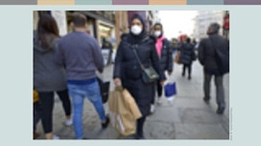 | I*dla yika lshkafk ol=Kq ,kavkfha fjfik ì%;dkH cd;sl uqia,sï ldka;djla' miq.sh ld,fha oS tlai;a rdcOdksfha ffjÍ wmrdO úYd, jYfhka by< .syska ;sfhkjd' uqia,sïjre iy úfYaIfhka u ysi wdjrK m<¢k uqia,sï ldka;djka ^I*dla jf.a& fndfyda úg wka;¾cd,fha oS jf.au uyd ud¾.fhaoS;a b,lal njg m;a fjkjd' fujeks jd;djrKhla ;=<" úúO weoys,s iys; m%cdjka w;r tÈfkod isÿ flfrk ñ;%YS,S iy ;Hd.YS,S l%shd fndfyda fihska w¾:j;a úh yelshs'  I*dla f.a uqia,sï fkdjk wi,ajeishd weh fkdys;mq úoshg wehg iy wehf.a 14 yeúßÈ mq;d whdka g Boa W;aijh iurkak ;E.s ÿka úg ukqIH;ajh ms<sn| weh ;=< ;snQ úYajdih kej;;a h:d ;;ajhg m;a jqKq nj I*dla lshkjd'
I*dla thd,g ,enqKq ;E.sj, f*dfgda tlla Üúg¾ tlg od,d fufyu lsh,d ;snqKd

—uqia,sï flfkla fkdfjk wfma wi,ajeishd wmsg we,af.aßhka rgb|shs" iïmQ¾K udih mqrd u Wmjdifha fhÿKq uf.a 14 yeúßos mq;dg hdÉ{d lrkak l,d,hl=hs ;E.s lf<a wms mqÿuhg m;a lrñka' thd wjqreÿ úiailg jeä ld,hla wmf.a wi,ajeishd fj,d ysáh;a Boa ;E.s j,ska wmj iïmQ¾Kfhka u mqÿu l<d'˜

—whdka Wmjdifha fhfok nj thdg f;aß,d ;snqKd lshd ug oekqfKa keye' fï isÿùfuka uf.a mq;dg we;a;g u ;uka úfYaIhs lsh,d oekqKd' thd,d wms;a tlal ys;j;a wi,ajeishka¦ thd,d uf.a wïud yok nqßhdksj,g leu;s ksid wms iEu úgu thd,g nqßhdks fmÜáhla hjkjd' wms fjkia m%cdjkag whs;s jqk;a" wfma wi,ajeishd whdka .ekhs wd.ñl úYajdih .ekhs ta ;rug u l,amkdldÍ fj,d whdkaj ffO¾hu;a lrmq tl yoj; WKqiqï lrjk fohla'˜

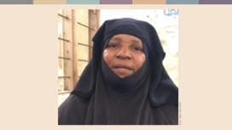 | id,syd iy ue.av,Skd lshkafka;a b;d fjkia jd;djrKhla ;=< fjkila isÿ lrñka isák wh' id,syd lshkafka iekaisnd¾ ¥m;a iuQyfha fmïnd lshk ¥mf;a bkak ieoeyej;a uqia,sïjßhla fukau ñ;a;kshla' weh tu m%foaYfha uøid mdif,a W.kajkjd'
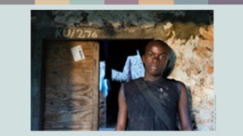 | id,syd fufyu lshkjd  —wfma m%cdjka w;fr ;sfnk fkdikaiqka;djh .ek uu lkiai,af,ka bkafk' wfma ;reK whg wfma foaYmd,k kdhlhka .ek úYajdihla keye' thd,g wjia:d ,efnkafk keye'˜
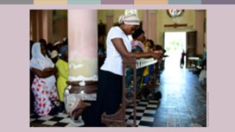 | weh ;j;a fufyu lshkjd"  —ixpdrl wxYfha /lshd lrkak m%Odk N+ñ m%foaYfha b|,d fufyg tk jeä fofkla l%sia;shdks wh' uu okak uqia,sï wh fndfyda fofkla ;ukag lrkak ;sfhk /lshd l%sia;shdks wh weú;a wr.kak tl .ek fodia lshkjd' uu wjqreÿ .Kkdjla ;siafia mej;=Kq foaYmd,k fkdikaiqka;djh iy wd.ñl l,n,ldÍ ;;a;ajh w;aú|, ;sfhkjd' m,a,s .sksn;a lrkjd" ffjÍ l:d iys; m;%sld fnod yßkjd" m,a,shg hk mdfros ls%ia;shdks whg ysßyer lrkjd uu oel, ;sfhkjd' wfma ;reK wh jvd;a /äl,a fjñka isák nj oelSfuka uu lkiai,a,g m;afj,d bkafk' ta ksid ;uhs uu ldka;djkaf. wka;¾ wd.ñl lñgqjg ne÷fKa'˜
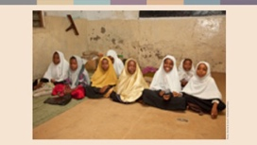 | —uu wfma ¥mf;a wd.ñl m%pKav;ajh je<elaùug Woõ lrkak leu;shs' uøid mdief,a§ uu orejkag W.kajkafka bjiSu iy wdorh wfma wd.fï uQ,sl wx. njhs' wkd.;h ;sfhkafka wfma orejka wf;a¦ ta ksid Tjqkag yß ud¾.h fmkaùu ;uhs wfma j.lSu'˜
m%Odk N+ñ m%foaYfha b|,d iekaisnd¾ oQmf;a mÈxÑhg .sh l%sia;shdks ldka;djla jk ue.av,Skd o wka;¾ wd.ñl lghq;=j, ksr; fjkjd' weh w¢k m<¢k wdldrh;a wehf.a wd.u;a ksid weh fjkiafldg i,lkq ,eîug uqyqK §,d ;sfhkjd' ta jqk;a weh ls%ia;shdks whhs uqia,sï whhs w;r ;sfhk fNaoh ;=rka lsÍug wêIaGdk lrf.k bkafk' weh wka;¾ wd.ñl wNsfhda. .ek;a ldka;djkaf.a whs;sjdislï .ek;a l;d lsÍug m%cdjka w;rg hk ixúOdkhla jk Wkaf.dahd m%dfoaYSh ldka;d ljqkais,hg iïnkaO jqKd'

—uu lñgqjg ne÷fKa bia,dï .ek jeäÿrg;a bf.k f.k uqia,sïjreka Ôj;a jk wdldrh wjfndaO lr .ekSughs˜ hkqfjka weh meyeÈ,s lrkjd' ˜‍wms yefudau ldka;djka' ta ksid wms yefudau fjkiafldg ie,lSïj,g uqyqK fokjd – wms tlg tlaj tlsfkldg iyfhda.h oelaúh hq;=hs'˜‍

I*dlaf.a wi,ajeishd iy id,syd iy ue.av,Skd jeks wh .Kka lrkak neß ;rï ixLHdjla bkakjd' ;uka isák m%cdjka ;=< ;ukaf.au mqxÑ l%uj,ska udkj ysñlï h:d¾:hla njg m;a lsÍug W;aidy lrk wms jf.a idudkH ñksiaiq – m%dfoaYSh iudc mßj¾;lhskaæ

wms ljqreka jqk;a" udkj ysñlï h:d¾:hla njg m;a lsÍug wmsg;a hula l< yelshsæ

uQ,dY%(
Faith Matters www.faith-matters.org
https://www.faith-matters.org/family-surprised-by-presents-from-non-muslim-neighbour-to-celebrate-eid/
Zanzibar Inter-faith Centre (ZANZIC)
https://www.facebook.com/ZanzicMeansPeace/
https://english.danmission.dk/project/zanzibar-peacebuilding-through-interfaith-dialogue/

