mkuÊT 1
- kdpjj; Njitfs; - kdpj cupikfs;
- kdpjg; nghWg;Gf;fs;

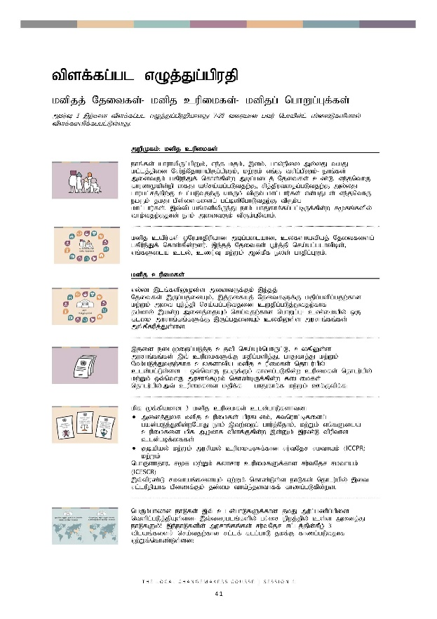
tpsfÊfgÊgl
vOjÊJgÊgpujp

tpsfÊfgÊgl vOjÊJgÊgpujp
kdpjj; Njitfs;- kdpj cupikfs;- kdpjg; nghWg;Gf;fs;
mkuÊT 1 ,wÊfhd tpsfÊfgÊgl vOjÊJgÊgpujpahdJ 7-28 tiuahd gtuÊ nghapdÊlÊ ]ÊiyLfspdhyÊ tpsfÊfkspfÊfgglÊLsÊsJ.

 | mwpKfk;: kdpj cupikfs;
 | ehq;fs; ahuhapUg;gpDk;> ve;j kjk;> ,dk;> ghy;epiy my;yJ taJ kl;lj;jpid Nru;e;NjhuhapUg;gpDk;> kw;Wk; vq;F trpg;gpDk;- ehq;fs; midtUk; gfpu;e;Jf; nfhs;fpd;w mbg;gilj; Njitfs; cz;L. ve;jnthU fhuzKkpd;wp ifJ nra;ag;gLtjw;F> rpj;jputijg;gLtjw;F my;yJ ghugl;rj;jpw;F cl;gLtjw;F ahUk; tpUk;gkhl;lhu;fs; vd;gJld; ve;jnthU egUk; jkJ gps;isfisg; gl;bdpNghLtjw;F tpUk;g khl;lhu;fs;. ,t;tplaq;fspypUe;J ehk; ghJfhf;fg;gl;bUf;fpd;w r%fq;fspy; tho;tjw;Fjhd; ehk; midtUk; tpUk;GNthk;.
 | kdpj capu;fs; xNukhjpupahd mbg;gilahd> cyfshatpaj; Njitfisg; gfpu;e;Jf; nfhs;fpd;wdu;. ,e;jj; Njitfs; G+u;j;jp nra;ag;glhtpbd;> vq;fSila cly;> czu;T kw;Wk; Md;kPf eyd; ghjpg;GWk;.
 | kdpj cupikfs;
 | vy;yh ,lq;fspYKs;s midtUf;Fk; ,e;jj; Njitfs; ,Ug;gjidAk;> ,j;jifaj; NjitfSf;F kjpg;gspg;gjw;fhd kw;Wk; mit g+u;j;jp nra;ag;gLtjid cWjpg;gLj;Jtjw;fhf jk;khy; ,ad;w midj;ijAk; nra;tjw;fhd nghWg;G- cz;ikapy; xU flik murhq;fq;fSf;F ,Ug;gjidAk; cyfpYs;s murhq;fq;fs; mq;fPfupj;Js;sd.
 | ,jid eilKiwg;gLj;j cjtp nra;Ak;nghUl;L> cyfpYs;s murhq;fq;fs; ,t; cupikfSf;F kjpg;gspj;J> ghJfhj;J kw;Wk; Nkk;gLj;Jtjw;fhf cyfshtpa kdpj cupikfs; njhlu;gpy; cld;gl;;Ls;sd - xt;nthU egUf;Fk; fhzg;gLfpd;w cupikfs; njhlu;gpy; kw;Wk; xt;nthU murhq;fKk; nfhz;bUf;fpd;w filikfs; njhlu;gpy;.mtÊ cupikfis kjpfÊf ghJfhfÊf kwÊWkÊ CfÊFtpfÊf
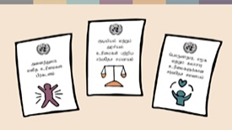 | kpf Kf;fpakhd 3 kdpj cupikfs; cld;ghLfshtd:  - midj;Jyf kdpj cupikfs; gpufldk;> Rtnuhl;bfisg; gad;gLj;Jfpd;wNghJ ehk; ,tw;iwg; ghu;j;Njhk;> kw;Wk; vq;fSila cupikfis kpf Mokhf tpsf;Ffpd;w ,d;Dk; ,uz;L tpupthd cld;gbf;iffs;  - Fbapay; kw;Wk; murpay; cupikfSf;fhd ru;tNjr rkthak; (ICCPR) kw;Wk;  - nghUshjhu> r%f kw;Wk; fyhrhu cupikfSf;fhd ru;tNjr rkthak; (ICESCR)  ,t;tpuz;L rkthaq;fisAk; Vw;Wf; nfhz;Ls;s ehLfs; njhlu;gpy; ,it rl;luPjpahf gpizf;Fk; jd;ik tha;e;jdthff; fhzg;gLfpd;wd.
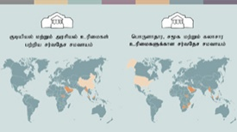 | ngUk;ghyhd ehLfs; ,t; cld;ghLfSf;fhd jkJ mu;g;gzpg;gpid ntspg;gLj;jpAs;sd- ,t;tiuglq;fspy; gr;ir epwj;jpy; cs;s midj;J ehLfSk;! ,e;ehLfspd; murhq;fq;fs; ru;tNjr rl;lj;jpd;fPo; 3 tplaq;fisr; nra;tjw;fhd rl;lf; flg;ghL jkf;F fhzg;gLtjhf Vw;Wf;nfhz;Ls;sd:

- mtu;fs; Mf;Ffpd;w rl;lq;fs; kw;Wk; mjpfhupfs; Nkw;nfhs;fpd;w eltbf;iffspy; kdpj cupikfSf;F kjpg;gspj;jy;. cjhuzkhf> ghugl;rkhd rl;lq;fs; fhzg;glf;$lhJ vd;gJld; ve;jnthU egUk; rpj;jputij nra;ag;glf;$lhJ.
- murpdhy; my;yJ NtW ahNuDnkhUtuhy; jq;fSila cupikfs; kPwg;gLfpd;wNghJ ePjpapid ehLtjw;F xt;nthUtUf;Fk; KbAk; vd;gjid cWjpg;gLj;JtjD}lhf kdpj cupikfisg; ghJfhj;jy;.
- kw;Wk; xt;nthU egUk; jq;fSila cupikfSf;fhd mZFjiyf; nfhz;Ls;sdu; vd;gjid cWjpg;gLj;Jtjw;F jk;khy; ,ad;w midj;ijAk; nra;tjD}lhf> kdpj cupikfis Nkk;gLj;jy;. cjhuzkhf> xt;nthU egUk; Rfhjhu guhkupg;G kw;Wk; fy;tpf;fhd mZFjiyf; nfhz;Ls;sdu; vd;gjid cWjpg;gLj;Jtjw;F jk;khy; ,ad;w midj;ijAk; nra;jy;. midj;J murhq;fq;fSk; xNukhjpupahd tsq;fisf; nfhz;bUg;gjpy;iy vd;gJ re;Njfj;jpw;fplkw;w tplak;> MfNt> ,j;jifa r%f kw;Wk; nghUshjhu cupikfis eilKiwg;gLj;jy; fpukkhf epfof;$banjhU nrad;KiwahFk;.

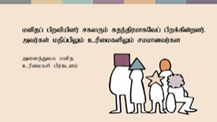 | xt;nthU kdpjDk; ,j;jifa cupikfis rkkhff; nfhz;Ls;shd; vd;gjid murhq;fq;fs; Vw;Wf; nfhz;Ls;sd. midj;Jyf kdpj cupikfs; gpufldj;jpd; KjyhtJ cWg;GiuahdJ> “kdpjg; gpwtpapdu; rfyUk; Rje;jukhfNt gpwf;fpd;wdu;. mtu;fs; kjpg;gpYk; cupikfspYk; rkkhdtu;fs;” vd $Wfpd;wJ.
 | Jujp~;ltrkhf> mjpfkhd murhq;fq;fs; ,j;jifa mu;g;gzpg;Gf;fis eilKiwg;gLj;Jtjpy;iy- gy egu;fSila cupikfs; kPwg;gl;Ls;sd. ngz;fs;> ngz; gps;isfs;> rpWghd;ikapdu;> ,ayhikfisAila egu;fs; kw;Wk; Gyk;ngau;e;Njhu; vd;Nghu; cupik kPwy;fSf;F ,yFtpy; cl;glf;$batu;fshapUf;fpd;wdu;. cyfpYs;s xt;nthU ehl;bYk; ,lk;ngWfpd;w ghy;epiy mbg;gilapyhd td;Kiw ,jw;fhd nghJthdnjhU cjhuzkhFk;.
 | kdpj cupikfs; gw;wpa tpku;rdk;
 | murhq;fq;fs; cupikfis kPWfpd;wNghJ my;yJ kf;fis cupik kPwy;fspypUe;J ghJfhf;fj; jtWfpd;wNghJ> murhq;fj;jpidj; jz;bg;gjw;fhf tuf;$ba cyfshtpa nghyp]; gilnahd;W ,y;iy. MfNt> kdpj cupikfisg; gpd;gw;Wk;gb murhq;fq;fis fl;lhag;gLj;jf;$ba ru;tNjr nghyp]; gilnahd;W ,y;iynadpy;- kdpj cupikfs; tYtw;wjhfptplhjh- khw;wj;jpw;fhd tpidj;jpwdhd fUtpnahd;whf ,y;yhky; fhfpjj;jpypUf;fpd;w thu;j;ijfshfptplhjh?
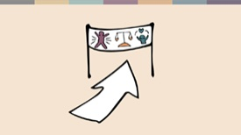 | ,jpy; nfhQ;rk; cz;ik ,Uf;fpd;wJ- rpy murhq;fspy; nry;thf;F nrYj;Jjy; kpff; fbdk;. Mdhy; mjpfsthd ehLfspy;> kdpj cupik kPwy;fs; njhlu;ghd ru;tNjr kw;Wk; cs;ehl;L tpku;rdq;fs; rhjfkhd khw;wj;jpw;F toptFj;Js;sd. ru;tNjr nghyp]; gilnahd;wpd;wp kdpj cupikfis Nkk;gLj;Jtjw;F gy topfs; fhzg;gLfpd;wd.
kf;fs; kdpj cupikfs; njhlu;gpy; tpku;rpg;gjw;F NtW rpy fhuzq;fSk; fhzg;gLfpd;wd. rpy Ntisfspy; cq;fSf;Fk; ,e;j rpe;jidfs; ,Ue;jpUf;fyhk;?
- ngUk;ghYk; kdpj cupikfs; cq;fSf;F kpf El;gkhd tplankhd;whfj; njupayhk;- mJ ePq;fs; <Lglf;$ba tplankhd;whf ,y;yhky;> khwhf> rl;lj;juzpfs; kw;Wk; murpay;thjpfSf;fhd tplakhf cq;fSf;F njupayhk;.
- my;yJ ngUk;ghYk;> kdpj cupikfs; cq;fs; ehshe;j tho;;f;ifapypUe;J ntF njhiytpypUg;gjhf- efu;g;Gwq;fspYs;s cau;Fbfs; ftiyg;gl Ntz;banjhU tplakhf mJ cq;fSf;F njupayhk;.
- my;yJ rpyNtisfspy;> kdpj cupikfs; cyfshtpa murpay; tpisahl;bd; xU MAjk;Nghy Njhd;wyhk;. murhq;fq;fs;; jhq;fSk; kdpj cupikfis kPwpf; nfhz;Nl jkJ vjpupfis tpku;rpg;gjw;fhf Neu;ikaw;wKiwapy; gad;gLj;Jfpd;w xU tplakhf kdpj cupikfs; fhzg;glyhk;.
Mk;> kdpj cupikfs; rl;lj;ijg; gw;wpaJ> murpay;thjpfs; rl;lj;ij Mf;Ffpd;wdu; kw;Wk; rl;lj;juzpfs; ePjpkd;wq;fspD}lhf kdpj cupikfSf;fhf thjpLfpd;wdu;. mj;Jld;> Mk;> ,g;gjkhdJ rpyNtisfspy; murpay; fhuzpfSf;fhf gad;gLj;jg;gLfpd;wJ kw;Wk; KiwNflhfg; ghtpf;fg;gLfpd;wJ. Mdhy;> kdpj cupikfs; vd;gd mjw;Fk; mg;ghYs;s tplankhd;whFk;.
 | kdpj cupikfSk; ehq;fSk;
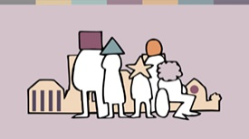 | ehq;fs; fhz;fpd;wjw;fika> kdpj cupikfs; vd;gd cz;ikapy; vkJ ehshe;j tho;f;ifapy; ehk; nfhz;bUf;fpd;w Njitfs; gw;wpajhFk;. vq;fSila ghlrhiyfs;> gz;izfs;> njhopy; epiyaq;fs;> tPLfs; kw;Wk; mayplq;fspy; ,lk;ngWfpd;w tplaq;fs; njhlu;ghdjhFk;. ehk; VidNahiu vt;thW elj;Jfpd;Nwhk; kw;Wk; ehk; vt;thW elj;jg;gLfpd;Nwhk; vd;gJ gw;wpaJ. vkJ tho;f;ifapy; mjpfhuj;jpidf; nfhz;Ls;s egu;fshy;- tPl;L cupikahsu;fs;> njhopw;jUdu;fs;> Mrpupau;fs; my;yJ FLk;g cWg;gpdu;fshy; kw;Wk; nghyp];> ePjpkd;wq;fs;> ,uhZtk; kw;Wk; murhq;fj;jpdhy;- ehk; J~;gpuNahfj;jpw;Fs;shfhky; vk;ikg; ghJfhj;Jf; nfhs;tJ gw;wpajhFk;.  ngUk;ghYk;> kdpj cupikfs; vd;gJ ehk; tho tpUk;Gfpd;w kw;Wk; ehk; fl;bnaOg;g epidf;fpd;w r%fk; gw;wpajhFk; vd ,jid ehq;fs; RUq;ff; $wyhk;.  vq;fSila rKjhaq;fspy; kdpj cupikfs; eilKiwapy; fhzg;glNtz;Lkhapd;> mJ njhlu;gpy; ehk; midtUk; Mw;wNtz;ba xU tfpghfKz;L. rhjhuz kf;fs; Vida kf;fspd; cupikfis kjpf;fhkypUg;gjdhNyNa mjpfkhd kdpj cupik kPwy;fs; ,lk;ngWfpd;wd- cjhuzkhf rpy egu;fis mtu;fs; rkkw;wtu;fs; vd;wuPjpapy; ehk; elj;Jfpd;Nwhk;. egu;fs; VidNahUf;fhf Kd; tUtjpy;iy kw;Wk; ,t;tplaq;fis khw;w Kaw;rpg;gjpy;iy vd;gjdhy; jhd; murhq;fq;fs;> tpahghu epWtdq;fs; kw;Wk; jdpegu;fshy; njhlu;r;rpahf kdpj cupik kPwy;fis nra;af;$bajhf cs;sJ. Vnddpy;> ehq;fs; ngUk;ghYk; mikjpahfNt ,Uf;fpNwhk;.
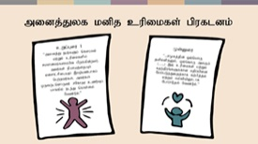 | ehq;fs; murhq;fq;fs; my;y- ehq;fs; ru;tNjr kdpj cupikfs; cld;ghLfspy; ifnahg;gkpltpy;iy. kdpj cupikfs; gpd;gw;wg;gLfpd;wd vd;gjid cWjpg;gLj;Jtjw;fhd rl;lf; flg;ghL vkf;F ,y;iy. Mdhy;> ehq;fs; gFj;jwpT> epahak; kw;Wk; kdrhl;rpAs;s kdpjg; gpwtpfs; vd;gJld; vq;fSf;F kw;iwatu; njhlu;gpy; xOf;ff; flg;ghnlhd;W cs;sJ. midj;Jyf kdpj cupikfs; gpufldk; $WtJ Nghy.  “kdpjg; gpwtpapdu; rfyUk; Rje;jpukhfNtg; gpwf;fpd;wdu;. mtu;fs; kjpg;gpYk; cupikfspYk; rkkhdtu;fs;. mtu;fs; epahaj;ijAk; kdrhl;rpiaAk; ,aw;gz;ghfg; ngw;wtu;fs;> mtu;fs; xUtUlndhUtu; rNfhju czu;Tg;ghq;fpy; ele;J nfhs;sy; Ntz;Lk;.”  “...r%fj;jpd; xt;nthU jdpkdpjDk;> xt;nthU myFk; (.......) ,t; cupikfs; kw;Wk; Rje;jpuq;fSf;fhd kjpg;gpid Nkk;gLj;Jtjw;fhf fw;gpj;jy; kw;Wk; fy;tpapD}lhf NghuhLjy; Ntz;Lk;.”  Vida egu;fSila tho;f;ifapy; ey;y my;yJ nfl;l tplaq;fisr; nra;tjw;fhd mjpfhuk; ek;kplj;jpy; fhzg;gLfpd;wNghJ> kdpj cupikfis epiyepWj;Jtjw;fhd xOf;ff; flg;ghL vkf;F fhzg;gLfpd;wJ.  vk;khy; midj;ijAk; nra;a KbahJ- rpy re;ju;g;gq;fspy; ehk; nra;af;$ba vjidAk; gw;wp rpe;jpj;jNy fbdkhdjhf ,Uf;Fk;- Mdhy;mePjp ,iof;fg;gLtjid ehk; fhz;fpd;wNghJ> kw;Wk; cjtp nra;tjw;fhf vijahfpYk; vk;khy; nra;af;$bajhf cs;sNghJ> mjid Kaw;rp nra;J ghu;g;gjw;fhd xOf;ff; flg;ghL vkf;F cz;L.  nra;jy; xU ey;y maytuhf ,UgÊgNj ehkÊ nraÊafÊ$ba kpf vspikahd tplankhd;whf ,Uf;fyhk;.
 | khw;wKz;lhf;Feupd; fijfs;
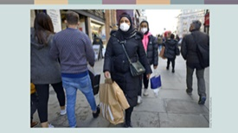 | Shafaq Hassan vd;gtu; njd; yd;ldpy; cs;s xU gpupj;jhdpa K];ypk; ngz; Mthu;. mz;ika tUlq;fspy; gpupj;jhdpahtpy; ntWg;Gf; Fw;wk; mjpfstpy; mjpfupj;jpUe;jJ. K];ypk;fs; FwpgÊghf Shafaq Nghd;w jiy kiwg;Gf;fis mzpfpd;w K];ypk; ngz;fs; ,aq;fiyapYk; kw;Wk; njUf;fspYk; ngUk;ghYk; ,yf;F itf;fg;gl;ldu;. ,j;jifa #oiktpy;> NtWgl;l kj rKjhaq;fisr; Nru;e;j kf;fSf;fpilapyhd ehshe;j el;G kw;Wk; jhuhs kdg;ghd;ik nraw;ghLfs; caupa tplaq;fshff; fUjg;glf;$bait.  Nehd;G gz;bifapidf; nfhz;lhLtjw;fhf jdf;Fk; jdJ 14 taJ kfdhd Ayaan ,w;Fk;> vjpu;ghuhjtpjkhf jq;fsJ K];ypky;yhj maytnuhUtu; guprpyÊfis nfhLj;j NghJ kdpjhgpkhdk; kPjhd jdJ ek;gpf;if kPsf; fl;bnaOg;gg;gl;ljhf Shafaq $Wfpd;whu;.
me;jg; gupRfis Gifg;glnkLj;J Ltpl;lupy; gjptpl;l Shafaq gpd;tUkhW vOjpapUe;jhu;:

“K];ypky;yhj vq;fsJ maytnuhUtu; xU khj fhykhf Nehd;gpUe;j vdJ 14 taJ kfDf;F my;[Puad; Ngupr;rk;goq;fisAk;> gpuhu;j;jid ghnahd;iwAk; toq;fp vq;fis Mr;rupag;gLj;jpAs;shu;. mtu; 20 tUlq;fSf;Fk; Nkyhf vq;fsJ maytuhf cs;shu;> Mdhy; Nehd;G gupRfspD}lhf vq;fis KOikahf Mr;rupj;jpw;Fs;shf;fpAs;shu;.”

“Ayaan Nehd;gpUe;jjid mtu; ftdpj;jhu; vd;gjid ehd; czutpy;iy. vdJ kfd; kpfTk; tpNrlkhf czu;e;jhu;. mtu;fs; el;Gkpf;f maytu;fs;> vdJ mk;kh nra;fpd;w gpupahzpf;F mtu;fs; jPtpu ,urpfu;fs;> MfNt ehq;fs; vg;NghJk; gpupahzp mDg;GNthk;. ehq;fs; NtWgl;l rKjhaq;fisr; Nru;e;jtu;fs; vd;gJld; vq;fSila maytu;> Ayaan kw;Wk; mtdJ kj ek;gpf;iffis vz;zpg;ghu;j;J mtw;iw Cf;fg;gLj;Jfpd;w tpjkhfr; nraw;gl;lik vd; kdij nefpo;tilar; nra;fpd;wJ.”

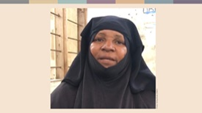 | Zaliha kw;Wk; Magdalena MfpNahUk; kpf NtWgl;l #oiktpy; tpj;jpahrnkhd;wpid cUthf;Ffpd;wdu;. Zaliha gw;Wkpf;f K];ypk; xUtu; vd;gJld; ghl;bnahUtUk; Mthu;. ,tu; Zanzibar ,Ys;s Pemba jPtpidr; Nru;e;jtu;. ,q;Fs;s xU cs;@u; Fu;-Md; ghlrhiyapy; mtu; fw;gpf;fpd;whu;.
Zaliha gpd;tUkhW $Wfpd;whu;>

“vq;fSila rKjhaq;fspYs;s gjl;lepiyapid Fwpj;J ehd; ftiyailfpd;Nwd;. vq;fSila ,sk; rKjhaj;jpdUf;F vq;fSila murpay; jiytu;fspy; ek;gpf;if ,y;iy kw;Wk; mtu;fSf;fhd tha;g;Gf;fSk; ,y;iy.”

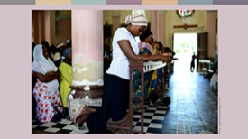 | “,q;F Rw;Wyhj; Jiwapy; gzp Guptjw;fhf jiyefuq;fspypUe;J tUfpd;w mNefkhNdhu; fpwp];jtu;fs;. vdf;F njupe;j gy K];ypk;fs; mtu;fSila njhopy;fis vLj;Jf; nfhs;tjw;fhf fpwp];jtu;fis Fw;wk; nrhy;fpd;wdu;. murpay; kw;Wk; kj gjl;lepiyfs; fhzg;gLkÊ gy tUlq;fSfÊ$lhf ehd; tho;e;jpUf;fpd;Nwd;. Njthyaq;fs; vupf;fg;gLtij> ntWg;Gg;Ngr;rpid cs;slf;fpa Jz;L gpuRuq;fs; gfpug;gLtjid> Njthyaj;jpw;F Nghfpd;w topfspy; fpwp];jtu;fs; Jd;GWj;jg;gLj;jg;gLtjid ehd; ghu;j;jpUf;fpNwd;. vk;Kila ,isQu;fs; kpjthjKilatu;fsha; khWtjid ehd; ghu;f;fpNwd;> mJ vd;id ftiyailar; nra;fpd;wJ. mjdhy;jhd;> ehd; ngz;fspd; kj ey;ypzf;ff; FOtpy; ,ize;Njd;.”
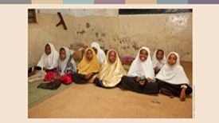 | “vkJ jPtfj;jpy; kj td;Kiwapidj; jLg;gjw;F cjt Ntz;Lnkd ehd; tpUk;Gfpd;Nwd;. Fu;-Md; ghlrhiyapy;> vkJ kjj;jpd; mbg;gil gFjpahf rfpg;Gj;jd;ik kw;Wk; md;G cs;snjd;gij ehd; rpWtu;fSf;F fw;W nfhLf;fpNwd;. vjpu;fhyk; vkJ gps;isfspy; jq;fpAs;sJ vd;gJld; mtu;fSf;F rupahd topapidf; fhz;gpf;f Ntz;baJ vkJ nghWg;ghFk;.”
Zanzibar ,w;F te;j fpwp];jt jiyefu tjptplthsuhd Magdalena ck; kj ey;ypzf;f gzpapy; <Lgl;Ls;shu;. mtu; Mil mzpfpd;w tpjk; kw;Wk; mtuJ kjk; fhuzkhf mtUk; ghugl;rj;jpid vjpu;nfhz;Ls;shu;> Mdhy; mtu; fpwp];jtu;fSf;Fk; K];ypk;fSf;fpilapyhd gpuptpid rupnra;a Ntz;Lnkd cWjp g+z;Ls;shu;. mtu; rKjhaq;fSf;F nrd;W kj ey;ypzf;fj;jpYs;s rthy;fs; kw;Wk; ngz;fs; cupikfs; njhlu;ghfg; NgRfpd;w cq;Nfhah gpuhe;jpaj;jpd; ngz;fs; rigapy; ,ize;jhu;.

“,];yhikg; gw;wp Nkyjpfkhff; fw;Wf; nfhs;tjw;fhfTk; K];ypk;fs; vt;thW tho;fpd;wdu; vd;gjid Gupe;Jf;nfhs;tjw;fhfTk; ehd; mf;FOtpy; ,ize;Njd;” vd mtu; tpsf;Ffpd;whu;. “ehq;fsidtUk; ngz;fs;> mj;Jld; me;j fhuzj;jpdhy; ehq;fs; midtUk; ghugl;rj;jpw;F Kfq;nfhLf;fpd;Nwhk;- ehq;fs; xd;whf ,ize;jpUf;f Ntz;Lnkd;gJld; xUtUf;nfhUtu; Mjutspf;fTk; Ntz;Lk;.”

Shafaq ,d; maytu;> Zaliha kw;Wk; Magdalena kw;Wk; ,JNghy vz;zpylq;fhj egu;fs; fhzg;gLfpd;wdu;. vk;ikg; Nghd;w rhjhuz kf;fs; jq;fSila rKjhaq;fspy; kdpj cupikfis eilKiwapy; nfhz;LtUtjw;fhf jk;Kila nrhe;j kw;Wk; rpwpa topfspy; Kaw;rpj;Jf; nfhz;bUf;fpd;wdu;- ,tu;fNs cs;@u; kl;l khw;wKz;lhf;Feu;fs;!

ehq;fs; ahuhapUg;gpDk;> kdpj cupikfis eilKiwg;gLj;Jtjw;F vijNaDnkhd;iw nra;a KbAk;!

Sources
Faith Matters www.faith-matters.org
https://www.faith-matters.org/family-surprised-by-presents-from-non-muslim-neighbour-to-celebrate-eid/
Zanzibar Inter-faith Centre (ZANZIC)
https://www.facebook.com/ZanzicMeansPeace/
https://english.danmission.dk/project/zanzibar-peacebuilding-through-interfaith-dialogue/

