2 jeks ieish
is;Sfï" yDoh idlaIsfha" wd.u weoySfï iy
úYajdi oeÍfï ksoyi y÷kajdoSu

bÈßm;a lsÍu i|yd l:k msgm;
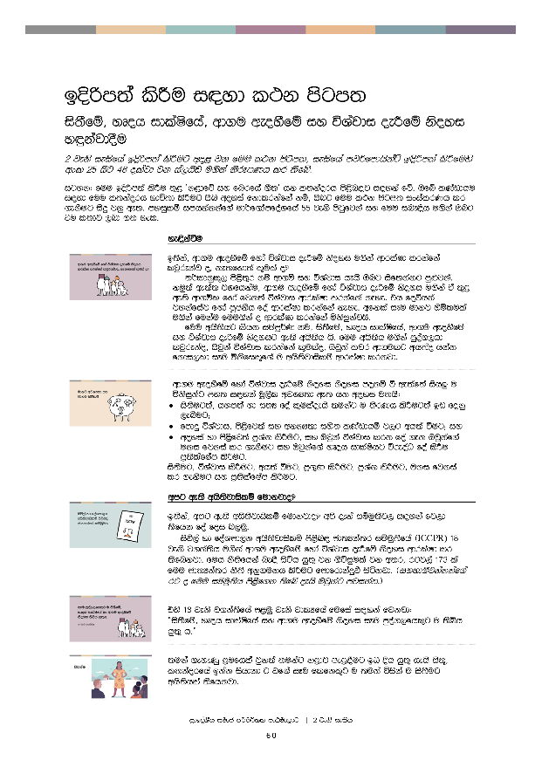
bÈßm;a lsÍu i|yd l:k msgm;
is;Sfï" yDoh idlaIsfha" wd.u weoySfï iy úYajdi oeÍfï ksoyi y÷kajdoSu
2 jeks ieisfha bosßm;a lsÍug wÞ< jk fuu l:k msgm;" ieisfha mj¾fmdhskaÜ bosßm;a lsÍfuys wxl 25 isg 46 olajd jk ia,hsv u.ska ksrEmKh lr ;sfí'

igyk( fuu bÈßm;a lsÍu ;=< zk<dfõ iy fnrfha .S;Z hk l;kaorh ms<sn|j i|yka fõ' Tfí lKavdhu i|yd fuu l;kaorh Ndú;d lsÍug Tn woyia fkdlrkafka kï" Tng fuu l:k msgm; ixialrKh lr .ekSug isÿ jkq we;' myiqlï imhkakkaf.a ud¾f.damfoaYfha 55 jeks msgqfjka iy fuu ine¢h u.ska Tng tu l;dj ,nd .; yel'

 | ye¢kaùu
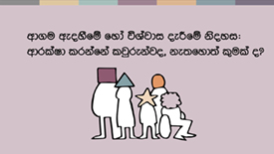 | b;ska" wd.u weoySfï fyda úYajdi ±Ífï ksoyi u.ska wdrlaId lrkafka ljqrekaj o" ke;fyd;a l=ula o@  ;¾ldkql+, ms<s;=r kï wd.ï iy úYajdi hehs Tng isf;kakg mq¿jka' kuq;a we;a; jYfhkau" wd.u weoySfï fyda úYajdi ±Ífï ksoyi u.ska ta ;=< we;s wd.ñl fyda fjk;a úYajdi wdrlaId lrkafka keye' th foúhka jykafiaj fyda mQckSh foa wdrlaId lrkafka keye' wfkla iEu udkj ysñlula u.ska fukau fuu.ska o wdrlaId lrkafka ñksiqkajhs'  fuu whs;shg lshk iïmQ¾K ku" is;Sfï" yDoh idlaIsfha" wd.u weoySfï iy úYajdi ±Ífï ksoyig we;s whs;sh hs' fuu whs;sh u.ska mqoa.,hd ljqrekao" Tjqka úYajdi lrkafka l=ulao" Tjqka ljr wd.ulg wh;ao hkak fkdi,ld iEu ñksfil=f.a u whs;sjdislï wdrlaId lrkjd'
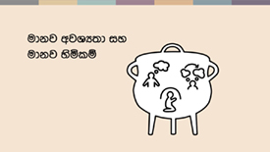 | wd.u weoySfï fyda úYajdi ±Ífï ksoyi ksoyi mokï ù we;af;a ish¨‍ u ñksiqkag my; i|yka uQ,sl wjYH;d we; hk woyi u;hs(  - is;Sug;a" hym;a yd i;H foa l=ulaoehs ;ukag u ;SrKh lsÍug;a bv fokq ,eîug¦  - fmdÿ úYajdi" ms<sfj;a iy wkkH;d iys; lKavdhï j,g wh;a ùug¦ iy  - woyia yd ms<sfj;a m%Yak lsÍug" iy Tjqka úYajdi lrk foa .ek Tjqkaf.a uki fjkia lr .ekSug iy Tjqkaf.a yDoh idlaIshg úreoaO foa lsÍu m%;slafIam lsÍug'  is;Sug" úYajdi lsÍug" wh;a ùug" m%.=K lsÍug" m%Yak lsÍug" uki fjkia lr .ekSug iy m%;slafIam lsÍug'
 | wmg we;s whs;sjdislï fudkjdo@
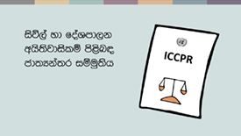 | b;ska" wmg we;s whs;sjdislï fudkjdo@ wms ±ka iïuq;sj, i|yka fj,d ;sfhk foa foi n,uq'  isú,a yd foaYmd,k whs;sjdislï ms<sn| cd;Hka;r iïuq;sfha ^ICCPR) 18 jeks j.ka;sh u.ska wd.u weoySfï fyda úYajdi ±Ífï ksoyi wdrlaId lr ;sfnkjd' fuh kS;sfhka ne£ isáh hq;= jk .súiqula jk w;r" rgj,a 173 la fuu cd;Hka;r kS;s wkq.ukh lsÍug fmdfrdkaÿù isákjd' ^iyNd.Sjkakkaf.a rg o fuu iïuq;sh ms<sf.k ;sfí oehs Tjqkag mjikak'&
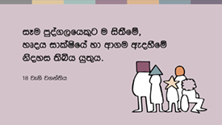 | tys 18 jeks j.ka;sfha m<uq jeks jdlHfha fufia i|yka fjkjd(  —is;Sfï" yDoh idlaIsfha iy wd.u weoySfï ksoyi iEu mqoa.,fhl=g u ;sìh hq;= h'˜
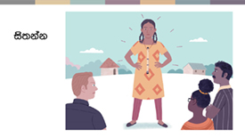 | ;uka .eyeKq <ufhla jqk;a ;ukag k<dj me<£ug bv Èh hq;= hehs is;+" l;kaorfha bkak ishdkd g jf.a iEu flfkl=g u ;uka úiska u is;Sug whs;shla ;sfhkjd'
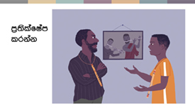 | ;ukaf.a mshdf.a l%shd jerÈ hehs úYajdi l< ksid mshdg Woõ lsÍu m%;slafIam lrmq fn%dakag jf.a wmf.a yDoh idlaIshg weyqïlka §ug wmg;a whs;shla ;sfnkjd'
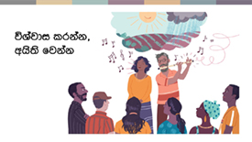 | úYajdi ±Íug yd wh;a ùug" tkï wd.ñl fyda wd.ñl fkdjk úYajdi ±Íug iy wd.u fyda úYajdih mokï lr .;a wkkH;djhla we;s lr .ekSug wmg whs;shla ;sfnkjd' k<dfõ iy fnrfha .S; l;dfõ .ïjeishka fuka wmf.ka fndfyda fofkla o wjxl úYajdi orkjd' wmf.a úYajdi iy wms tu úYajdi fnod.kakd mqoa., m%cdj wmg úYd, jYfhka jeo.;a fjkjd'
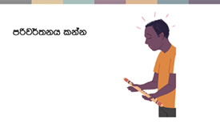 | kuq;a wms Ôj;a jkafka l=uk iudchl jqk;a" wmf.a úYajdi fl;rï i;H iy ksjerÈ jqk;a" ;ukaf.a k<dj .,jd oud ;u m%cdj yer .sh fn%daka jf.a l=uk fya;=jla ksid fyda ;ukaf.a úYajdi fyda ;ukaf.a m%cdj flfrys úYajdih ke;s jqKq wh bkak mq¿jka'
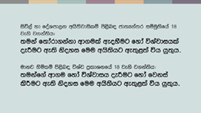 | cd;Hka;r udkj ysñlï kS;sfha §" Tfí wd.u weoySfï fyda úYajdi ±Ífï whs;sh iu. u Tfí wd.u fyda úYajdi yer hdug iy fjkia lsÍug we;s whs;sh;a wdrlaId fjkjd'
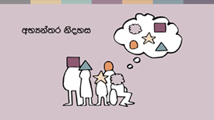 | is;Sug" úYajdi lsÍug" m%Yak lsÍug iy wmf.a úYajdi fjkia lsÍug we;s fuu whs;sjdislï fndfyda úg wNHka;r ksoyi f,i y÷kajkjd' tajd wmf.a ukfia iy wmf.a wd;aufha isÿ fjñka mj;sk foaj,a ms<sn|j jk w;r" th wmf.a wkkH;djhg" ta lshkafk wms ljqrekao hkak ms<sn| wm ;=< we;s yeÕSug wod< fjkjd'  fï fya;=j ksid tajd mru whs;sjdislï fjkjd' cd;Hka;r kS;sh hgf;a lsis úfgl;a fuu whs;sjdislï iSud lsÍug lsisÿ mqoa.,fhl=g fyda rchlg wjir keye'  kuq;a we;a; jYfhkau" wd.u iy úYajdi lshkafk wfma ukfia yd wd;aufha isÿjk fohg jvd fndfyda fihska jeä fohlaæ wms lrk foa .ekhs – jpk iy l%shdjka ;=<ska wmf.a úYajdi m%ldY lrk wdldrh .ekhs thg we;=<;a fjkjd'
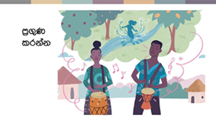 | wms wymq l;kaorfha" .ïjeishkaf.a Ôú; k<d me<£fï isg tÈfkod Ôú;fha fnr jdokh olajd jQ Tjqkaf.a úYajdi yd wh;aùu m%ldY flfrk ms<sfj;a j,ska msÍ ;snqKd'  wd.u weoySfï fyda úYajdi ±Ífï ksoyi yryd fuu whs;sjdislï o wdrlaId lrkjd' wms kej; iïuq;sh foi n,uq(
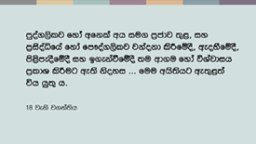 | 18 jeks j.ka;sfha fufia i|yka fjkjd(  —mqoa.,slj fyda m%cdj ;=< fjk;a wh iu. iy m%isoaêfha fyda fm!oa.,slj" jkaokd lsÍfï §" ms<sme§fï §" m%.=K lsÍfï oS iy b.ekaùfï § ;u wd.u fyda úYajdih m%ldY lsÍug we;s ksoyi ''' fuu whs;shg we;=<;a jkafkah'˜  wmsg mqoa.,slj hdÉ{d lsÍug iy iduqysl jkaokd lsÍï iy iïm%odhka iys;j m%cdjl fldgila f,i wmf.a wd.u weoySug fyda úYajdi m%ldY lsÍug whs;shla ;sfnkjd' tu m%cdjg;a whs;sjdislï ;sfnkjd – tajd ;u m%cdfõ idudðlhkaj md,kh lsÍfï whs;sjdislï fkdfjhs" tajd rdcHh iïnkaOfhka mj;sk whs;sjdislï' WodyrKhla úÈhg" wd.ñl yd úYajdi m%cdjkag wjYH kï nexl= .sKqï mj;ajd .ekSug" ñksiqka fiajfha fhoùug iy f.dvke.s,s whs;s lr .ekSug yels jk mßÈ Tjqkag kS;suh wkkH;djhla ,nd .; yels njg rdcHh iy;sl úh hq;=hs'  mqoa.,hskag iy lKavdhïj,g wd.ula weoySug fyda úYajdihla ±Íug úúO l%u ;sfnkjd' wdrlaId lrkq ,nk l%shdldrlï ms<sn| WodyrK tlai;a cd;Skaf.a úfYaI{hska úiska ´kE ;rï ,nd § ;sfnkjd' WodyrKhla f,i" wmsg my; i|yka l%shdldrlï isÿlrkakg whs;sjdislï ;sfnkjd(
- jkaokd lsÍu i|yd tla/ia ùug" W;aij ieuÍug iy wd.ñl ms<sfj;a lrk Èkj, j;dj;a lsÍug'
- wd.ñl we÷ï we£ug iy úfYaI wdydr fõ,a .ekSug'
- mQckSh ia:dk iy iqidk N+ñ ;sîug iy wd.ñl ixfla; m%o¾Ykh lsÍug'
- iudcfha ld¾h Ndrhla bgq lsÍug¦ WodyrKhla f,i" mqKHdh;k msysgqùug" iy
- wd.u fyda úYajdi .ek l:d lsÍug iy b.ekaùug" iy kdhlhska mqyqKq lsÍug fyda m;a lsÍug'
fuu wjia:dfjys§" Tn fufia is;kjd úh yelsh( —úYsIaGhs – fï wdldrfha whs;sjdislï ;uhs uf.a m%cdjg;a wjYHæ˜' ke;s kï Tn lkiai,a,g m;afjkjd úh yelshsæ

 | iafõÉPdjdoh yd iudkd;au;djh – wka whg ydkshla fkdlrkakæ
wka wh flfrys ffjrh fyda m%pKav;ajh m%j¾Okh lsÍu i|yd ;u wd.u fyda úYajdi Ndú;d lrk" wka whg fjkia fldg i,lk fyda ;u lKavdhu ;=< isák wka whj hgm;a lrk iy md,kh lrk mqoa.,hska .ek l=ula lsj yelso@
wd.u weoySfï fyda úYajdi ±Ífï ksoyi hkafkka woyia lrkafka" wfkla mqoa.,hskag l=uk n,mEula we;s jqj;a" Tjqkag tfia lsÍug ksoyi we;s njo@
jdikdjg th tfia fkdfõæ

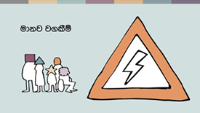 | udkj ysñlï iïuq;Ska wmf.a whs;sjdislï fudkjdo hkak fukau wmf.a whs;sjdislï i|yd we;s iSudjka fudkjdo hkak;a wmg lshd fokjd' fjk;a wdldrhlska lshkjd kï – wmf.a whs;sjdislï l%shd;aul lsÍfï§ wm i;= j.lSï fudkjdo hkak lshd fokjd'  lsisfjla ;ukaf.a whs;sjdislï iy ksoyi wka whg ydkshla jk whqßka Ndú;d fkdl< hq;=hs lshd wmg fuu j.lSï idrdxY.; l< yelshs' udkj ysñlï iïuq;Skag wkqj fuh iEu mqoa.,fhl=f.a u iodpdrd;aul hq;=lula' iEu flfkl=f.a u whs;sjdislïj,g .re lsÍug;a" iEu flfkl=u ydksj,ska wdrlaId lsÍug;a rchg kS;suh j.lSula ;sfnkjd' ±ka wms ydksùfuka wm wdrlaId úh hq;= wdldrh ms<sn|j jvd;a meyeos,s lr.ksuq'
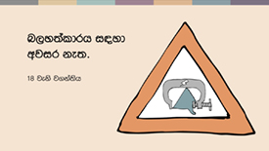 | m<uqj( n,y;aldrhla fkd;sìh hq;=hsæ  wd.u weoySu fyda úYajdi ±Íu hk ldrKdj,§ n,y;aldrhg wjir keye' úYajdi lsÍu yd wh;aùu iafõÉPdfjka isÿ úh hq;=hs' hful=g úYajdi lsÍug fyda úYajdi fkdlsÍug" ms<sfj;a bgq lsÍug fyda fkdlsÍug" wd.ulg wh;a ùug fyda wh;a fkdùug n,lsÍu i|yd n,OdÍkag" úYajdi woyk m%cdjkag iy mjq,aj,g ;¾ckh lsÍï" ìh .ekaùï fyda m%pKav;ajh fhdod .ekSug wjir keye'
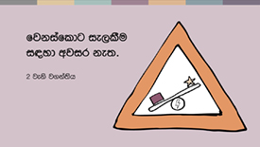 | fojkqj( fjkiafldg ie,lSu fkdl< hq;=hsæ  iïuq;sfha 2 jeks j.ka;sh u.ska" wd.u" cd;sh" ia;%S mqreI iudcNdjh fyda NdIdj hkdoS lreKla u;" ljr fyda wdldrhlg fjkiafldg ie,lSu ;ykï lr ;sfnkjd' udkj ysñlï .súiqï w;aika lr we;s rdcHhka" iEu flfkl=g u tl yd iudkj ie,lSug;a" wm bf.k .;a l;kaorfha fj<|fmd< iNdj úiska isÿ lrk ,o mßÈ" iudcfha fjkiafldg ie,lSu wjika lsÍu i|yd l%shdYS,Sj lghq;= lsÍug;a tlÕ ù ;sfnkjd'
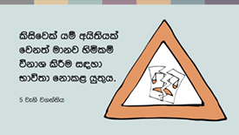 | f;jkqj( whs;sjdislï úkdY fkdl< hq;=hsæ  5 jeks j.ka;sfha i|yka jkafka tla udkj ysñlula fjk;a udkj ysñlï úkdY jk whqßka l%shd;aul lsÍfï whs;sh ,efnkakla f,i w¾: oelaùug lsisÿ rchlg" lKavdhulg fyda mqoa.,fhl=g wjir ke;s njhs'  20 jeks j.ka;sh u.ska fjkia fldg ie,lSug" tÈßjdÈlï j,g fyda m%pKav;ajhg fmd<Ujd .ekSu yryd wd.ñl ffjrh me;sÍu fjkqfjka fmkS isàu ;ykï lrhs'  hï wd.ula ;ukaf.ka b,a,d isákafka l=ulao hkak ms<sn|j rchla fyda mqoa.,fhla l=ula is;=j;a" wd.u weoySfï fyda úYajdi ±Ífï ksoyi u.ska Tjqkag fjk;a ck;djkaf.a whs;sjdislï md.d oeóug whs;shla ,nd fokafka hehs lsisfjl=g ;¾l l< fkdyelshs' tneúka" fnr jdolhskag ysßyer lsÍu ksjerÈ foh hehs fn%daka f.a mshd is;=j o" Tyqg tfia lsÍug whs;shla keye'  m%pKav;ajh idOdrKSlrKh lsÍug fyda Wis.ekaùug wd.u fhdod.kakd wjia:d fyda ñksiqkag ydks lrk wd.ñl j;ams<sfj;a ms<sn| WodyrK ´kE ;rï Tfí is;g kef.kjd we;s nj ug úYajdihs' ñksiqka iduldój ;u wd.u weoySu fyda úYajdi ±Íu widOdrK f,i j<lajk ,o wjia:d .eko Tfí is;g kef.kjd we;s'
 | wd.u weoySfï fyda úYajdi ±Ífï ksoyig we;s iSud
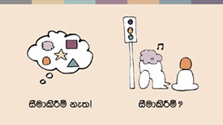 | tfyu kï" fuu kS;s fudkjdo@ rchkag wd.ï weoySfï fyda úYajdi ±Ífï ksoyi iSud lrkakg wjir ,efnk wjia:d fudkjdo@ wms fï kS;s ms<sn| blaukska úuid n,uq'  m<uqfjka u" is;Sug yd úYajdi lsÍug we;s whs;sh ^wNHka;r ksoyi& lsis úfgl;a iSud l< fkdyelshs' fojkqj" wd.u weoySfï fyda úYajdi ±Ífï ksoyi iSud lrkq ,eìh yelshs – kuq;a tfia l< yelafla my; i|yka kS;s y;r wkq.ukh lrk úg muKhs(
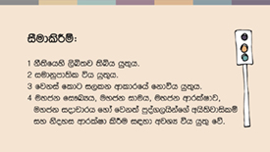 | - iSudj úia;r flfrk kS;shla ;sìh hq;=hs' fjk;a jpk j,ska lsjfyd;a" fmd,sishg Tjqka leu;s leu;s foa l< fkdyelshs'  - mkjk iSudj" tu.ska úi£ug W;aidy lrk .eg¨‍jg iudkqmd;sl úh hq;=hs' ksoiqkla jYfhka" hï úYajdihla woyk m%cdjl YíojdyskS moaO;sh b;d f>daIdldÍ kï" tys y`v wvq lrk f,ig fyda ovhlg hg;a jk f,i tu weoys,s m%cdjg ksfhda. lrkq ,eìh yelshs' Tjqka tla/iaùu iïmQ¾Kfhka u ;ykï lsÍu iudkqmd;sl fkdfjhs'  - ish¨u iSud lsÍï fjkiafldg ie,lSfuka f;dr úh hq;=hs – tajd iEu flfkl=gu wod< úh hq;=hs'  - tu iSud lsÍï my; i|yka foa j,ska tlla wdrlaId lsÍu i|yd wjYH jk tajd úh hq;=hs( uyck wdrlaIdj" uyck iduh" uyck fi!LHh" uyck iodpdrh fyda mqoa.,hskaf.a fjk;a whs;Ska iy ksoyi'  zwjYHZ hk jpkh we;a;g u jeo.;a' iSud lsÍï mekùu iqÿiqhs lshd rch fyda ck.ykfhka nyq;rhla úiska is;Su muKla m%udKj;a jkafka keye¦ iSudj mekùu wjYH úh hq;=hs' fjk;a jpk j,ska lsjfyd;a" wod< whs;sjdislï iSud fkdlr tu ms<sfj;a yryd ks¾udKh jQ .eg¿j úi£fï fjk;a l%uhla fkd;sìh hq;=hs' whs;sjdislï iSud lsÍu hkq wjidk úi÷uls' tfia jqj;a" iuyr úg th wjYH fõ'
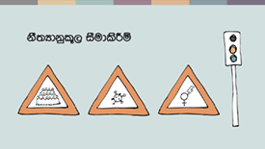 | WodyrKhla .ksuq – ´kEjg jvd ñksiqka ixLHdjla mQckSh ia:dkhlg tla/ia ùu wk;=reodhl úh yelsh' tneúka" uyck wdrlaIdj u; mQckSh ia:dkhg we;=,aùug wjir Èh yels mqoa.,hska ixLHdj iSud lsÍug n,OdÍkag wjYH úh yelshs'  fldfrdakd ffjria jix.;h ;=<§ jkaokd lsÍu i|yd tla/iaùï iïnkaO uyck fi!LH iSud lsÍï b;d iq,N ù ;sfnkjd – iuyr úg fuu iSudjka wjYH" iudkqmd;sl yd fjkia fldg fkdi,lk tajd fõ' iuyr úg tajd w;sYhska fjkia fldg i,lk yd wiudkqmd;sl iajNdjfhka hqla;hs'  ldka;djkaf.a ,sx.fþokh ;ykï lsÍu wka whf.a" tkï fï wjia:dfõ§ .eyeKq <uhskaf.a whs;sjdislï iy ksoyi wdrlaId lrk iSud lsÍulg WodyrKhla' fuh ixialD;sl fyda wd.ñl ms<sfj;la f,i i,lkq ,enqj;a" th .eyeKq <uhskaf.a fi!LHhg wk;=reodhl jk w;r" wd.u weoySfï fyda úYajdi ±Ífï ksoyig wod<j th idOdrŒlrKh l< fkdyelshs'
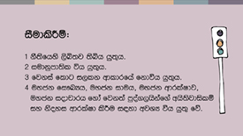 | fuu kS;s we;af;ka u jeo.;a' tu kS;s ke;s kï rchhkag ;uka wleu;s ´kEu lKavdhula fyda ms<sfj;la iSud lsÍug yelshs' iSud lsÍï lshkafka wjidk úi÷ula ñi rdcH md,kh i|yd jk fuj,ula fkdfjhs' ó<Õ ieisfha§ wms f,dalh mqrd isÿjk úúO wdldrfha wd.u weoySfï fyda úYajdi ±Ífï ksoyi W,a,x>khùï ms<sn|j jvd;a .eUqßka úuid n,uq'

