mku;T 2

rpe;jid> kdrhl;rp kjk;

my;yJ ek;gpf;iff;fhd Rje;jpuk;

Kd;itg;gpw;fhd

vOj;Jg;gpujp
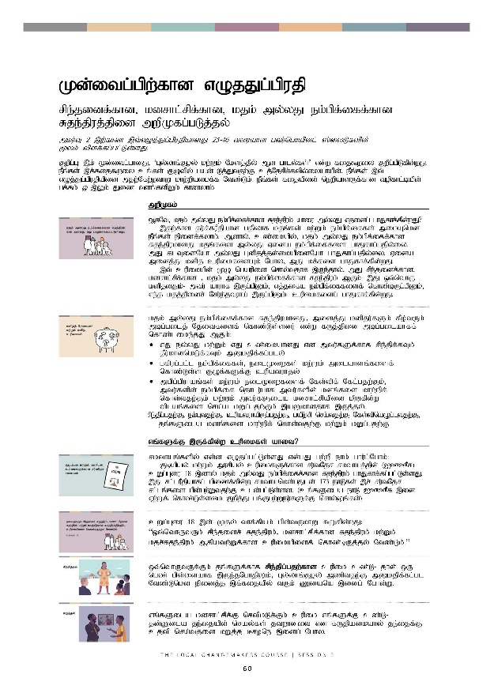

Kd;itg;gpw;fhd vOj;Jg;gpujp

rpe;jidf;fhd> kdrhl;rpf;fhd> kjk; my;yJ ek;gpf;iff;fhd Rje;jpuj;jpid mwpKfg;gLj;jy;

mku;T 2 ,wÊfhz ,tÊvOj;Jg;gpujpahdJ 25-46 tiuahd gtuÊnghapdlÊ ]ÊiyLfspd; %ykÊ tpsfÊfgÊglÊLsÊsJ.

Fwpg;G: ,k; Kd;itg;ghdJ> ‘Gy;yhq;Foy; kw;Wk; NksjÊjpyÊ Md ghly;fs;’ vd;w fij$wiy Fwpg;gpLfpd;wJ. ePq;fs; ,f;fij$wiy cq;fs; FOtpy; gad;gLj;Jtjw;F cj;Njrpf;ftpy;iyahapd;> ePq;fs; ,t; vOj;Jg;gpujpapid mjw;Nfw;wthW khw;wpaikf;f Ntz;Lk;. ePq;fs; fijapid; newpahsUfÊfhd topfhl;bapd; gf;fk; 55 ,Yk; Jiz tsqÊfspYkÊ fhzyhkÊ.

 | mwpKfk;
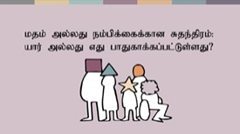 | MfNt> kjk; my;yJ ek;gpf;iff;fhd Rje;jpuk; ahiu my;yJ vjidg; ghJfhf;fpd;wJ?  ,jw;fhd ju;f;fuPjpahd gjpyhf kjq;fs; kw;Wk; ek;gpf;iffs; mikAnkd ePq;fs; epidf;fyhk;. Mdhy;> cz;ikapy;> kjk; my;yJ ek;gpf;iff;fhd Rje;jpukhdJ kjq;fis my;yJ Vida ek;gpf;iffis ghJfhg;gjpy;iy. mJ flTisNah my;yJ Gdpjj;jd;ikapidNah ghJfhg;gjpy;iy. Vida midj;J kdpj cupikfisAk; Nghy> mJ kf;fis ghJfhf;fpd;wJ.  ,t; cupikapd; KO ngaupid nrhy;tjhf ,Ue;jhy;> mJ rpe;jidf;fhd> kdrhl;rpf;fhd > kjk; my;yJ ek;gpf;iff;fhd Rje;jpuk; MFk;- ,J xt;nthU kdpjdJk;- mtu; ahuhf ,Ug;gpDk;> vj;jifa ek;gpf;iffisf; nfhz;bUg;gpDk;> ve;j kjj;jpidr; Nru;e;jtuha; ,Ug;gpDk;- cupikfisg; ghJfhf;fpd;wJ.
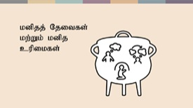 | kjk; my;yJ ek;gpf;iff;fhd Rje;jpukhdJ> midj;J kdpju;fSk; fPo;tUk; mbg;gilj; Njitfisf; nfhz;Ls;sdu; vd;w fUj;jpid mbg;gilahff; nfhz;like;jJ MFk;:  - vJ ey;yJ kw;Wk; vJ cz;ikahdJ vd mtu;fSf;fhf rpe;jpf;fTk; jPu;khdnkLf;fTk; mDkjpf;fg;gly;  - gfpug;gl;l ek;gpf;iffs;> eilKiwfs; kw;Wk; milahsq;fisf; nfhz;Ls;s FOf;fSf;F cupatuhjy;  - mgpg;gpuhaq;fs; kw;Wk; eilKiwfisf; Nfs;tpf; Nfl;gjw;Fk;> mtu;fspd; ek;gpf;if njhlu;ghf mtu;fspd; kdq;fis khw;wpf; nfhs;tjw;Fk; kw;Wk; mtu;fSila kdrhl;rpapid kPWfpd;w tplaq;fis nra;a kWg;gjw;Fk; ,aYkhdjhf ,Uj;jy;.  rpe;jpg;gjw;F> ek;Gtjw;F> cupatuhapUg;gjw;F> gapwÊrp nraÊtjw;F Nfs;tpnaOg;Gtjw;F> jq;fSila kdq;fis khw;wpf; nfhs;tjw;F kw;Wk; kWg;gjw;F.
 | vq;fSf;F ,Uf;fpd;w cupikfs; ahit?
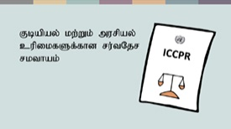 | rkthaq;fspy; vd;d vOjg;gl;Ls;sJ vd;gJ gw;wp ehk; ghu;g;Nghk;:  Fbapay; kw;Wk; murpay; cupikfSf;fhd ru;tNjr rkthaj;jpd; (ICCPR) cWg;Giu 18 ,dhy; kjk; my;yJ ek;gpf;iff;fhd Rje;jpuk; ghJfhf;fg;gl;Ls;sJ. ,J rl;luPjpahfg; gpizf;fpd;w rkthankd;gJld; 173 ehLfs; ,r; ru;tNjr rl;lq;fis gpd;gw;Wtjw;F cld;gl;Ls;sd. (cq;fSila ehL ICCPR ,id Vw;Wf; nfhz;Ls;sik Fwpj;J gq;Fgw;Weu;fSf;F nrhy;Yq;fs;.)
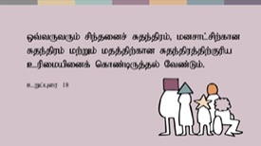 | cWg;Giu 18 ,d; Kjy; thf;fpak; gpd;tUkhW $Wfpd;wJ:  “xt;nthUtUk; rpe;jidr; Rje;jpuk;> kdrhl;rpf;fhd Rje;jpuk; kw;Wk; kjr;Rje;jpuk; Mfpatw;Wf;fhd cupikapidf; nfhz;bUj;jy; Ntz;Lk;.”
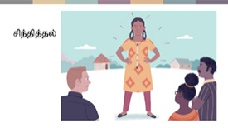 | xt;nthUtUf;Fk; jq;fSf;fhf rpe;jpg;gjw;fhd cupik cz;L- jhd; xU ngz; gps;isahf ,Ue;jNghjpYk;> Gy;yhq;Foy; mzptjw;F mDkjpf;fg;gl Ntz;Lnkd epidj;j ,f;fijapy; tUk; Ziana ,idg; Nghd;W.
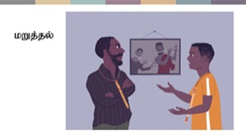 | vq;fSila kdrhl;rpfÊF nrtpkLfÊFkÊ cupik vq;fSf;F cz;L- jd;Dila je;ijapd; nray;fs; jtwhdit vd fUjpaikahy; je;ijf;F cjtp nra;tjid kWj;j Brone ,idg; Nghy.
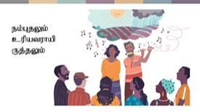 | NkYkÊ vq;fSf;F> kj my;yJ kjk;rhuhj ek;gpf;iffisf; nfhz;bUg;gjw;fhd kw;Wk; kj my;yJ ek;gpf;iff;fhd milahsnkhd;wpidf; nfhz;bUg;gjw;fhd- kjk; my;yJ ek;gpf;ifnahd;wpid ek;Gtjw;fhd kw;Wk; mjw;F cupatuhapUg;gjw;fhd cupik cz;L. Gy;yhq;Foy; kw;Wk;; Nks fpuhkj;jtu;fisNghy> vq;fSs; gyUf;F cs;shu;e;j ek;gpf;iffs; cs;sd. vq;fSila ek;gpf;iffs; kw;Wk; mtw;iw ehk; gfpu;e;J nfhs;fpd;w rKjha cWg;gpdu;fs; vq;fSf;F kpfg; ngupa tplakhf ,Uf;Fk;.
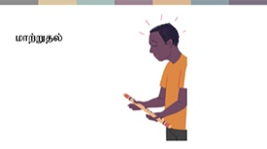 | Mdhy;> ehq;fs; ve;j r%fj;jpy; tho;fpd;wNghjpYk; my;yJ vq;fSila ek;gpf;iffs; ve;jstpw;F cz;ikahdjhf kw;Wk; rupahdjhf ,Ue;jNghjpYk;> VNjDk; fhuzq;fSf;fhf jq;fSila ek;gpf;iffis my;yJ rKjhaj;jpy; ek;gpf;ifapid ,of;fpd;w egu;fSk; ,Ug;ghu;fs;- jdJ Gy;yhq;Foiy vLj;J itj;Jtpl;L jdJ rKjhaj;jpid tpl;L ntspNawpa Brone ,idg; Nghy.
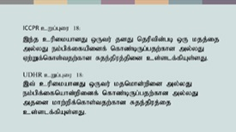 | ru;tNjr kdpj cupikfs; rl;lj;jpy;> kjk; my;yJ ek;gpf;ifapidf; nfhz;bUg;gjw;fhd cq;fsJ cupikAld; Nru;e;J> cq;fSila kjk; my;yJ ek;gpf;ifapidtpl;L ePq;Ftjw;fhd kw;Wk; mjid khw;Wtjw;fhd cupikAk; ghJfhf;fg;gl;Ls;sJ.
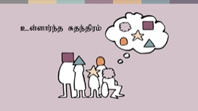 | rpe;jpg;gjw;fhd> ek;Gtjw;fhd> Nfs;tpnaOg;Gtjw;fhd kw;Wk; vq;fsJ ek;gpf;iffis khw;Wtjw;fhd cupikfs; ngUk;ghYk; cs;shu;e;j Rje;jpuq;fs; vd miof;fg;gLfpd;wd. mit vq;fSila kdjpy; kw;Wk; vq;fSila Md;khtpy; vd;d elf;fpd;wJ vd;gd gw;wpaitahFk;> ,it vkJ milahsk;- ehq;fs; ahnud;w vq;fsJ czu;Tld; njhlu;GgLfpd;wd.  ,f;fhuzj;jpw;fhf> mit kPwKbahj cupikfshf cs;sd. ru;tNjr rl;lj;jpd;fPo;> ve;jnthU egUk; my;yJ murhq;fKk; vg;NghJk; ,t; cupikfis kl;Lg;gLj;Jtjw;F mDkjpf;fg;gltpy;iy.  Mdhy;> re;Njfj;jpw;fplkw;wtifapy;> kjk; kw;Wk; ek;gpf;if vd;gd vq;fsJ kdq;fs; kw;Wk; Md;khf;fspy; vd;d elf;fpd;wJ vd;gjw;Fk; mg;ghw;gl;l tplaq;fisg; gw;wpajhFk;.
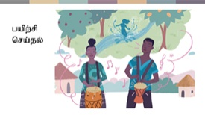 | mJ ehq;fs; vd;d nra;fpNwhk; vd;gJ gw;wpajhFk;- vq;fSila ek;gpf;iffis nrhw;fspy; kw;Wk; nray;fspy; ehk; vt;thW ntspg;gLj;JfpNwhk; vd;gJ gw;wpajhFk;. vq;fSila fijapy;> fpuhkj;jtu;fspd; tho;f;if> mtu;fSila ek;gpf;iffs; kw;Wk; mtu;fs; cupatu;fshAs;stw;wpid ntspg;gLj;Jfpd;w eilKiwfs; epiwe;jjhff; fhzg;gl;lJ.  kjk; my;yJ ek;gpf;iff;fhd Rje;jpuk; ,t; cupikfisAk; ghJfhf;fpd;wJ. ehq;fs; kPz;Lk; rkthaj;jpidg; ghu;g;Nghk;.
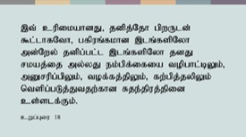 | cWg;Giu 18 MdJ gpd;tUkhW $Wfpd;wJ:  “,t; cupikahdJ>..... jdpj;Njh gpwUld; $l;lhfNth> gfpuq;fkhd ,lq;fspNyh md;Nwy; jdpg;gl;l ,lq;fspNyh jdJ rkaj;ij my;yJ ek;gpf;ifia topghl;bYk;> mDrupg;gpYk;> tof;fj;jpYk;> fw;gpj;jypYk; ntspg;gLj;Jtjw;fhd Rje;jpuj;jpid cs;slf;Fk;.”  vq;fSf;F jdpg;gl;luPjpapy; gpuhu;j;jid nra;tjw;fhd cupik kw;Wk; $l;Lg; gpuhu;j;jid kw;Wk; ghuk;gupaq;fspD}lhf rKjhaj;jpd; mq;fnkhd;nwd;wuPjpapy; vq;fsJ kjk; my;yJ ek;gpf;ifapid ntspg;gLj;Jtjw;fhd cupik vd;gd fhzg;gLfpd;wd. mj;Jld;> rKjhaj;jpw;Fk; cupikfs; fhzg;gLfpd;wd- mjd; cWg;gpdu;fisf; fl;Lg;gLj;Jtjw;fhd cupikfs; my;y> Mdhy; muRld; njhlu;Gila cupikfs;. cjhuzkhf> kj kw;Wk; ek;gpf;iff;fhd rKjhaq;fs; jhq;fs; tpUk;Gfpd;wgl;rj;jpy;> rl;l milahsnkhd;wpidg; ngw;Wf;nfhs;sf; $bajhf cs;sd vd;gjid muR cWjpg;gLj;j Ntz;Lk;> MfNt> mit tq;fpf; fzf;Ffis itj;jpUf;fTk;> egu;fis gzpf;fku;j;jTk;> kw;Wk; fl;blq;fis nrhe;jq;nfhs;sTk;> KbAk;.  jdpegu;fSk; FOf;fSk; kjk; my;yJ ek;gpf;ifnahd;wpid eilKiwg;gLj;Jtjw;F NtWgl;l topfs; fhzg;gLfpd;wd vd;gJld; If;fpa ehLfspd; epGzu;fs; ghJfhf;fg;gl;Ls;s gy nraw;ghLfis cjhuzq;fshf; Fwpg;gpl;Ls;sdu;. cjhuzkhf> vkf;F fPo;tUtdtw;Wf;fhd cupikfs; cz;L:
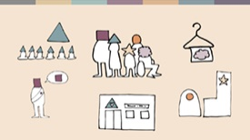 | - topghl;bw;F $l;lhf tUtjw;fhd> gz;biffisf; nfhz;lhLtjw;fhd kw;Wk; Xa;T ehl;fisf; nfhz;bUg;gjw;fhd cupik.  - kj Milfis mzptjw;fhd kw;Wk; tpNrl czT Kiwfisg; gpd;gw;Wtjw;fhd cupik.  - topghl;blq;fs;> kahdq;fisf; nfhz;bUg;gjw;fhd kw;Wk; kj milahsq;fisf; fhl;rpg;gLj;Jtjw;fhd cupik.  - r%fj;jpy; tfpghfnkhd;wpid tfpg;gjw;fhd cupik> cjhuzkhf njhzÊL epWtdqÊfis ];jhgpg;gjw;fhd cupik  - kjk; my;yJ ek;gpf;if gw;wp NgRtjw;fhd kw;Wk; mtw;iwf; fw;gpg;gjw;fhd kw;Wk; jiytu;fis gapw;Wtpg;gjw;fhd my;yJ epakpg;gjw;fhd cupik. ,j;jUzj;jpy;> “rpwgÊG -,t; cupikfis vd;Dila rKjhaj;jpy; vdf;F Njitahd cupikfs; vd ePq;fs; vz;zf;$Lk;! my;yJ ePq;fs; ftiyailaf;$Lk;!
 | jd;dhu;tf;nfhs;if kw;Wk; rkj;Jtk;- VidNahUf;F CW tpistpf;f Ntz;lhk;!
jq;fSila kjk; my;yJ ek;gpf;ifapidg; gad;gLj;jp VidNahu;kPjhd ntWg;G my;yJ td;Kiwapid Cf;Ftpf;fpd;w> VidNahiu ghugl;rg;gLj;Jfpd;w my;yJ jq;fSila FOtpDs; VidNahiu mlf;Ffpd;w kw;Wk; fl;Lg;gLj;Jfpd;w egu;fs; my;yJ FOf;fs; gw;wp vd;d nrhy;yyhk;?
kjk; my;yJ ek;gpf;iff;fhd Rje;jpunkd;gJ> Vida egu;fSf;F vd;d jhf;fk; Vw;gl;lhYk;> ,j;jifa egu;fs; my;yJ FOf;fs; ,jid nra;tjw;fhd Rje;jpuj;jpidf; nfhz;Ls;sdu; vd;gjidf; Fwpf;fpd;wjh?
,y;iy vd;gJ ed;wpf;Fupa tplak;!

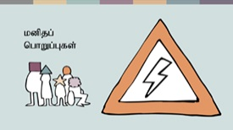 | kdpj cupikfs; rkthaq;fs; vk;Kila cupikfs; kw;Wk; vk;Kila cupikfSf;fhd kl;Lg;ghLfs; Mfpa ,uz;ilAk; $wfpd;wd. my;yJ NtW tifapy; $Wtjhapd;> vq;fSila cupikfis ehq;fs; gpuNahfpf;fpd;wNghJ vq;fSf;Fs;s nghWg;Gf;fs; vitnad $Wfpd;wd.  ,g;nghWg;Gf;fisnay;yhk; ehk; njhFj;J $WNthkhapd;> ve;jnthU egUk; jdJ cupikfs; kw;Wk; Rje;jpuq;fis Vida egu;fSf;F CW tpistpf;fpd;w topfspy; gad;gLj;jf;$lhJ vd $wyhk;. kdpj cupikfs; rkthaq;fSf;fika> ,J xt;nthU egupdJk; xOf;ff; flg;ghlhFk;. mj;Jld; xt;nthUilaJk; cupikfis kjpg;gjw;Fk; kw;Wk; xt;nthUtiuAk; CwpypUe;J ghJfhg;gjw;Fkhd rl;lf; flg;ghnlhd;W murhq;fj;jpw;F ,Uf;fpd;wJ. ehq;fs; vt;thW CwpypUe;J ghJfhf;fg;gl Ntz;Lk; vd ehq;fs; kpff; Fwpg;ghfg; ghu;g;Nghk;.
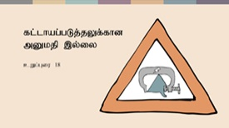 | Kjyhtjhf: gyte;jg;gLj;jypd;ik!  kjk; my;yJ ek;gpf;ifAld; njhlu;GWfpd;w tplaq;fspy; gyte;jg;gLj;jy; mDkjpf;fg;gLtjpy;iy. ek;Gjy; kw;Wk; cupatuhapUj;jy; vd;gd jd;dhu;tkhf ,lk;ngw Ntz;bad. ve;jnthU egiuAk; ek;gr; nrhy;yp my;yJ ek;ghjpUf;fr; nrhy;yp> eilKiwg;gLj;jr; nrhy;yp my;yJ eilKiwg;gLj;j Ntz;lhnkd nrhy;yp> kjnkhd;wpw;F cupatuhapUf;Fk;gb my;yJ kjnkhd;wpw;F cupatuhapUf;f Ntz;lhnkd gyte;jg;gLj;Jtjw;fhf mr;RWj;jy;fs;> kpul;ly;fs; my;yJ td;Kiwapidg; gad;gLj;Jtjw;F mjpfhupfs;> kj rKjhaq;fs; kw;Wk; FLk;gq;fs; mDkjpf;fg;gltpy;iy.
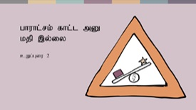 | ,uz;lhtjhf: ghugl;rkpd;ik!  rkthaj;jpd; cWg;Giu 2 MdJ> vt;tifahd ghugl;rj;jpidAk; - mJ kjk;> ,dk;> ghy;epiy my;yJ nkhop vd vjd; mbg;gilapy; nra;ag;gbDk;- jil nra;fpd;wJ. kdpj cupikfs; xg;ge;jq;fSf;F ifnahg;gkpl;Ls;s muRfs; xt;nthUtiuAk; rkkhf elj;Jtjw;Fk; r%fj;jpYs;s ghugl;rj;jpid xopg;gjw;Fk;- vkJ fijapy; re;ij rig nra;jJ Nghy- cld;gl;Ls;sd.
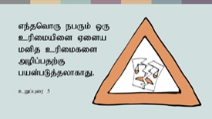 | %d;whtjhf: cupikfis mopf;f KbahJ!  cWg;Giu 5 MdJ> murhq;fk;> FOf;fs; my;yJ egu;fs;> ve;jnthU kdpj cupikiaAk;> mt; cupik Vida kdpj cupikfis mopg;gjw;fhd topfspy; nraw;gLtjw;fhd cupikapid mtu;fSf;F toq;Ftjhf nghUl;Nfhly; nra;af;$lhJ vd $Wfpd;wJ.  mj;Jld; cWg;Giu 20 MdJ> ghugl;rk;> tpNuhjk; my;yJ td;Kiwf;fhd J}z;lypD}lhf kj ntWg;gpid Mjupj;J thjhliyj; jil nra;fpd;wJ.
murhq;fnkhd;W my;yJ egnuhUtu; Fwpg;gpl;l tplankhd;iw nra;a Ntz;Lnkd;W jdJ kjk; Njitg;gLj;Jtjhf epidf;fpd;wNghjpYk;> kjk; my;yJ ek;gpf;iff;fhd Rje;jpuk; mtu;fSf;F Vida egu;fspd; cupikfis mlf;Ftjw;fhd cupikapid toq;Ffpd;wJ vd ahUk; thjpl KbahJ. MfNt> NkskÊ thrpg;gtu;fis Jd;GWj;JtJ rupnad Brone ,d; je;ijf;F fw;gpf;fg;gl;bUe;jhYk; mtu;fisj; Jd;GWj;Jtjw;fhd cupik mtUf;F ,y;iy.
td;Kiwapid J}z;;Ltjw;F my;yJ kf;fSf;F CW tpistpf;fpd;w kj eilKiwfis epahag;gLj;Jtjw;F kjk; gad;gLj;jg;gl;Ls;s Vuhskhd cjhuzq;fs; Fwpj;J cq;fshy; rpe;jpf;f KbAnkd vdf;F epr;rakhf njupAk;. egu;fs; jq;fsJ kjj;ij my;yJ ek;gpf;ifapid mikjpahdKiwapy; eilKiwg;gLj;JtjpypUe;J epahakw;w Kiwapy; jLf;fg;gl;l re;ju;g;gq;fs; Fwpj;Jk; cq;fshy; rpe;jpf;ff;$bajhf ,Uf;Fk;.

 | kjk; my;yJ ek;gpf;iff;fhd Rje;jpuj;jpw;fhd kl;Lg;ghLfs;
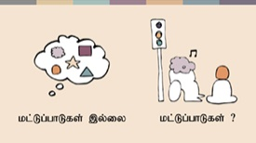 | MfNt> tpjpfs; ahit? kjk; my;yJ ek;gpf;iff;fhd Rje;jpuj;jpid kl;Lg;gLj;Jtjw;F murhq;fq;fs; mDkjpf;fg;gl;Ls;s re;ju;g;gq;fs;; ahit?  ,tÊ tpjpfis ehq;fs; tpiuthfg; ghu;g;Nghk;. Kjyhtjhf> rpe;jid nra;tjw;Fk; ek;Gtjw; Fkhd cupik (cs;shu;e;j Rje;jpuk;) xUNghJk; kl;Lg;gLj;j KbahjJ. ,uz;lhtjhf> fPo;tUk; ehd;F tpjpfs; gpd;gw;wg;gLfpd;wNghJ khj;jpuNk kjk; my;yJ ek;gpf;ifapd; eilKiwg;gLj;jy; kl;Lg;gLj;jg;glyhk;.
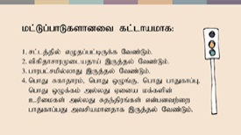 | - kl;Lg;ghbidf; Fwpf;fpd;w rl;lnkhd;W ,Uj;jy; Ntz;Lk;. NtW nrhw;fspy; $WNthkhapd;> nghyp]hu; tpUk;gpatw;iw mtu;fshy; ntWkNd nra;a KbahJ.  - kl;Lg;ghlhdJ mJ jPu;f;f vz;Zfpd;w gpur;rpidf;F tpfpjrkdhdjhf mika Ntz;Lk;. cjhuzkhf> kj rKjhankhd;wpd; xypngUf;fpapd; rj;jk; kpf mjpfnkdpy;> mjidf; Fiwf;FkhW my;yJ jz;lg; gzk; nrYj;JkhW Fwpg;gpl;l kj rKjhaj;jpw;F fl;lisaplyhk;. Mdhy;> mtu;fs; re;jpg;gjid Kw;whf jil nra;jyhdJ tpfpjrkdhdjhf mikahJ.  - midj;J kl;Lg;ghLfSk; ghugl;rkw;witahff; fhzg;gLjy; Ntz;Lk;- mit midtUf;Fk; Vw;ghf Ntz;Lk;.  - Fwpg;gpl;l kl;Lg;ghdJ fPo;tUtdtw;Ws; VNjh xd;wpidg; ghJfhg;gjw;F mtrpakhdjhf ,Uf;f Ntz;Lk;: nghJ ghJfhg;G> nghJ xOq;F> nghJ Rfhjhuk;> nghJ xOf;fq;fs; my;yJ Vida egu;fspd; cupikfs; my;yJ Rje;jpuq;fs;.  ‘mtrpakhdjhf’ vd;w nrhy; kpf Kf;fpakhdjhFk;. ,t; ,yf;Ffis mile;Jf; nfhs;tjw;F Fwpj;j kl;Lg;ghL tpUk;gj;jf;fJ vd murhq;fk; my;yJ ngUk;ghd;ikahd kf;fs; fUjpdhy; khj;jpuk; NghjhJ. kl;Lg;ghL cz;ikapy; mtrpakhdjhf ,Uf;f Ntz;Lk;. NtW nrhw;fspy; $WNthkhapd;> eilKiwfspdhy; cUthf;fg;gl;l mg;gpur;rpidiaj; jPu;g;gjw;F cupikfis kl;Lg;gLj;Jtjidj;jtpu NtW vt;topAk; ,y;yhjpUf;f Ntz;Lk;. cupikfis kl;Lg;gLj;jnyd;gJ ,Wjpahd toptifahf ,Uf;f Ntz;Lk;.
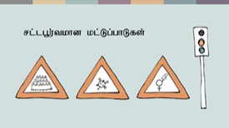 | cjhuzkhf- topghl;blnkhd;wpy; mjpfsthd vz;zpf;ifahd egu;fis epiwj;jy; Mgj;jhdjhf ,Uf;fyhk;. MfNt> nghJ ghJfhg;G vd;w mbg;gilapy; topghl;blnkhd;wpy; xd;WNruf;$ba egu;fspd; vz;zpf;ifapid kl;Lg;gLj;jy; mjpfhupfSf;F mtrpakhdjhf ,Uf;fyhk;.  nfhNuhdh itu]; njhw;wpd;NghJ topghl;bw;fhf xd;W $Ljy; njhlu;gpy; tpjpf;fg;gl;l nghJ Rfhjhu kl;Lg;ghLfs; kpfg; nghJthditahFk;- rpyNeuq;fspy; ,j;jifa kl;Lg;ghLfs; mtrpakhdjhf> tpfpjrkdhdjhf kw;Wk; ghugl;rkw;witahff; fhzg;gl;ld. rpyNeuq;fspy;> mit caupastpy; ghugl;rk;kpf;fitahfTk; tpfpjrkdw;witahfTk; fhzg;gl;ld.  VidNahUila cupikfs; kw;Wk; Rje;jpuq;fisg; ghJfhg;gjw;fhd kl;Lg;ghnlhd;whf ngz; gpwg;GWg;G rpijtpw;fhdj; jilfisf; Fwpg;gplyhk;- ,t;tplaj;jpy; ngz; gps;isfspd; cupikfs; ghJfhf;fg;gl;Ls;sd. ,J fyhrhu my;yJ kj eilKiwnahd;whfg; ghu;f;fg;gLfpd;wNghjpYk;> mJ ngz; gps;isfspd; MNuhf;fpaj;jpidg; ghjpf;fpd;wJ vd;gJld; kjk; my;yJ ek;gpf;iff;fhd Rje;jpuj;jpidf; fhuzk;fhl;b mjid epahag;gLj;j KbahJ.
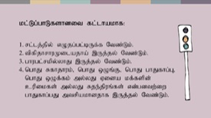 | ,t;tpjpfs; cz;ikapy; Kf;fpakhditahFk;. mit ,d;wp> murhq;fq;fs; mtw;Wf;F gpbf;fhj ve;jnthU kw;Wk; midj;J FOf;fs; kw;Wk; eilKiwfisAk; kl;Lg;gLj;jKbAk;. kl;Lg;ghLfs; ,Wjp topKiwahfNtf; fhzg;gl Ntz;Lk;> mJ mur fl;Lg;ghl;bw;fhd fUtpnahd;wy;y. mLj;j mku;tpy;> cynfq;fpYk; eilngWfpd;w kj my;yJ ek;gpf;iff;fhd Rje;jpuj;jpd; NtWgl;l tifahd kPwy;fs; njhlu;gpy; ehq;fs; kpf Mokhfg; ghu;f;fg; Nghfpd;Nwhk;.

