SESSION 2
INTRODUCING FREEDOM OF THOUGHT,
CONSCIENCE, RELIGION and BELIEF

The Songs of the Flute and the Drum
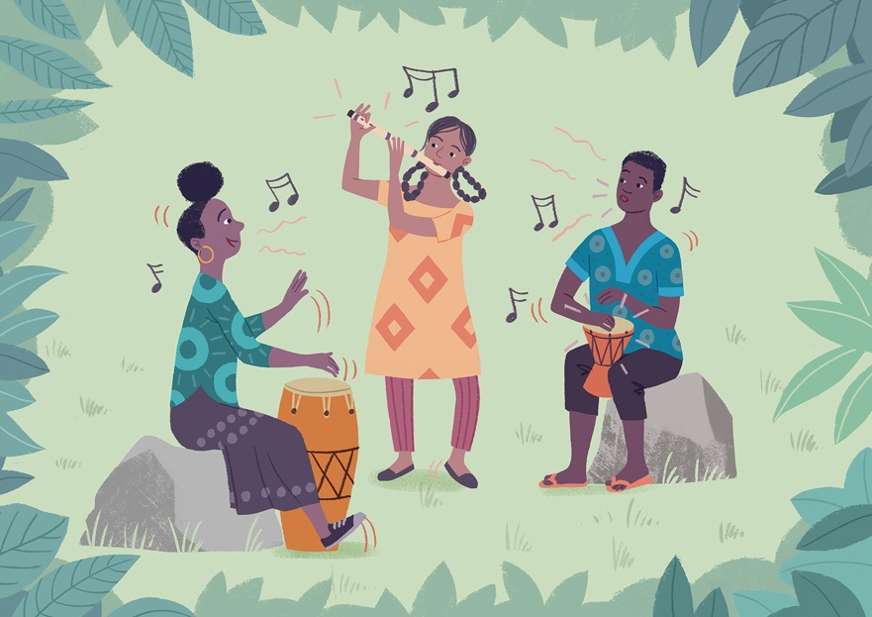
The Songs of the Flute and the Drum

By Katherine Cash and Sidsel-Marie Winther Prag
Illustrated by Toby Newsome

This story forms the basis of the ‘Once upon a time exercise’ and is illustrated by slides 3-23
of the session 2 PowerPoint.

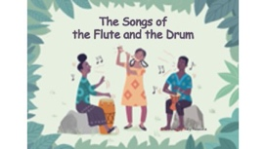 | THE SONGS OF THE FLUTE AND THE DRUM
 | Once upon a time, there were two villages.
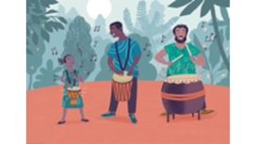 | The people of the village in the forest were renowned for drumming and dancing. The moment a child could sit upright, they were given a drum. There were tiny drums that sounded like quiet rainfall and great thunderous drums that took two to carry. Drumming accompanied life – celebrations, mourning and everything in between – and the people believed that the drumming kept their lives in harmony with the spirits of the forest.
 | The people of the village in the valley below had never understood the drummers. They found the drumming intrusive and sniggered at the simple ‘banging’. When a boy was born in this village, his father carved a flute from wood or bone and the boy carried it on a string around his neck until his life’s end. It took many years to master their traditional melodies and the highest honour was bestowed upon men whose skill made the flute sing so sweetly that the God of the heavens would be enchanted and grant rain and sunshine for the fields.
 | Although villagers from Drum village went to the weekly market in Flute village to sell their wares, people from the two villages did not mingle. Drumming was banned in the marketplace. Many stall owners from Flute village refused to sell to the drummers and the drummers resented the flute villagers.
 | A young girl, an only child named Ziana, lived in Flute village. Her curiosity and kindness made her loved by all. When she was 10 years old, her father fell ill. One day, he called her to him, “My dearest daughter, I will not live for long. Take my flute and wear it so we will always be together”. Ziana was mortified; it was not customary for girls to carry a flute, but soon she asked herself, “Why shouldn’t I be allowed to play?” On the night her father died, Ziana took the flute and hung it round her neck.

 | As Ziana grew, she worked hard helping her mother grow vegetables to sell at their market stall. Although she was diligent and kind, people in Ziana’s village often sneered at her because she wore the flute. Sometimes they would try to convince her to take it off, but she refused. Whenever she had the chance, Ziana would escape to the forest and play her father's flute.
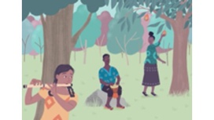 | On one such day, Ziana heard a faint drumming. Curious, she followed the drumbeats through the forest to a clearing, where a young man was drumming and singing, while his sister picked fruit from a tree. Ziana recognised them from the market – they were siblings called Ono and Iris.  Hiding behind the trees, Ziana began to play along on her flute. The song of the flute and the rhythm of the drums danced alongside each other in beautiful music.  When the song finished, Ziana stepped cautiously into the clearing. Ono and Iris were surprised to see a girl with a flute but smiled, realising that she, like them, was not allowed to play her instrument in Flute village. Iris offered Ziana some fruit, and the three chatted and played music until evening fell.
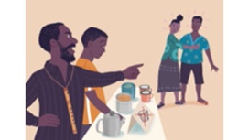 | Next market day Ziana saw her new friends in front of the tea stall. The stall owner was yelling at them, “Get away drummer filth!” Ono was angry, but Iris dragged him away. The stall owner’s son, who had been pouring tea for Ono, looked ashamed.
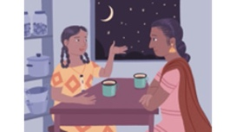 | Ziana had never thought about the ‘No Drummers’ signs before. Her heart felt heavy as she realised that she and her mother had never bought anything from the drummers’ stalls.  That night Ziana talked to her mum and asked why they never went to the drummers’ stalls. “It’s better to stick to what you know,” her mother replied, but Ziana couldn’t understand and kept asking why everyone shouldn’t be welcome everywhere and raving about the delicious fruits Ono and Iris sold at their stall. Finally, Ziana’s mother agreed to try some of their fruit on the next market day.
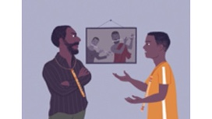 | Meanwhile in the tea stall owner’s house a row had broken out when the owner’s son, Brone, questioned his father’s treatment of the drummers. The stall owner was one of the most honoured flute players in the village and a proud man. His father and grandfather had been skilled musicians, but his son was a deep disappointment. No matter how hard Brone tried, he could not master even the most basic melody. After years of forced practice and cruel comments, Brone had lost all appreciation for the flute. He felt drawn to the distant rhythm of the drums and dreamed of another life.

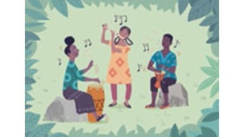 | As time went by Ziana, Iris and Ono kept meeting in the forest to play together. They too dreamed – of a time when everyone would be welcome, where drums and flutes could be played openly and where they could play their beautiful music together in the marketplace.
Each week, Ono and Iris would visit Ziana and her mother at the vegetable stall and Ziana’s mum would buy fruits and nuts from them. One day, Ono noticed Ziana’s mother looking curiously at the drum he carried on his belt.
“This is the laughing drum”, Ono said, “Its sound means happiness and the children dance and laugh when I play it”. Ziana’s mother was fascinated.
Other drummers began to gather around, and Ziana and her mother asked about their drums too. That day, Ziana’s mother sold her vegetables very quickly. Some neighbouring stall owners were upset with her for welcoming drummers to their part of the market, but Ziana’s mother reasoned that if everyone could buy from each other, they would all be better off.
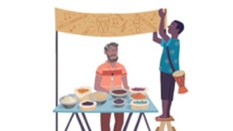 | Next to their stall, an old man was selling spices, but business was bad. Ono suggested putting up a sign saying, “Everyone welcome” to boost trade and painted the sign for the old man, with the image of a drum and a flute.  The old man’s sales increased, and slowly other stall owners were convinced. The “Everyone welcome” sign began to appear on stalls owned by drummers and flute players alike. The market thrived.
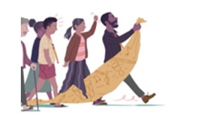 | But all was not well. Brone’s father was horrified by the drummers entering his part of the marketplace. He saw them as a threat to the old ways and gathered people who felt the same to tear down the signs and harass the drummers. Tension grew in the marketplace and the market council grew worried.
 | Brone refused to participate in his father’s scheme. Instead, he and the old spice seller spoke to the market council and persuaded them to host a concert for everyone in the marketplace. Perhaps Brone’s father and the others might learn to accept the drummers if they could listen to their stories and hear their songs.
Word about the concert spread and people came from afar. The stall owners sold much more than usual that day.
Finally, it was time for the concert. The old spice seller played a beautiful tune on his wooden flute, while his daughter sang a song of gratitude to the God of the heavens for a good harvest. He explained why the song meant so much to him after years of hardship in his youth.
Brone’s father raised an eyebrow as he observed the smiles and nods of some of the drummers in the crowd.

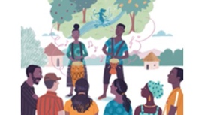 | The old man invited Ono and Iris to the stage. They told stories of their drums and performed playful melodies in honour of the dancing spirit of the forest stream, and thunderous songs to thank the storm spirit for keeping their fruit trees safe. For the first time, the flute villagers began to understand what the drums meant to the drummers. Brone’s father scowled.
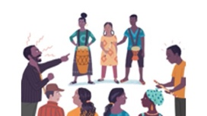 | Finally, Ziana joined Ono and Iris on the stage. She thought of her father, put his flute to her lips and the three began to play together. A shocked silence fell. Never before had the flute and the drums been heard together or a girl been seen playing the flute.  The melody of gratitude for sun and rain from Ziana’s flute floated through the air in time to the rhythm of the dancing stream from Ono’s drum.  The song ended and the crowd looked from one to another. Some clapped hesitantly while others looked away. Brone’s father exploded at Ziana. “Traitor!” he shouted and stormed off.  Brone’s face was sorrowful as he looked at his father. Shaking his head, he took the flute from his neck, laid it on his father’s stall, and left the village for good.
There was much discussion in both villages after the concert. Should everyone be served at all market stalls? Should girls be allowed to play the flute and should the flute and the drum ever be played together? After many months, the villagers could still not agree.
Having listened to the drummers’ experiences and seen the sincerity of all the people, the market council ruled.
“All people will be treated well in the marketplace!”
The ban on drumming was lifted and the remaining ‘no drummers’ signs were taken down. But for other questions on the playing of instruments, the council refused to take sides. Instead, the sincere belief of each person would be respected and they would be free to follow it.
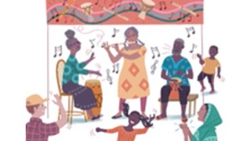 | It took many years before the drummers felt welcome at every stall in the market, but every week Ziana, Ono and Iris could be seen together playing the songs of the flute and the drum, until their fingers grew stiff and their hair turned white.

