3 jeks ieish
wmf.a úúO wkkH;d

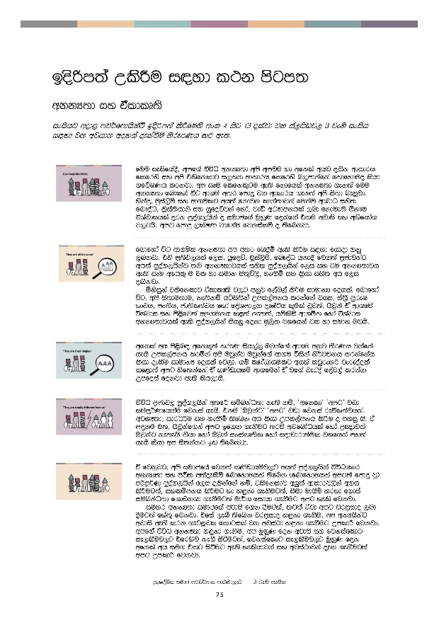
bosßm;a lsÍu i|yd l:k msgm;
bosßm;a lsÍu i|yd l:k msgm;

wkkH;d iy taldlD;s

ieishg wod< mj¾fmdhskaÜ bosßm;a lsÍfuys wxl 4 isg 13 olajd jk ia,hsvj, 3 jeks ieish i|yd jk wjika lsÍfï woyia oelaùï ksrEmKh lr we;'

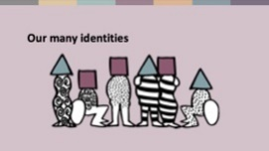 | fuu ieisfha §" wmf.a úúO wkkH;d wms wmj u yd wfkla whj olsk wdldrh flfrys iy wms tlsfkldg i,lk wdldrh flfrys n,mdkafka flfiao lshd .fõIKh lrkjd' wm iEu flfkl=gu we;s fkdfhla wkkH;d .ek;a fuu wkkH;d fndfyda úg wd.ï w;r fmdÿ jk wdldrh .ek;a wms is;d ne¨jd' yskaÿ" uqia,sï iy wd.ulg wh;a fkdjk ldka;djka fukau wdndO iys; fn!oaO" l%sia;shdks iy hqfoõjka fyda" jeä wOHdmkhla ,nd fkdue;s ´kEu úYajdihla ork mqoa.,hska o iudcfha uqyqK fokafka tlu wjdis iy wNsfhda. j,g hs' wmg fmdÿ ,laIK jdf.au fjkialï o ;sfnkjd'
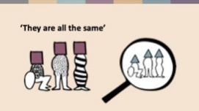 | fndfyda úg wd.ñl wkkH;d wm w;r fn§ï we;s lsÍu i|yd fhdod .kq ,nkjd' tys m%;sM,hla f,i" hqfoõ" uqia,sï" fn!oaO hkd§ fjk;a m%cdjkag wh;a mqoa.,hskaj ;ks wkkH;djhla iys; mqoa.,hska f,i iy tu wkkH;djh we;s iEu wfhl= u tl yd iudk is;=ú,s" ye`.Sï iy l%shd iys; wh f,i olskjd'  ñksiqka tlsfkldj taldlD;s j,g wkqj f,an,a lsÍu idudkH fohla' fndfyda úg" wms is;du;d u" ke;s kï háis;ska Wml,amkh lrkafka jhi" ia;%S mqreI Ndjh" mx;sh" cd;sl;ajh fyda foaYmd,k oDIaáh l=ula jqj;a" Tjqka tA wd.fï úYajdi iy ms<sfj;a wkq.ukh l<;a ke;;a" hïlsis wd.ñl fyda úYajdi wkkH;djhla we;s mqoa.,hska ish¨ fokd uQ,sl jYfhka tl yd iudk njhs'
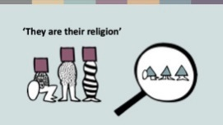 | wfkla wh ms<sn| wfkl=;a lreKq ish,a, Tjqkaf.a wd.u wkqj ;SrKh jkafka hehs Wml,amkh lrñka wms Tjqkaj Tjqkaf.a wd.u úiska ks¾jpkh lrkafkah hkqfjka oelSu idudkH fohla fj,d' hï lKavdhulg wh;a ljqreka fyda je/oaola l< fyd;a wmg isf;kafka tA lKavdhfï wd.fuka tA jf.a jeros foaj,a lrkak Wmfoia fokjd we;s hkqfjks'
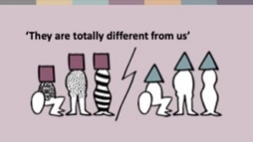 | úúO m%cdj, mqoa.,hska w;f¾ iïnkaO;d" ke;s kï" zwfkldZ zwmgZ jvd iïmQ¾Kfhka u fjkia hehs" tkï zTjqkagZ zwmgZ jvd fjkia reÑl;ajhka" wjYH;d" idrO¾u iy yeÕSï ;sfnk wh hehs Wml,amkh lsÍu o myiq hs' ta moku u;" Tjqkaf.ka wmg bf.k .ekSug ;rï wjfndaOhla fyda m%{djla Tjqkag ke;ehs lshd fyda Tjqka ixialD;sl fyda iodpdrd;aul jYfhka my;a hehs lshd wm is;kakg bv ;sfnkjd'
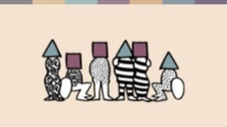 | ta fjkqjg" wms iudcfha fjk;a lKavdhïj,g wh;a mqoa.,hska úúOdldr wkkH;d iy Ôú; w;aoelSï fndfyduhla ;sfnk ^fndfyduhla wmg;a fmdÿ jQ& mßmQ¾K mqoa.,hska f,i olskafka kï" tlsfkldj w¨;a wdldrj,ska w.h lsÍug;a" iylïmkh oelaùug yd y÷kd .ekSug;a" iSud udhsï yryd f.dia iïnkaO;d f.dvk.d .ekSug;a ud¾. fidhd .ekSug wmg yels fjkjd'  iuyr wkkH;d iudcfha wjdis f.k §ug;a" ;j;a tajd wmg jrm%ido ,nd §ug;a fya;= fjkjd' tfia ,eî ;sfnk jrm%ido y÷kd .ekSu" wm wkHhskag wjdis we;s lrk .eg¨‍jl fldgila jk wjia:d y÷kd .ekSug WmldÍ fjkjd' wmf.a úúO wkkH;d y÷kd .ekSu" wm uqyqK fok wjdis iy fjkiafldg ie,lSïj,g tfrysj ke.S isàug;a" fjkiafldg ie,lSïj,g uqyqK fok wfkla wh iu. tlg isàug we;s yelshdjka iy wjia:djka oel .ekSug;a wmg WmldÍ fjkjd'
 | iudc mßj¾;lhskaf.a l;dj
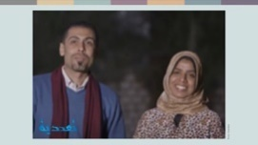 | l%sia;shdks ;reKfhl= jk ifï iy uqia,sï ;re‚hla jk ykd Ôj;a fjkafka Bðma;=fõ lajdkd m%foaYfha yscdid .ïudkfha hs' .fï uqia,sï yd l%sia;shdks m%cdjka w;r we;s ndOl ì| oeóug Tjqka tlg tlaj jev lrkjd'  ykd fufyu lshkjd"  —fjkia wd.ïj,g whs;s wh <Õska jdä ùug fyda tlg lghq;= lsÍug wlue;s orejka uu ±lald'˜  ifï fufyu lshkjd"  —tlg tl;=fj,d fï iïnkaOfhka jev lsÍu;a" Tjqka olsk wdldrh tlg tl;=fj,d fjkia lsÍug W;aidy lsÍu;a myiq nj ug yeÕ=Kd‍' wmg wjYH jqfKa fï m%foaYfha orejka fjkila Wod lrk îc njg m;alsÍughs'˜
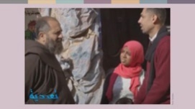 | orejkag mdmkaÿ l%Svd lsÍug wjYH nj Tjqka jgyd .;a kuq;a mdmkaÿ l%Svd lsÍug bv we;s tlu ia:dkh jqfka lf;da,sl m,a,sfhka msg; msysá p;=rY%hhs' fï fofokd m%foaYfha mQcl *%ekaisia msh;=ud fj; .sh w;r" msh;=ud úYd, iyfhda.hla ,nd foñka l%shdldrlï ixúOdkh lsÍug;a Tjqkag Woõ l<d'  t;=ud mjikafka"  —fuu .fï ifï iy ykd lrk foa wmg we;af;ka u wjYHhs' th ish¨‍ .ïudk w;f¾ me;sf¾ú lshd wms n,dfmdfrd;a;= fjkjd'˜
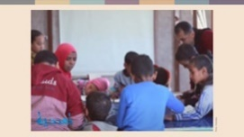 | uqia,sï orejka uq,ska u tys hdug leu;s fkdjqk kuq;a wjidkfha § Tjqka ish,af,dau ykd f.a kdhl;ajh wkq.ukh l<d'  —fiñka kuq;a ksielj u uu W;aidy lf<a <uhska tlg ñY% lsÍughs' Tjqkaf.a m<uq m%;sl%shdj jqfka m%;slafIam lsÍuhs' kuq;a mshjfrka mshjr Tjqka úiska u w¨;ska ñY% lKavdhï msysgqjd .;a;d'˜  ykd iy ifï fouõmshkag tu orejka lKavdhfï l%shdldrlï keröug meñfKk f,i wdrdOkd l<d' orejka tlg tlaj lghq;= lrk wdldrh oel uq,ska u Okd;aul m%;spdrhla oelajQfha uõjreka úiska'  ifï lshk úÈhg"  —wms fjkia úh hq;=hs' fjki wdrïN fjkafka hï woyila .ek we;slr .kakd úYajdih ;=<ska˜  ykd thg fufia tl;= l<d"  —wms fokakd fï i|yd Ôjudk WodyrKhla' wms fjkia wd.ïj,g wh;a jqk;a tlg tlaj jev lrkjd' wms tlsfkldj iïmq¾K lrk w;r wms fokakg u ;sfhkafka tlu wruqKla' wmf.a mrud¾:h orejka'˜
 | iudma;sh
oji wjidkfha§" wms ish¨ fokd u leu;s Ôú; iQmh fmdfydi;a yd rij;a fjkjdghsæ wms tlu ñksia mjq,lg wh;a jk w;r tlu uQ,sl wjYH;d iy whs;sjdislï wmg fmdÿhs' iEu fokdf.a u whs;sjdislï fjkqfjka jev lsÍug tlg tl;= jQ úg" wms jvd;a id¾:l fõú'
wmf.a B<Õ ieis fofla§ wms wd.u weoySfï fyda úYajdi ±Ífï ksoyi W,a,x>khùï .ek jeäÿr bf.k .ekSug iy wmf.a m%cdj ;=< fuu W,a,x>khùï fmfkkafka flf,i oehs is;shï .; lsÍug W;aidy lrkjd' m%dfoaYSh iudc mßj¾;lhska njg m;aùfï B<Õ mshjr .ekSug tu oekqu wmg WmldÍ jkq we;ehs wms wfmala‍Id lrkjd'

uQ,dY%(
iudc mßj¾;l l;dfõ uq,dY%h( Taadudiya, www.taadudiya.com
Tng fuu ine¢fhka ykd iy ifï Tjqkaf.a l:dj lshk" bx.%Sis Wm is/is iys;j wdrì NdIdfjka ;sfhk YouTube Ñ;%mghla krUkak mq¿jka( What is your story? Egypt (English Subtitles) - YouTube
2019 j¾Ifha oS b;d lK.dgqodhl f,i ykd ßh wk;=rlska urKhg m;a jQjd h'

