mku;T – 3
vkJ gyÊtif milahsqÊfs;

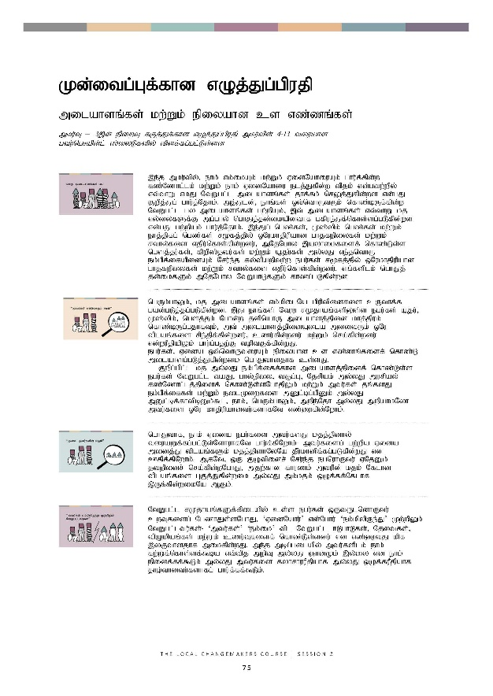
Kd;itg;Gf;fhd vOj;Jg;gpujp
Kd;itg;Gf;fhd vOj;Jg;gpujp

milahsq;fs; kw;Wk; epiyahd cs vz;zq;fs;
mku;T – 3,dÊ epiwT fUjÊJfÊfhd vOj;Jg;gpujp mku;tpdÊ 4-13 tiuahd gtuÊnghapdÊlÊ ]ÊiyLfspyÊ tpsfÊfgÊglÊLsÊsd.

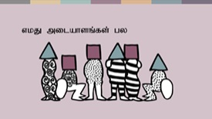 | ,e;j mku;tpy;> ehk; vk;ikAk; kw;Wk; VidNahiuAk; ghu;f;fpd;w fz;Nzhl;lk; kw;Wk; ehk; VidNahiu elj;Jfpd;w tpjk; vd;gtw;wpy; vt;thW vkJ NtWgl;l milahsq;fs; jhf;fk; nrYj;Jfpd;wd vd;gJ Fwpj;Jg; ghu;j;Njhk;. mj;Jld;> ehq;fs; xt;nthUtUk; nfhz;bUf;fpd;w NtWgl;l gy milahsq;fs; gw;wpAk;> ,t; milahsq;fs; vt;thW kj vy;iyfSf;F mg;ghy; nghJj;jd;ikapdthf gfpue;Jf;nfhs;sg;gLfpd;wd vd;gJ gw;wpAk; ghu;j;Njhk;. ,e;Jg; ngz;fs;> K];ypk; ngz;fs; kw;Wk; ehj;jpfg; ngz;fs; r%fj;jpy; xNukhjpupahd ghjfepiyfs; kw;Wk; rthy;fis vjpu;nfhs;fpd;wdu;> mNjNghy ,ayhikfisf; nfhz;Ls;s ngsj;ju;fs;> fpwp];jtu;fs; kw;Wk; êjuÊfsÊ; my;yJ ve;jnthU ek;gpf;ifapidAk; Nru;e;j fy;tpawptw;w egu;fs; r%fj;jpy; xNukhjpupahd ghjfepiyfs; kw;Wk; rthy;fis vjpu;nfhs;fpd;wdu;. vq;fsplk; nghJj; jd;ikfSk; mNjNghy NtWghLfSk; fhzg;gLfpd;wd.
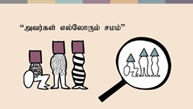 | ngUk;ghYk;> kj milahsq;fs; vk;kpilNa gpuptpidfis cUthf;f gad;gLj;jg;gLfpd;wd. ,J ehq;fs; NtW rKjhaq;fspYs;s egu;fs; A+ju;> K];ypk;> ngsj;jk; Nghd;w jdpnahU milahsj;jpid khj;jpuk; nfhz;bUg;gjhfTk;> mt; milahsj;jpidAila midtUk; xNu tplaq;fis rpe;jpf;fpd;wdu;> czu;fpd;wdu; kw;Wk; nra;fpd;wdu; vd;wuPjpapYk; ghu;g;gjw;F toptFf;fpd;wJ. egu;fs;> Vida xt;nthUtiuAk; epiyahd cs vz;zq;fisf; nfhz;L milahsg;gLj;Jfpd;wik nghJthdjhf cs;sJ.  Fwpg;gpl;l kj my;yJ ek;gpf;iff;fhd milahsj;jpidf; nfhz;Ls;s egu;fs; NtWgl;l taJ> ghy;epiy> tFg;G> Njrpak; my;yJ murpay; fz;Nzhl;lj;jpidf; nfhz;Ls;sNghjpYk; kw;Wk; mtu;fs; jq;fsJ ek;gpf;iffs; kw;Wk; eilKiwfis mDl;bg;gpDk; my;yJ mDl;bf;fhtpbDk;$l> ehk;> ngUk;ghYk;> mwpe;Njh my;yJ mwpahkNyh mtu;fis xNu khjpupahdtu;fshfNt vz;Zfpd;Nwhk;.
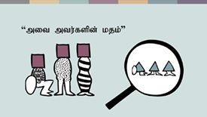 | nghJthf> ehk; Vida egu;fis mtu;fsJ kjj;jpdhy; tiuaWf;fg;gl;Ls;NshuhfNt ghu;f;fpNwhk;- mtu;fisg; gw;wpa Vida midj;J tplaq;fSk; kjj;jpdhNyNa jPu;khdpf;fg;gLfpd;wJ vd Cfpf;fpNwhk;. MfNt> xU FOtpidr; Nru;e;j egnuhUtu; VNjDk; jtwpidr; nra;fpd;wNghJ> mjw;fhd fhuzk; mtupd; kjk; Nflhd tplaq;fis GFj;Jfpd;wik my;yJ mk;kjk; xOf;ff;Nflhf ,Uf;fpd;wikNa MFk;.
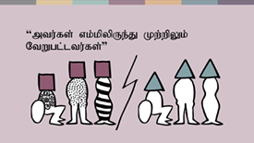 | NtWgl;l rKjhaq;fSf;fpilapy; cs;s egu;fs; xUtUlndhUtu; cwTfisg; NgzhJs;sNghJ> ‘VidNahu;’ vd;Nghu; ‘ek;kpypUe;J’ Kw;wpYk; NtWgl;ltu;fs;- ‘mtu;fs;’ ‘ek;ik’ tpl NtWgl;l <LghLfs;> Njitfs;> tpOkpaq;fs; kw;Wk; czu;Tfisf; nfhz;Ls;sdu; vd vz;ZtJ kpf ,yFthdjhf mikfpd;wJ. me;j mbg;gilapy; mtu;fsplk; ehk; fw;Wf;nfhs;sf;$ba vt;tpj mwpT my;yJ QhdKk; ,y;iy vd ehk; epidf;ff;$Lk; my;yJ mtu;fis fyhrhuuPjpahf my;yJ xOf;fuPjpahf jho;thdtu;fshfg; ghu;f;ff;$Lk;.
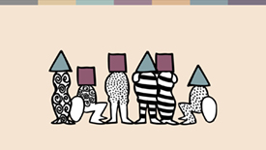 | gjpyhf> r%fj;jpy; cs;s Vida FOf;fisr; Nru;e;j egu;fis ehk;> NtWgl;l milahsq;fs; kw;Wk; tho;f;if mDgtq;fisf; (,tw;Ws; ngUk;ghyhdtw;iw ehKk; nfhz;bUg;Nghk;) nfhz;l KOikahd egu;fshfg; ghu;f;fpd;wNghJ> ngUk;ghYk;> ehk; Gjpa topfspy; xt;nthUtiuAk; kjpg;gjw;F> Gupe;Jf;nfhs;tjw;F kw;Wk; mq;fPfupj;Jf;nfhs;tjw;F KbAk;. mj;Jld; vy;iyfisf; fle;J nrd;W cwTfisf; fl;bnaOg;Gtjw;fhd topfisf; fz;lwpa KbAk;.  rpy milahsq;fs; r%fj;jpy; ghjfepiyf;F ,l;Lr; nry;tJld;> rpy vkf;F rpwg;Gupikfis mspf;fpd;wd. vkJ rpwg;Gupikfs; vitnad ehk; milahsk; fhz;gjhdJ> ehk; vg;NghJ Vida egu;fSf;F ghjfepiyfis Vw;gLj;Jfpd;w gpur;rpidnahd;wpd; mq;fkhf ,Uf;fpd;Nwhk; vd;gjid milahsk; fhz cjtp nra;Ak;. mj;Jld;> vq;fsJ NtWgl;l milahsq;fis ehk; mwpe;J nfhs;fpd;wikahdJ> ehk; vjpu;nfhs;fpd;w ghjfepiyfs; kw;Wk; ghugl;rj;jpw;F vjpuhf NghuhLtjw;fhd kw;Wk; ghugl;rj;jpid vjpu;nfhs;fpd;w VidNahUld; xd;wpize;J epw;gjw;fhd tha;g;Gf;fs; kw;Wk; rhj;jpag;ghLfisf; fhZtjw;F vkf;F cjTk;.
 | khw;wKz;lhf;Feu;fspdÊ fij
Sameh vDk; fpwp];jt ,isQDk; Hanaa vDk; K];ypk; ,sk; ngz;Zk; vfpg;jpYs;s Fthdh vDk; epu;thfg; gpuptpw;F cl;gl;l `p[hdh vDk; fpuhkj;ijr; Nru;e;jtu;fs; Mthu;. mtu;fs; fpuhkj;jpy; fhzg;gl;l fpwp];jt kw;Wk; K];ypk; rKjhaq;fSf;fpilapyhdj; jilfis cilg;gjw;fhf xd;wpize;J Ntiy nra;fpwhu;fs;.

“NtWgl;l kjq;fisr; Nru;e;j rpWtu;fSld; xd;whf mku;tjw;F my;yJ njhlu;Gnfhs;s kWf;fpd;wij ehd; ghu;j;jpUf;fpNwd;” vd Hanaa $Wfpd;whu;.

“,ij xd;wpize;J ifahs;tJ ,yFthdjhf ,Uf;Fk; vd ehd; czu;e;Njd;. mj;Jld;> mtu;fsJ fz;Nzhl;lq;fis khw;Wtjw;F xd;wpize;J Kaw;rp nra;Njhk;. ,e;j gpuNjrj;jpYs;s rpWtu;fs; khw;wj;jpw;fhd tpijfshf ,Uf;f Ntz;Lk; vd;Nw ehq;fs; tpUk;gpNdhk;” vd Sameh $Wfpd;whu;.

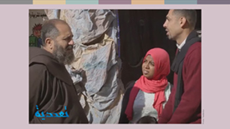 | rpWtu;fs; fhw;ge;J tpisahl tpUk;gpdhu;fs;> Mdhy;> fhw;ge;J tpisahLtjw;F Vw;w xNunahU rpwe;j ,lkhf fj;Njhypf;fj; jpUr;rigf;F ntspNa rJu tbtpy; ,Ue;j xU ,lNk fhzg;gl;lJ vd;gjid mtu;fs; czu;e;Jf;nfhz;lhu;fs;. mtu;fs; ,UtUk; cs;@u; kjFU xUtuhd tz. ghjpupahu; Francis ,id mZfpdhu;fs;. mtu; mjpfkhf xj;Jiog;G nra;jJld;> nraw;ghLfis xOq;F nra;tjw;Fk; cjtpdhu;.  “cz;ikapy;> Sameh kw;Wk; Hanaa ,f;fpuhkj;jpy; nra;fpd;w tplaq;fs; vkf;Fj; Njit. mj;Jld;> ,J midj;J fpuhkq;fSf;Fk; gug;gg;gLnkd ehk; ek;Gfpd;Nwhk;” vd mtu; $Wfpwhu;.
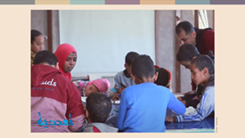 | Muk;gj;jpy; K];ypk; rpWtu;fs; mq;F Nghf tpUk;gtpy;iy. Mdhy;> ,Wjpahf vy;NyhUk; mtsJ topfhl;liyg; gpd;gw;w njhlq;fpdhu;fs;.  “nkJthf Mdhy; epr;rakhf> ehd; gps;isfis xd;whf;f Kaw;rp nra;Njd;>” vd;W mts; $Wfpd;whs;. “Muk;gj;jpy; mtu;fs; kWj;jhu;fs;> Mdhy; gbg;gbahf> mtu;fs; jhkhfNt Gjpa fyg;Gf; FOf;fis cUthf;f Muk;gpj;jhu;fs;.”  Sameh kw;Wk; Hanaa MfpNahu; FOf;fspd; nraw;ghLfis ghu;g;gjw;fhf rpWtu;fspd; ngw;Nwhu;fis mioj;jhu;fs;. gps;isfs; xd;wpize;J ClhLfpd;wikapid ghu;g;gjw;fhd rhjfkhd Jyq;fiy Kjypy; ntspg;gLj;jpatu;fs; jha;khu;fNs Mthu;.  “ehk; khw Ntz;Lk; vd;gJld; khw;wkhdJ xU mgpg;guhaj;jpy; ehk; ek;gpf;if itg;gjD}lhfNt Muk;gkhfpd;wJ” vd Sameh $Wfpd;whu;. mj;Jld;> “ehk; ,UtUk;jhd; eilKiw cjhuzq;fs;. ehk; ,UtUk; ntt;NtW kjq;fisr; Nru;e;jtu;fshapDk; ehk; xd;wpize;J nraw;gLfpNwhk;. ehq;fs; xUtiunahUtu; KOikahf;FtJld; ehk; xNu Fwpf;Nfhspidg; gfpu;e;Jf; nfhs;fpNwhk;. vq;fSila Fwpf;Nfhs; rpWtu;fNs!”
 | KbT
,Wjpahfg; ghu;f;fpd;wNghJ> vkJ tho;f;if vdg;gLfpd;w ,urk; tsk; kpf;fjhAk; RitahdjhAk; ,Uf;f Ntz;Lnkd;Nw ehk; tpUk;Gfpd;Nwhk;! ehq;fs; xNu kdpjf; FLk;gj;jpidr; Nru;e;jtu;fs; vd;gJld; xNukhjpupahd mbg;gilj; Njitfs; kw;Wk; cupikfisg; gfpu;e;Jf; nfhs;fpNwhk;. ehq;fs; xt;nthUtupdJk; cupikfSf;fhf xd;wpize;J gzpahw;Wfpd;wNghJ> ehq;fs; tpidj;jpwd; kpf;ftu;fshf ,Ug;Nghk;.
vkJ mLj;j ,uz;L mku;Tfspy;> kjk; my;yJ ek;gpf;iff;fhd Rje;jpuj;jpd; kPwy;fs; gw;wpf; fw;Wf; nfhs;sg;NghtJld;> ,e;j kPwy;fs; vkJ rKjhaj;jpy; vt;thW ,Uf;fpd;wd vd;gjid tptuizahf;fk; nra;a Kaw;rpg;Nghk;. mt; mwpthdJ> ehk; khw;wKz;lhf;Feu;fshf tUtjw;fhd mLj;j gbKiwfis Kd;ndLg;gjw;F vkf;F cjTk; vd ek;gg;gLfpd;wJ.

%yk;
khw;wKz;lhf;Feu;fspdÊ fij %yk;: Taadudiya, www.taadudiya.com
Sameh kw;Wk; Hanaa MfpNahu; muG nkhopapNy jq;fSilaf; fijia $Wfpd;w xU tiynahsp jpiuglj;jpid ePq;fs; Mq;fpy nkhopapyhd trdtupfSld; ,j;njhLg;gpy; fhzyhk;: What is your story? Egypt (English Subtitles) - YouTube
Jujp~Êltrkhf 2019 ,yÊ thfd tpgjÊnjhdÊwpyÊ Hanaa fhykhdhuÊ

