SESSION 4
violations of FREEDOM OF RELIGION OR BELIEF

Presentation
Script

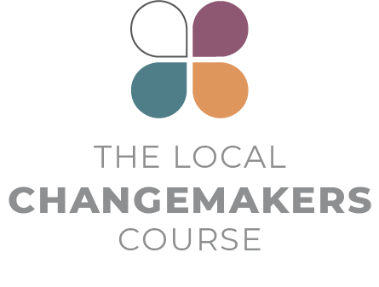
Presentation Script

Understanding violations of Freedom of Religion or Belief
This script for the session 4 presentation is illustrated by slides 4-39 of the session PowerPoint.

NOTE: This presentation is long (just under 20 minutes) and includes many examples. You may wish to cut the examples that seem least relevant to your group. You may also wish to replace some examples with stories from your context. Key messages in the ‘Stories of…’ sections are highlighted in bold. Please include these points in your talk! Use the PowerPoint, printouts of key PowerPoint slides or equivalent flip chart illustrations to help your participants process the contents.

 | INTRODUCTION
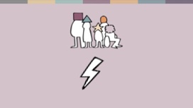 | All sorts of people in all sorts of countries face problems because of a lack of freedom of religion or belief. What varies is who is affected, the severity of the violations and who is committing them.
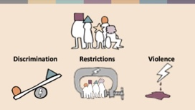 | In this presentation, we are going to hear real life stories about discrimination, restrictions of rights and violence.
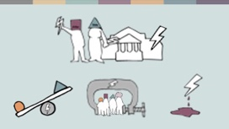 | These violations are committed both by the state and by people in the community. We often refer to this as government violations and social hostilities. But violations can also take place within the family and within faith communities.
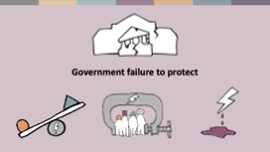 | There is also a fourth kind of violation: government failure to protect people from violations in the community. The state has a duty to protect every human being within its territory from discrimination, undue restrictions of their rights and violence. Many states fail to do this.
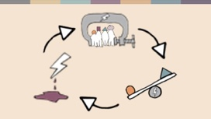 | Discrimination, restrictions on rights and violence are usually interrelated and overlapping. A restriction can be discriminatory and contribute to violence, for example. And often government violations and social hostilities contribute to each other, creating a vicious circle.  Government legislation that discriminates against minorities legitimises intolerance in society, resulting in discrimination, harassment and violence in the community. If the authorities turn a blind eye to violations in the community, people think they can get away with it and the discrimination, harassment and violence get worse.  Let’s take a look at what discrimination, restrictions and violence can look like in different parts of the world using some real-life stories. Perhaps some of them relate to things you have experienced.
 | STORIES OF DISCRIMINATION
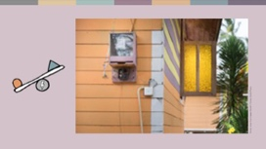 | Discrimination is very common and affects every area of life.  Rev Kumar is a pastor in rural Sri Lanka. His family has faced discrimination from the Buddhist majority community in his village. Teachers and classmates have bullied his children, and the family’s electricity and water supply were switched off on the grounds that their home was an illegal place of worship.
 | Some governments discriminate in the allocation of public finances – for example, investing far less in infrastructure, health or education in minority areas. This can create long term risks for communal tension and political instability.  Discrimination can also happen in the way institutions function. For example, school children can face discrimination, forced participation in confessional religious activities, or textbooks that speak ill of their community. In rare cases, groups are denied education – Baha’is are not allowed to attend university in Iran.
 | STORIES OF RESTRICTION AND DISCRIMINATION
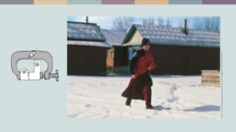 | Many types of law create restrictions that directly or indirectly result in discrimination. Planning regulations, which may appear to be neutral are a common roadblock stopping minorities from building places of worship.  In Russia a range of minorities have faced difficulties – for example, permission not being granted, municipal leases being terminated after construction has begun, or demolitions.
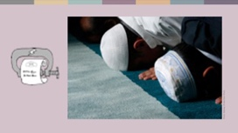 | Laws governing the registration of religious communities can be restrictive and discriminatory too. The Algerian government requires all groups, religious or otherwise, to register as an association prior to conducting activities. The small Ahmadi community has not been granted registration. At the end of 2020, there were 220 legal cases against community members charged with crimes such as holding prayers in unauthorized locations.
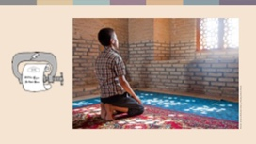 | Some governments restrict the religious practices of majority communities too. In 2020, officials in the Lebap region of Turkmenistan ordered state employees such as teachers and nurses not to attend Friday prayers and  threatened them with the sack if they were seen in mosques.
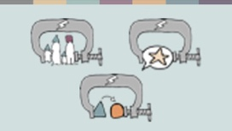 | Let’s think about 2 more kinds of law that can create restrictions: Family law and blasphemy or apostacy laws.  FAMILY LAW  Both secular and religious laws that govern marriage, divorce, inheritance and child custody can restrict rights and discriminate.
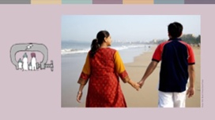 | In India, the secular Special Marriage Act requires interfaith couples to notify a magistrate 30 days before the wedding. The magistrate investigates the application and sends a notice home to the couple’s families. This puts many couples at risk of honour-based violence.
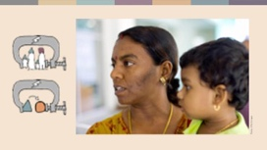 | Revathi Massosai is Malaysian. She was born to Muslim parents but brought up a Hindu by her Hindu grandmother. A religious court sent Revathi to an Islamic re-education centre for six months for marrying a Hindu and refusing to return to Islam.
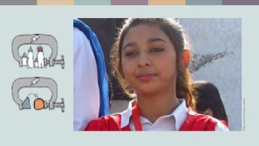 | Sometimes religious family law and apostasy laws make minorities vulnerable to criminal attack.  Each year, hundreds of Hindu and Christian girls in Pakistan experience kidnapping, forced conversion and marriage. This happened to Maira Shahbaz when she was 14. Her parents went to court to get her back, but leaving Islam is banned in Pakistan, and Christian parents cannot have custody of Muslim children, so the High Court ruled that she be returned to her abductor. Two weeks later Maira escaped. She lives in hiding and is fighting to have her marriage annulled and her legal status changed back to Christian.
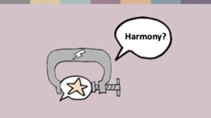 | BLASPHEMY AND APOSTACY LAWS  Laws on blasphemy and apostasy (leaving your religion) are often justified with reference to maintaining harmony. However, these laws can have the opposite effect. In some countries the laws are misused, with false accusations used for personal vendettas. But the laws themselves often restrict speech and behaviour in ways that compromise the freedom of religion or belief – particularly for people whose beliefs the state or majority community don’t like.  Ahmadis, who believe in a prophet after Mohammed, atheists and people who criticize the state or religious power holders are often at risk, but anyone can become a victim.
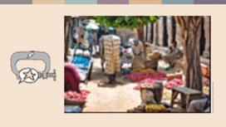 | In 2020, a religious court in Northern Nigeria sentenced a 12-year-old Muslim boy to 10 years in prison after he was accused of insulting the Prophet. His conviction was overturned by a secular appeals court in 2021, but the risk of reprisal attacks makes it unsafe for his family to live in the area.
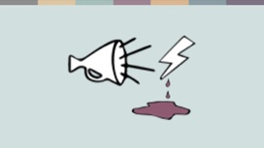 | According to international law, the speech that should be banned is incitement to violence. Instead of stopping violence, blasphemy and apostasy laws tend to encourage it by supporting the idea that people who peacefully express beliefs that the majority don’t like should be punished.
 | STATE MONITORING AND CONTROL  Another area of state activity that creates restrictions is government surveillance, monitoring and control of the activities and finances of faith communities. For example, some churches in Sri Lanka report monitoring by state authorities. This is part of a wider trend of shrinking space for civil society.  Nowhere is surveillance more extreme than in Western China where facial recognition technology has been developed to enable security cameras to identify members of the mostly Muslim Uighur minority and notify the police of their location.
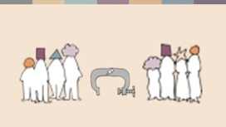 | SOCIETAL RESTRICTIONS  Rights can also be restricted within families, faith groups or the wider community. This often affects men and women differently. Women are often denied opportunities – for example to study theology, and women’s behaviour and religious observance may be the subject of family or community control on religious grounds.  Majority societies often restrict the religious expression of minority women too, for example by pressuring women to hide their religious identity to gain employment.
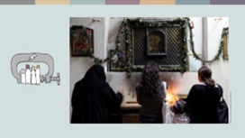 | Maria is a young Christian living in Egypt. When she graduated from university, Maria was offered a job at a bank but told that if she took it, she would have to wear a hijab. Maria didn’t think it was fair to have to pretend to have a different religious identity, so she turned the job down.
 | STORIES OF VIOLENCE
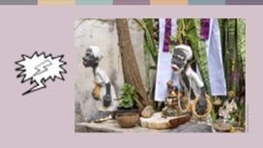 | Let’s move on to think about violence. Hate speech and hate crimes are among the most commonly experienced forms of violence. Places of worship and people attending them are particularly vulnerable to hate crimes.  In Brazil, followers of traditional Afro-Brazilian religions are facing violent attacks from neo-Pentecostal Christian neighbours who consider their religion to be demonic. Father Marcio, a priest of the Candomblé religion, has reported over 20 attacks on his temple. The police have taken no action.
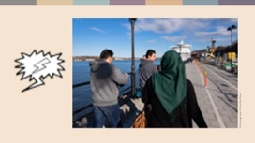 | Once again, women and men tend to be affected differently.  Muslim women in Sweden, particularly those who wear religious clothing, such as the hijab, are more likely to experience hate crimes committed by strangers in public spaces, while Muslim men are more likely to experience hate crimes from neighbours or colleagues.
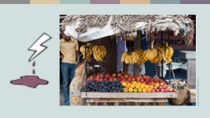 | In many places, the corona virus pandemic strengthened existing patterns of discrimination and hate. Muslims in India were accused of conducting a corona jihad after a virus outbreak followed a Muslim religious festival. Ahmed Shaikh is a Muslim street vendor who struggles to make a living. In April 2020, a gang of Hindu nationalists told him to pack up his stall and leave because Muslims were conspiring to spread corona. Ahmed pleaded, but was severely beaten with sticks. He tried to file a complaint with the police, who refused to register the case, saying that street vending was illegal.
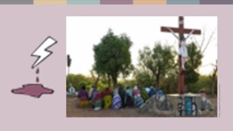 | The most extreme forms of violation in the community are communal violence and terror attacks.  Pastor Samuel is from northern Burkina Faso. The country has a tradition of religious tolerance that terror groups are undermining. In 2019, attacks on churches became part of their strategy. Pastor Samuel now lives in a camp for internally displaced people.  “These attacks have shattered the lives of our people. We are filled with pain,” he says.  Terror attacks have escalated since 2019, affecting everyone, with over 1 million people displaced.

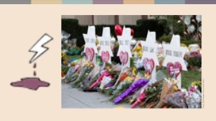 | Although terror groups with links to Islam dominate global statistics, there are many national contexts where other groups pose a greater threat. Security services in some western countries consider white supremacists and far-right extremists to be the biggest domestic terror threat. These groups target minorities. In 2018, eleven people were killed in a synagogue in Pittsburgh, USA and 51 people were killed at a mosque in Christchurch, New Zealand in 2019.
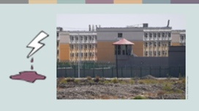 | Violence by the police, security services or military, or by mobs hired by the state, can target individuals or whole communities. The situation of Uighurs in Western China illustrates how extreme government violence can become. Uighur women have faced forced sterilization and contraception, resulting in a massive drop in birth rates, and around 1.8 million Uighurs have been sent to re-education camps for reasons like wearing a hijab or a beard. Torture and rape are reported from the camps, where inmates are denied their language and religion and indoctrinated in state ideology. The Chinese government claims these camps are voluntary education centres.
 | GOVERNMENT RESPONSIBILITIES AND FAILURES
 | Let’s take a final look at government failures to protect people. Governments have a responsibility to protect human rights. When they fail to do so, discrimination and violence tend to escalate, but effective police action in individual cases can help stop violations.
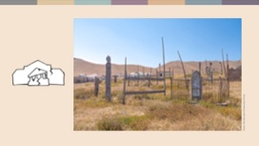 | In 2017, an old woman who had converted from Islam to Christianity died in southern Kyrgyzstan. When her daughter tried to bury her at the municipal cemetery, a group headed by the local imam violently protested. The body was repeatedly dug up until public attention made the authorities react. The perpetrators were charged. After that, radical voices against converts became less frequent.
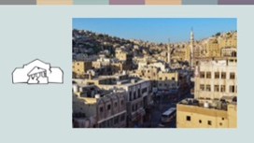 | Authorities often fail to intervene in relation to violations within families or faith communities. Nadia, a 22-year-old Christian university student in Jordan, fell in love with a fellow student – a Muslim. When her family found out, they refused to let her leave the house and tortured her. Nadia managed to run away, but two months later her father found her and killed her. The court considered his ‘honour’ based motives to be a mitigating circumstance and did not send him to prison.

 | CONCLUSION
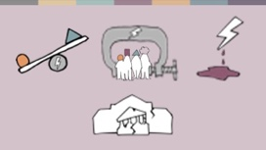 | In this presentation we have looked at discrimination, restrictions and violence committed by governments and by people in the community. We’ve also looked at state failures to protect people.  From the stories we have heard, we can draw several conclusions:
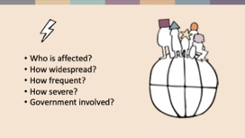 | - Violations happen in all kinds of countries and affect people of all religions and beliefs. What varies between contexts is who is affected, how widespread, frequent and severe violations are and the extent to which the government is involved in committing them.
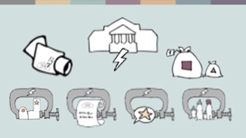 | - Many different kinds of law and government policy can contribute to violations.
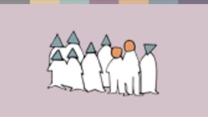 | - Usually, minorities are most severely affected, along with those who think differently within majorities. But majority communities can be affected by violations too – not least by terror violence.
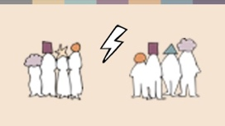 | - The stories we’ve heard illustrate how violations of freedom of religion or belief usually involve violations of other rights too – for example, the right to education or to marry or the right to life. Many of the stories illustrate how differently men and women can be affected – from hate crimes, to forced marriage, to honour killings to forced sterilization.
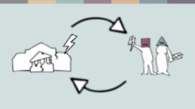 | - And several of the stories we’ve heard illustrate how violations in the community, government failures and government violations reinforce one another, creating a vicious cycle.
 | Violations of freedom of religion or belief cause enormous personal suffering for ordinary people. They also destabilize society. In the end, everyone suffers from the insecurity and economic and social impact.  Regardless of who we are or what faith community we belong to, we have much to gain from freedom of religion or belief being respected for all people in our own country. And we all have fellow believers who live as minorities in other countries and desperately want to see equal rights there. Equal rights for everyone, everywhere would create a happier, safer world for us all.

Local sources
The Guardian, https://www.theguardian.com/world/2013/feb/27/bahai-student-expelled-iranian-university
Forum 18, https://www.forum18.org/archive.php?article_id=2508
US State Dept., https://www.state.gov/reports/2020-report-on-international-religious-freedom/algeria/
Forum 18, https://www.forum18.org/archive.php?article_id=2555
The Leaflet, https://www.theleaflet.in/india-needs-to-overhaul-laws-on-interfaith-marriage-and-religious-conversion/
Forum Asia, https://www.forum-asia.org/?p=7086
UK Parliament, https://edm.parliament.uk/early-day-motion/57474/maira-shahbaz-and-child-abduction-forced-conversion-and-marriage-in-pakistan
BBC news, https://www.bbc.com/news/world-africa-55756834
Local sources
New York Times, https://www.nytimes.com/2019/04/14/technology/china-surveillance-artificial-intelligence-racial-profiling.html
Source: Maria, whose name has been changed for security reasons.
RioOnWatch, https://rioonwatch.org/?p=40117
The Swedish National Council for Crime Prevention, https://www.bra.se/om-bra/nytt-fran-bra/arkiv/press/2021-03-31-islamofobiska-hatbrott-yttrar-sig-i-manga-olika-former.html
Sabrang India, https://sabrangindia.in/article/stop-targeting-discriminating-against-and-attacking-vendors-and-hawkers-national-hawker
Open Doors UK, https://www.opendoorsuk.org/persecution/world-watch-list/burkina-faso
United States Congress, https://www.congress.gov/116/bills/s894/BILLS-116s894is.xml
The Guardian, https://www.theguardian.com/world/2020/sep/04/muslim-minority-teacher-50-tells-of-forced-sterilisation-in-xinjiang-china
Forum 18, https://www.forum18.org/archive.php?article_id=2248
Local sources

