SASHI NA 4
Sabawa ‘Yancin Addini ko Imani

Takardar
Gabatarwa

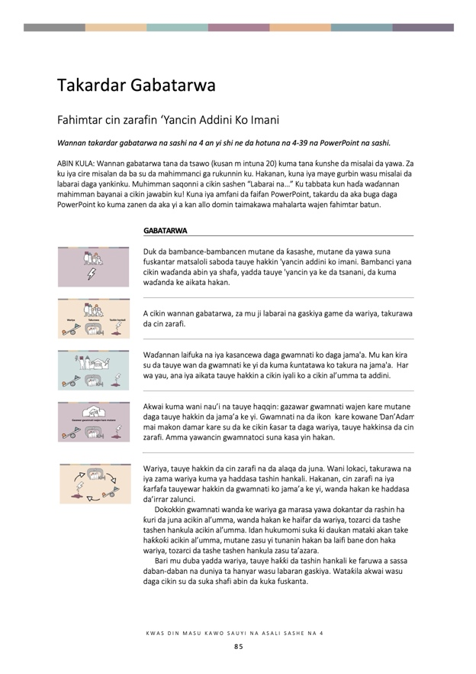

Takardar Gabatarwa
Fahimtar cin zarafin ‘Yancin Addini Ko Imani
Wannan takardar gabatarwa na sashi na 4 an yi shi ne da hotuna na 4-39 na PowerPoint na sashi.

ABIN KULA: Wannan gabatarwa tana da tsawo (kusan m intuna 20) kuma tana ƙunshe da misalai da yawa. Za ku iya cire misalan da ba su da mahimmanci ga rukunnin ku. Hakanan, kuna iya maye gurbin wasu misalai da labarai daga yankinku. Muhimman saqonni a cikin sashen “Labarai na…” Ku tabbata kun haɗa waɗannan mahimman bayanai a cikin jawabin ku! Kuna iya amfani da faifan PowerPoint, takardu da aka buga daga PowerPoint ko kuma zanen da aka yi a kan allo domin taimakawa mahalarta wajen fahimtar batun.

 | GABATARWA
 | Duk da bambance-bambancen mutane da ƙasashe, mutane da yawa suna fuskantar matsaloli saboda tauye hakkin 'yancin addini ko imani. Bambanci yana cikin waɗanda abin ya shafa, yadda tauye 'yancin ya ke da tsanani, da kuma waɗanda ke aikata hakan.
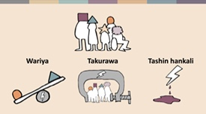 | A cikin wannan gabatarwa, za mu ji labarai na gaskiya game da wariya, takurawa da cin zarafi.
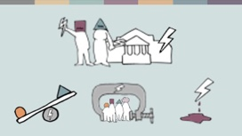 | Waɗannan laifuka na iya kasancewa daga gwamnati ko daga jama'a. Mu kan kira su da tauye wan da gwamnati ke yi da kuma ƙuntatawa ko takura na jama'a. Har wa yau, ana iya aikata tauye hakkin a cikin iyali ko a cikin al’umma ta addini.
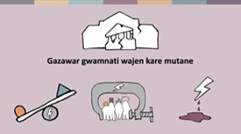 | Akwai kuma wani nau’i na tauye hakkin: gazawar gwamnati wajen kare mutane daga tauye hakkin da jama’a ke yi. Gwamnati na da ikon kare kowane Ɗan’Adam mai makon damar kare su da ke cikin ƙasar ta daga wariya, tauye hakkinsa da cin zarafi. Amma yawancin gwamnatoci suna kasa yin hakan.
 | Wariya, tauye hakkin da cin zarafi na da alaqa da juna. Wani lokaci, takurawa na iya zama wariya kuma ya haddasa tashin hankali. Hakanan, cin zarafi na iya ƙarfafa tauyewar hakkin da gwamnati ko jama’a ke yi, wanda hakan ke haddasa da’irrar zalunci.  Dokokkin gwamnati wanda ke wariya ga marasa yawa dokantar da rashin ha ƙuri da juna acikin al’umma, wanda hakan ke haifar da wariya, tozarci da tashe tashen hankula acikin al’umma. Idan hukumomi suka ƙi daukan mataki akan take haƙƙoƙi acikin al’umma, mutane zasu yi tunanin hakan ba laifi bane don haka wariya, tozarci da tashe tashen hankula zasu ta’azara.  Bari mu duba yadda wariya, tauye haƙƙi da tashin hankali ke faruwa a sassa daban-daban na duniya ta hanyar wasu labaran gaskiya. Wataƙila akwai wasu daga cikin su da suka shafi abin da kuka fuskanta.
 | LABARAN WARIYA
 | Wariya na faruwa a fannoni daban-daban na rayuwa.  Rev. Kumar wani fasto ne a wani ƙauye a Sri Lanka. Shi da iyalinsa sun fuskanci wariya daga al’ummar Buddah a garinsu. An zalunci ‘ya’yansa a makaranta, kuma an cire musu wutar lantarki da ruwan sha bisa dalilin cewa gidansu wurin ibada ne wanda baya bin dokoki.
 | Wasu gwamnatoci na nuna wariya wajen raba kuɗaɗen jama’a – misali, suna ware ƙananan kuɗi ga yankunan da ake da ƙananan ƙabilu. Wannan na iya haddasa tashin hankali da rashin zaman lafiya a cikin ƙasa.  Hakanan, ana iya nuna wariya a cikin tsarin ilimi. Misali, wasu yara na fuskantar matsin lamba su shiga ibadu na addini, ko kuma littattafan karatu masu zagin ko ƙasƙantar da addininsu. A wasu lokuta, ana hana wasu ƙungiyoyi damar samun ilimi – misali, a Iran, ana hana mabiya Bahá’í shiga jami’a.
 | LABARAN TAKURA DA WARIYA
 | Dokoki da dama na hana ‘yancin addini ko imani ta hanyar tauye hakkin wasu mutane ko ƙungiyoyi. Misali, dokokin gine-gine na iya zama wata hanya ta hana mabiya ƙananan addinai gina wuraren ibada.  A Rasha, wasu ƙananan mabiya addinai sun fuskanci matsaloli iri-iri, kamar hana su samun izini, ko rushe wuraren ibadarsu bayan sun fara gina wa.
 | A wasu ƙasashe, dokokin rajistar addinai na da matsanancin tsauri kuma suna nuna wariya. A Aljeriya, dukkan ƙugiyoyi dole ne su yi rajista kafin su fara ayyuka. Amma har yanzu mabiya Ahmadiyya ba su samu rajista ba. A ƙarshen 2020, akwai shari’o’i 220 da ake yi wa mambobinsu bisa tuhumar yin ibada a wuraren da ba su da izini.
 | Wasu gwamnatocin suna iyakantar da yin addini ga al’umma masu rinjaye. A 2020, jami’ai a yankin Lebap na Turkmenistan sun bada umurnin ga ma’aikata gwamnati irinsu malaman makaranta da malaman asibiti da kar su je sallar juma’ah da tsoratar dasu da kora in angansu a masallaci.
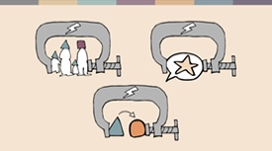 | Bari Mu Duba Wasu Ire-Iren Dokoki Biyu da Ke Hana ‘Yanci:  Dokokin Iyali da Dokokin Sabon/Sabawa Ra’ayi ko Zagin Addini.  DOKOKIN IYALI  Duk dokokin da ke kula da aure, saki, gadon dukiya da renon yara, ko na addini, na iya taƙaita ‘yanci kuma su nuna wariya.
 | A Indiya, dokar Special Marriage Act ta buqaci cewa dole ne ma’auratan da ke da addini daban-daban su sanar da alƙalai kwanaki 30 kafin a ɗaura auren su. Alƙalai zai binciki neman aure sannan ya aika wa iyalan ma’auratan da takardar sanarwa. Wannan yana iya jefa ma’auratan cikin haɗarin cin zarafi daga iyalansu.
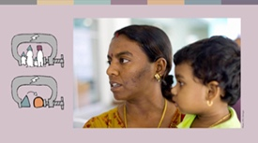 | Revathi Massosai, ‘yar qasar Malaysia, an haife ta ne a cikin musulunci amma kakarta ta rene ta a matsayin Hindu. Wata kotun addini ta tilasta mata shiga cibiyar koyar da addinin musulunci na tsawon watanni shida saboda ta auri wani Baturen Hindu kuma ta qi komawa addinin Islama.
 | Wasu lokuta, dokokin iyali na addini da dokokin sabon ra’ayi na iya jefa ƙananan ƙugiyoyin addini cikin haɗarin cin zarafi.  A kowace shekara, daruruwan ‘yan matan Hindu da Kiristoci a Pakistan na fuskantar sacewa, tilasta musu sauya addini da kuma tilasta musu aure. Wannan ya faru da Maira Shahbaz tana da shekara 14. Iyayenta sun garzaya kotu domin su mayar da ita gida, amma tunda ta fita daga addinin Islama haramun ne a Pakistan, kuma iyaye Kirista ba za su iya renon yaro da aka mayar da shi Musulmi ba, sai babbar kotu ta yanke hukuncin mayar da ita wajen wanda ya sace ta.
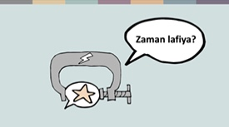 | DOKOKIN SABON RA’AYI DA ZAGIN ADDINI  Ana yawan kafa hujja da dokokin sabo da barin addini da dalilin kiyaye zaman lafiya da hadin kai. Duk da haka, wadannan dokoki sau da yawa suna haifar da akasin haka. A wasu qasahe, ana yawan amfani da su ta hanyoyin da ba daidai ba, inda ake yin qarya da zargin mutum domin biyan buƙatun ƙashin kai. Bugu da ƙari, wadannan dokoki kan taƙaita ‘yancin addini da imani – musamman ga mutanen da ke da ra’ayi da ba su yi daidai da na gwamnati ko yawancin al’umma ba.  Mutanen da ke cikin haɗari sun haɗa da Ahmadiyya, waɗanda ke yin imani da annabi bayan Annabi Muhammadu, marasa imani (atheists) da kuma mutanen da ke sukar gwamnati ko masu riƙe da iko na addini. Duk da haka, kowa na iya fuskantar wannan barazana.
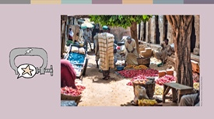 | A shekarar 2020, wata kotun addini a Arewacin Najeriya ta yanke wa wani yaro musulmi mai shekaru 12 hukuncin daurin shekaru 10 a gidan yari bayan da aka zarge shi da yin batanci ga Annabi Muhammadu. Daga bisani, wata kotu ta duniya (secular appeals court) ta soke wannan hukunci a shekarar 2021, amma har yanzu barazanar ramuwar gayya ta sanya iyalinsa cikin haɗari, har ma da matsin lamba na barin yankinsu.
 | A cewar dokokin duniya, irin maganganun da ya kamata a haramta sune waɗanda ke tada fitina da haddasa tashin hankali. Maimakon hana tashin hankali, dokokin sabo da barin addini kan ƙara hura wutar rikici, ta hanyar tabbatar da ra’ayin cewa dole ne a hukunta mutanen da suka bayyana abin da yawancin jama’a ba su da yardar da shi ba.
 | SANYA IDO DA IKON GWAMNATI  Wani fannin da gwamnati ke amfani da shi wajen tauye ‘yancin addini shine sanya ido, sa ido kan harkokin kuɗi da kuma gudanar da ayyukan qugiyoyin addini. Misali, wasu coci a Sri Lanka sun ruwaito cewa hukumomin gwamnati na sa ido a kansu. Wannan yana cikin matsalar taƙaita ayyukan ƙugiyoyin farar hula a duniya.  Babu inda ake amfani da fasahar leƙen asiri da sanya ido fiye da Yammacin Ƙasar Sin, inda ake amfani da fasahar gane fuska (facial recognition) don a iya gano mambobin al’ummar Uighur, waɗanda galibinsu Musulmi ne, tare da sanar da jami’an tsaro wurin da suke. Wannan mataki yana ƙara tsananta takura da cin zarafin ‘yancin addini a wannan yanki.
 | KALUBALE DAKE CIKIN AL’UMMA  Ana iya taqaita hakkin Ɗan’Adam ba kawai ta hanyar dokokin gwamnati ba, har ma ta hanyar iyali, ƙugiyoyin addini, ko ma al’umma gaba ɗaya. Wannan matsala na shafar maza da mata ta hanyoyi daban-daban. Sau da yawa, ana hana mata damar yin wasu abubuwa, kamar karatun neman ilimin addini (theology), sannan ana iya ta ƙaita halayensu da yadda suke bin addini bisa dalilai na al’ada ko iyali.  Haka kuma, a wasu ƙasahe, ana tauye ‘yancin addini na mata ‘yan ƙabilu ko addinai marasa rinjaye. Misali, ana matsa wa mata lamba su boye asalin addininsu don samun aiki.
 | Maria, wata matashiya Kirista a Masar, ta fuskanci irin wannan matsala. Bayan da ta kammala jami’a, an bata aiki a banki amma aka ce dole sai ta sa hijabi idan tana son aikin. Maria ta ga cewa hakan ba adalci bane don a tilasta mata nuna wata aqidar addini da ba nata ba, don haka ta ƙi amincewa da aikin.
 | LABARAN TASHIN HANKALI
 | Yanzu kuma bari mu duba batun tashin hankali. Kalaman ƙiyayya da laifukan ƙyama (hate speech and hate crimes) suna daga cikin abubuwan da aka fi fuskanta a fannin cin zarafi. Wuraren ibada da mutanen da ke halartar su suna cikin hatsari sosai daga irin wadannan hare-hare.  Misali, a Brazil, masu bin addinan gargajiya na Afro-Brazilian suna fuskantar hare-hare daga wasu ma ƙwabta Kiristoci masu bin Neo-Pentecostal, wadanda ke kallon addininsu a matsayin na shaidanu. Malam Marcio, wani firist na addinin Candomblé, ya ruwaito cewa an kai hare-hare fiye da 20 a yankin sa, amma jami'an tsaro ba su dauki wani mataki ba.
 | Har ila yau mata da maza na fuskantar irin wadannan çin zarafi ta hanyoyi daban-daban. A Sweden, Musulmai mata, musamman wadanda ke sanye da kayan addini kamar hijabi suna fuskanta fiye da kowa hare-haren, ƙyama daga mutanen da ba su san su ba. A cikin wuraren jama'a, mata Musulmai- musamman masu sanya hijabi-sun fi fuskantar hare-haren ƙyama daga mutanen da ba su san su ba. A daya bangaren kuma, mazan Musulmai sun fi fuskantar cin zarafi da hare-haren ƙyama daga maƙwabta ko abokan aiki.
 | A wurare da dama, annobar cutar korona ta ƙara tsananta wariya da ƙyama da ake yi wa wasu al'ummomi. A Indiya, Musulmai sun fuskanci zarge-zarge na cewa suna gudanar da wani abin da aka kira "Corona Jihad", bayan da barkewar cutar ta biyo bayan wani biki na addinin Musulunci. Ahmed Shaikh, wani Musulmi mai sayar da kaya a titi, yana fama da wahalar samun abin rayuwa. A watan Afrilun 2020, wata ƙungiyar masu goyon bayan a ƙidar Hindu Nationalism ta tilasta masa ya tattara kayansa ya bar kasuwa, da'awar cewa Musulmai na yunqurin yada cutar korona. Duk da rokon da yayi, sun yi imasa duka mai tsanani da sanduna. Da ya kai kuka ga 'yan sanda, sun ƙi daukar mataki, suna cewa sayar da kaya a titi ba bisa doka bane.
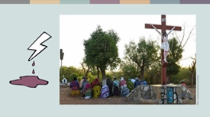 | Mafi munin nau'in cin zarafi a cikin al'umma shine rikicin addini da hare-haren ta'addanci. Fasto Samuel daga Arewacin Burkina Faso ya bayyana irin halin da ake ciki. Duk da cewa qasar na da tsohuwar al'adar zaman lafiya tsakanin addinai, qungiyoyin ta'addanci suna qoqarin rushe wannan hadin kai. A shekarar 2019, an fara kai hare-hare kan coci-coci a matsayin dabarar tsoratarwa. Yanzu haka, Fasto Samuel yana zaune a sansanin 'yan gudun hijira.  “Wadannan hare-hare sun rusa rayuwar al'ummarmu. Muna cikin baqin ciki da radadi," in ji shi.  Tun daga 2019, hare-haren ta'addanci sun ƙara yawa, suna shafar kowa, inda fiye da miliyan daya daga cikin al'ummar ƙasar suka rasa matsugunan su.
 | Duk da cewa ƙungiyoyi masu alaka da Musulunci suna da babban kaso a cikin kididdigar ta'addanci a duniya, akwai wasu ƙungiyoyi da ke barazana mafi girma a wasu ƙasahe. A ƙasahen Yamma, hukumomin tsaro sun gano cewa ƙungiyoyin masu tsattsauran ra'ayi na farar fata da masu tsattsauran ra'ayi na 'yan dama sune manyan barazanar ta'addanci a cikin gida. Wadannan ƙungiyoyi suna kai hare-hare kan al'ummomin tsiraru. Misali, a shekarar 2018, an kashe mutane 11 a wata majami'ar Yahudawa da ke Pittsburgh, Amurka. A shekarar 2019, an kashe mutane 51 a wani harin da aka kai a masallacin Christchurch, New Zealand. Wadannan hare-haren sun kara dagula barazanar da ake yi wa ƙungiyoyi marasa rinjaye.
 | Cin zarafi daga 'yan sanda, hukumomin tsaro, sojoji, ko ƙungiyoyi da qasa tayi jinga da su kan iya fuskatar mitane ko Al’umma baki daya. Halin da mutanen Uyghur ke ciki a Yammacin China misali ne na ta'addancin gwamnati mai tsanani. Ana tilasta wa mata 'yan Uyghur yin aikin hana haihuwa da kuma hana haihuwa, wanda hakan ya haifar da raguwar haihuwa sosai. An tura kimanin mutane miliyan 1.8 'yan Uyghur zuwa sansanonin "sake ilmantarwa" saboda laifuka kamar sanya hijabi ko barin gemu. Akwai rahotannin azabtarwa, fyade, da kuma hana 'yancin harshe da addini a wadannan sansanonin. Gwamnatin China ta yi iqirarin cewa wadannan sansanonin suna ba da ilimi na son rai.
 | HAƘƘOƘIN GWAMNATI DA GAZAWARTA
 | Gwamnati na da alhakin kare haqqin bil'adama! Idan ta kasa yin hakan, cin zarafi da tashin hankali kan ƙara tsananta. Duk da haka, idan aka dauki matakan hukunta masu laifi, hakan na iya rage wadannan cin zarafin.
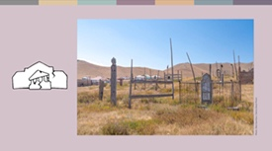 | A shekarar 2017, wata tsohuwar mata da ta bar addinin Musulunci ta koma Kiristanci ta rasu a kudancin Kyrgyzstan. Lokacin da 'yarta ta ƙoƙarta binne ta a maƙabartar gari, wani rukuni da wani limamin addini da ke jagoranta ya yi bore da ƙarfi. An tono gawar har sai da matsin lambar jama'a ya sa mahukunta suka dauki mataki. An gurfanar da wadanda suka aikata wannan laifi, wanda hakan ya sa masu tsananta wa masu sauya addini suka ja da baya.
 | Hukumomi sau da yawa suna kasa yin komai kan cin zarafi da ake yi a tsakanin iyalai ko ƙungiyoyin addini. Misali, Nadia, wata dalibar jami'a mai shekaru 22 daga Jordan, ta kamu da soyayya da wani dalibi Musulmi. Iyayenta sun gano hakan, suka hana ta fita daga gida tare da azabtar da ita. Bayan ta tsere, mahaifinta ya gano inda take bayan watanni biyu ya kashe ta. Kotun da ta yi shari'ar ta rage masa hukunci bisa dalilin cewa yana kare 'darajar' iyalinsa.
 | KAMMALAWA
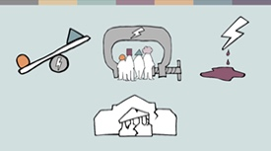 | A cikin wannan bayani/gabatarwa, mun yi nazari kan cin zarafi, takurawa, da tashin hankali da gwamnati da kuma jama'a ke aikatawa. Haka kuma, mun dubi gazawar hukumomi wajen kare mutane.  Daga wadannan labarai, mun fahimci abubuwa da dama:
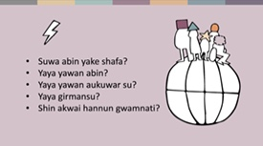 | - Cin zarafi yana faruwa a ƙasashe daban-daban, yana shafar mutane na addinai da imani daban-daban. Bambancin da ke tsakanin wadannan wurare shine wa ake ci wa zarafi, yawan faruwar hakan, da kuma yadda gwamnati ke da hannu a ciki.
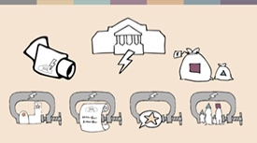 | - Doka da manufofin gwamnati na iya ƙara ta'azzara cin zarafi.
 | - Akasari, 'yan tsiraru ne suka fi fuskantar cin zarafi, sai kuma mutanen da ke da ra'ayi daban a cikin al'ummar da suke ciki. Duk da haka, yawancin al'ummomi suna fuskantar cin zarafi ta hanyar ta'addanci.
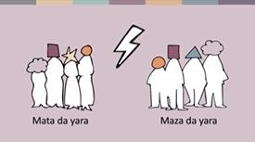 | - Cin zarafi na tauye haqqin addini ko imani, hakan kuma yana hade da tauye wasu haƙƙoƙi kamar 'yancin ilimi, aure, ko ma 'yancin rayuwa. Mafiya yawancin labaran na nuna yadda abin ke shafar mata ta hanyoyi daban-daban- daga miyagu aɓuɓuye na ƙi, zuwa auren dole, da daukaka kisan gilla zuwa ga dandatsa.
 | - Cin zarafi a cikin al'umma, gazawar gwamnati, da kuma cin zarafin da gwamnati ke aikatawa suna taimaka wa juna wajen qara tabarbarewar yanayi.
 | Cin zarafin 'yancin addini ko imani yana haifar da wahala mai yawa ga mutane. Baya ga haka, yana haddasa rudani a cikin al'umma. A ƙarshe, kowa na fuskantar matsalar rashin tsaro da koma bayan tattalin arziqi da zamantakewa. Duk da banbancinmu, muna da babbar moriya idan aka tabbatar da 'yancin addini ko imani ga kowa. Haka kuma, akwai 'yan'uwanmu da ke zama 'yan tsiraru a wasu ƙasahe wadanda ke buqatar ganin 'yancin su yana daidai da na kowa. Idan aka tabbatar da 'yancin addini da imani ga kowa a duniya, hakan zai haifar da zaman lafiya da kwanciyar hankali ga kowa.

Hanyoyi na Asali
The Guardian, https://www.theguardian.com/world/2013/feb/27/bahai-student-expelled-iranian-university
Forum 18, https://www.forum18.org/archive.php?article_id=2508
US State Dept., https://www.state.gov/reports/2020-report-on-international-religious-freedom/algeria/
Forum 18, https://www.forum18.org/archive.php?article_id=2555
The Leaflet, https://www.theleaflet.in/india-needs-to-overhaul-laws-on-interfaith-marriage-and-religious-conversion/
Forum Asia, https://www.forum-asia.org/?p=7086
UK Parliament, https://edm.parliament.uk/early-day-motion/57474/maira-shahbaz-and-child-abduction-forced-conversion-and-marriage-in-pakistan
BBC news, https://www.bbc.com/news/world-africa-55756834
Hanyoyi na Asali
New York Times, https://www.nytimes.com/2019/04/14/technology/china-surveillance-artificial-intelligence-racial-profiling.html
Asali: Maryamu, wanda aka canza sunanta saboda dalilan tsaro.
RioOnWatch, https://rioonwatch.org/?p=40117
The Swedish National Council for Crime Prevention, https://www.bra.se/om-bra/nytt-fran-bra/arkiv/press/2021-03-31-islamofobiska-hatbrott-yttrar-sig-i-manga-olika-former.html
Sabrang India, https://sabrangindia.in/article/stop-targeting-discriminating-against-and-attacking-vendors-and-hawkers-national-hawker
Open Doors UK, https://www.opendoorsuk.org/persecution/world-watch-list/burkina-faso
United States Congress, https://www.congress.gov/116/bills/s894/BILLS-116s894is.xml
The Guardian, https://www.theguardian.com/world/2020/sep/04/muslim-minority-teacher-50-tells-of-forced-sterilisation-in-xinjiang-china
Forum 18, https://www.forum18.org/archive.php?article_id=2248
Hanyoyi na Asali

