4 jeks ieish
wd.u weoySfï fyda úYajdi oeÍfï ksoyi W,a,x>khùï

bÈßm;a lsÍu i|yd l:k msgm;
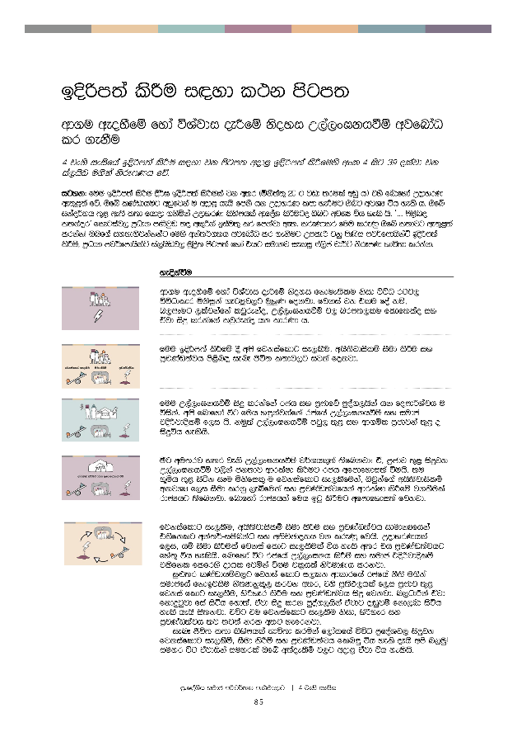

bÈßm;a lsÍu i|yd l:k msgm;

wd.u weoySfï fyda úYajdi ±Ífï ksoyi W,a,x>khùï wjfndaO lr .ekSu

4 jeks ieisfha bosßm;a lsÍu i|yd jk msgm; wod< bosßm;a lsÍfuys wxl 4 isg 39 olajd jk ia,hsv u.ska ksrEmKh fõ'

igyk( fuu bÈßm;a lsÍu §¾> bosßm;a lsÍula jk w;r ^ñks;a;= 20 g jvd ;rula wvq h& tys fndfyda WodyrK we;=<;a fõ' Tfí lKavdhug wvqfjka u wod< hehs fmkS hk WodyrK lmd yeÍug Tng wjYH úh yels h' Tfí ikao¾Nh ;=< we;s l;d fhdod .ksñka WodyrK lsysmhla wdfoaY lsÍugo Tng wjYH úh yels hs' z''' ms<sn| l;kaorZ fldgiaj, m%Odk m‚jqv ;o wl=ßka biau;= lr fmkajd we;' lreKdlr fuu lreKq Tfí l;djg we;=<;a lrkakæ Tnf.a iyNd.Sjkakkag fuys wka;¾.;h wjfndaO lr .ekSug WmldÍ jkq msKsi mj¾fmdhskaÜ bosßm;a lsÍï" m%Odk mj¾fmdhskaÜ ia,hsâj, uqøs; msgm;a fyda thg iudkj ieliQ *a,sma pd¾Ü ksrEmK Ndú;d lrkak'

 | yeÈkaùu
 | wd.u weoySfï fyda úYajdi ±Ífï ksoyi fkdue;slu ksid úúO rgj, úúOdldr ñksiqka .eg¨‍j,g uqyqK fokjd' fjkia jk tlu foa kï" n,mEug ,lajkafka ljqrekao" W,a,x>khùï j, nrm;,lu fldf;lao iy tajd isÿ lrkafka ljqrekao hk ldrKd h'
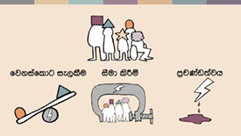 | fuu bÈßm;a lsÍfï § wms fjkiafldg ie,lSu" whs;sjdislï iSud lsÍu iy m%pKav;ajh ms<sn| ienE Ôú; l;dj,g ijka fokjd'
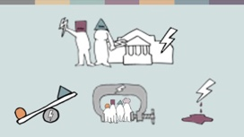 | fuu W,a,x>khùï isÿ lrkafka rch iy m%cdfõ mqoa.,hska hk fomd¾Yajh u úiska' wms fndfyda úg fuh y÷kajkafka rcfha W,a,x>khùï iy iudc tÈßjdÈlï f,i hs' kuq;a W,a,x>khùï mjq, ;=< iy wd.ñl m%cdjka ;=< o isÿúh yelshs'
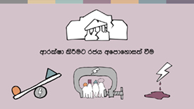 | óg wu;rj y;r jeks W,a,x>khùï j¾.hl=;a ;sfnkjd( ta" m%cdj ;=< isÿjk W,a,x>khùï j,ska ck;dj wdrlaId lsÍug rch wfmdfydi;a ùuhs' ;u N+ñh ;=< isák iEu ñksfil= u fjkiafldg ie,lSfuka" Tjqkaf.a whs;sjdislï wkjYH f,i iSud lrkq ,eîfuka iy m%pKav;ajfhka wdrlaId lsÍfï j.lSula rdcHhg ;sfnkjd' fndfyda rdcHhka fuh bgq lsÍug wfmdfydi;a fjkjd'
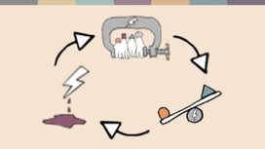 | fjkiafldg ie,lSu" whs;sjdislï iSud lsÍu iy m%pKav;ajh idudkHfhka tlsfklg wka;¾-iïnkaO iy w;sÉPdokh jk lreKq fjhs' WodyrKhla f,i" hï iSud lsÍula fjkia fldg ie,lSula úh yels w;r th m%pKav;ajhg fya;= úh yelshs' fndfyda úg rcfha W,a,x>kh lsÍï iy iudc tÈßjdÈlï tlsfkl flfrys odhl fjñka úIu pl%hla ks¾udKh lrkjd'  iq¿;r lKavdhïj,g fjkia fldg i,lk wdldrfha rcfha kS;s u.ska iudcfha fkdbjiSu kS;Hdkql+, lrjk w;r" tys m%;sM,hla f,i m%cdj ;=< fjkia fldg ie,lSu" ysßyer lsÍu iy m%pKav;ajh isÿ fjkjd' n,OdÍka tajd fkdÿgqjd fia isáh fyd;a" tajd isÿ lrk mqoa.,hska tajdg o`vqjï fkd,nd isáh yels hehs is;kjd' túg tu fjkiafldg ie,lSu ksid" ysßyer iy m%pKav;ajh ;j ;j;a krl w;g yefrkjd'  ienE Ôú; l;d lsysmhla Ndú;d lrñka f,dalfha úúO m%foaYj, isÿjk fjkiafldg ie,lSï" iSud lsÍï iy m%pKav;ajh fln÷ úh yels oehs wms n,uqæ iuyr úg tajdhska iuyrla Tfí w;aoelSï j,g wod< tajd úh yelshs'
 | fjkiafldg i,lkq ,eîu ms<sn| l;kaor
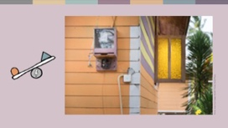 | fjkiafldg ie,lSu b;d iq,N jk w;r th Ôú;fha iEu wxYhlgu n,mdhs'  mQcH l=ud¾ mdÈ,s ;=ud Y%S ,xldfõ .%dóh m%foaYhl isák mdÈ,sjrfhla' Tyqf.a mjq, Tyqf.a .fï nyq;r fn!oaO m%cdj isÿ lrk fjkiafldg ie,lSïj,g uqyqK § ;sfnkjd' .=rejreka iy mx;sfha <uhska Tyqf.a orejkag ysßyer lr we;s w;r" Tjqkaf.a ksji kS;s úfrdaë jkaokd lrk ia:dkhla h lshñka Tjqkaf.a úÿ,sh yd c, iemhqu wl%sh lrkq ,enqjd'
iuyr rchhka rcfha uqo,a fjkalr §fï§ fjkiafldg i,lkjd – iq¿;r lKavdhï isák m%foaYj, há;, myiqlï" fi!LHh fyda wOHdmkh i|yd b;d wvqfjka wdfhdackh lsÍu WodyrKhla f,i ±laúh yelshs' fuh jd¾.sl wd;;sh iy foaYmd,k wia:djr;ajh ms<sn| È.= ld,Sk wjodkï we;s l< yelshs'
wdh;k l%shd;aul jk wdldrfhka o fjkiafldg ie,lSu isÿúh yelshs' WodyrKhla f,i" mdi,a isiqkag fjkiafldg ie,lSu" ks, jYfhka isÿlrk wd.ñl lghq;= j,g Tjqkaj n,y;aldrfhka iyNd.S lrùu fyda Tjqkaf.a m%cdj ms<sn| jerÈ f,i l:d lrk fm<fmd;a Ndú;d lsÍu jeks foaj,g uqyqK §ug Tjqkag isÿ úh yelshs' l,d;=rlska we;sjk ;;ajhkays §" iuyr lKavdhïj,g wOHdmkh wysñ ù ;sfí – brdkfha nydhsjrekag úYajúoHd,h wOHdmkh ,eîug wjir ,efnkafka keye'

 | iSud lsÍï iy fjkiafldg ie,lSï ms<sn| l;kaor
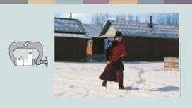 | fndfyda j¾.j, kS;s u.ska iDcqj fyda jl%j fjkiafldg ie,lSu i|yd fya;= jk iSud ks¾udKh flfrkjd' neÆ ne,aug uOHia: njla fmfkkakg ;sìh yels ie,iqïlrKh iïnkaO kshuhka iq¿;r lKavdhï mQckSh ia:dk bÈlsÍu j<lajk iq,N ndOlhla'  reishdfõ iq¿;r lKavdhï rdYshla ÿIalr;djkag uqyqK § ;sfnkjd – bÈlsÍï i|yd wjir ,nd fkd§u" bÈlsÍï wdrïN lsÍfuka miq kd.ßl l,anÿ wjika lsÍu" fyda bÈlsÍï lvd bj;a lsÍu WodyrK yeáhg ±laúh yelshs'
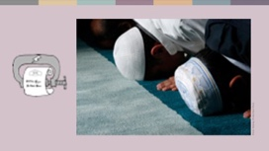 | wd.ñl m%cdjka ,shdmÈxÑ lsÍu md,kh flfrk kS;s o iSudldÍ iy fjkiafldg i,lk wdldrfha kS;s úh yelshs' wd.ñl fyda fjk;a ish¨‍ u lKavdhï" Tjqkaf.a l%shdldrlï isÿ lsÍug fmr ix.uhla f,i ,shdmÈxÑ úh hq;= hehs we,aÔßhdkq rch kshu lr ;sfnkjd' l=vd msßila jk wyuoshd m%cdjg ,shdmÈxÑh ,nd § keye' 2020 wjidkh jk úg" wkjir ia:dkj, hdÉ{d lsÍu jeks wmrdO iïnkaOfhka fpdaokd ,enQ m%cd idudðlhskag tfrysj kvq 220 la úNd. fjñka mej;shd'
 | iuyr rchka nyq;r m%cdjkaf.a;a wd.ñl j;ams<sfj;a iSud lrkjd' 2020 § g¾lafuksia;dkfha f,ndma m%foaYfha n,OdÍka isl=rdod hdÉ{dj,g .=rejreka yd fyÈhka jeks rcfha fiajlhska iyNd.S fkdúh hq;= hehs ksfhda. l< w;r" Tjqka m,a,sj, isákq ÿgqj fyd;a Tjqkaj fiajfhka mylrk njg ;¾ckh l<d'
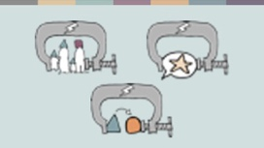 | iSudjka ks¾udKh l< yels ;j;a kS;s j¾. 2 la ms<sn|j wms idlÉPd lruq( tAjd kï" mjq,a kS;sh iy foajdmydi kS;sh fyda wd.u w;ayer ±ófï kS;sh hs'  mjq,a kS;sh  újdyh" Èlalidoh" Wreuh iy <uhskaf.a Ndrldr;ajh md,kh flfrk idudkH kS;s yd wd.ñl kS;s hk folu whs;sjdislï iSud lsÍug iy fjkia fldg ie,lSug fya;= úh yelshs'
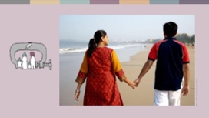 | bkaÈhdfõ" wd.ï follg wh;a hqj<la újdy ùfï§ újdyhg Èk ;sylg fmr ufyaia;%d;ajrfhl=g oekqï Èh hq;= hehs ftysl úfYaI újdy mk; u.ska kshu lr ;sfnkjd' ufyaia;%d;ajrhd whÿïm; úu¾Ykh lr hqj<f.a mjq,a fj; oekaùula hjhs' fuh" fndfyda hqj,a .re;ajh mokï lr.;a m%pKav;ajfha wjodkug ,la lrhs'
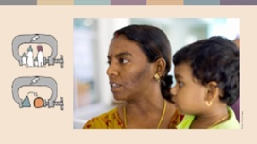 | f¾j;S ufidafihs uef,aishdkq cd;sl ldka;djla' weh uqia,sï fouõmshkag odj Wm; ,enqj;a wehf.a yskaÿ ñ;a;Ksh úiska wehj yskaÿ Nla;slfhl= f,ihs we;s oeä lf<a' yskaÿ Nla;slfhl= újdy lrf.k kej; bia,dï wd.ug meñŒu m%;slafIam lsÍu ksid wd.ñl wêlrKhla wehj udi 6 l ld,hla i|yd bia,dóh kej;-wOHdmk uOHia:dkhlg hjd ;sfnkjd'
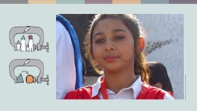 | wd.ñl mjq,a kS;sh iy wd.u yer±ófï kS;s iuyr úgl iq¿;r lKavdhï idmrdë m%ydrhkag f.dÿre ùfï wjodkug m;a lrkjd'  iEu jirlu mdlsia;dkfha yskaÿ yd l%sia;shdks .eyeKq <uhska ish .Kkla meyer .ekSug iy n,y;aldrfhka wd.ug yerùug yd újdy lsÍug uqyqK fokjd' jhi wjqreÿ 14 § uhsrd Idndiag fuh isÿjQjd' wehf.a fouõmshka wehj wdmiq ,nd .ekSu i|yd wêlrKhg .sh kuq;a bia,dï wd.fuka bj;aùu mlsia;dkfha ;ykï lr we;s ksid;a uqia,sï orejka l%sia;shdks fouõmshka Ndrfha ;nd .; fkdyels ksid;a wehj meyer.;a ;eke;a;dg u wdmiq Ndr Èh hq;= hehs uydêlrKh ;SrKh l<d' i;s follg miq uhsrd mek .shd' weh ±ka ieÕù Ôj;a fjñka wehf.a újdyh wj,x.= lr .ekSug;a" wehf.a ffk;sl ;;a;ajh ls%ia;shdks f,i kej; fjkia lr .ekSug;a igka jÈñka isákjd'
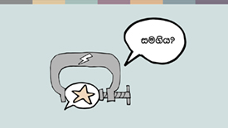 | foajdmydi kS;sh iy wd.u yer±ófï kS;s  foajdmydih ms<sn| iy wd.u yer±óu ^;u wd.fuka bj;aùu& ms<sn| kS;s fndfyda úg idOdrŒlrKh lrkq ,nkafka iu.sh mj;ajd .ekSug wod<jhs' flfia fj;;a" tu kS;s u.ska thg m%;súreoaO n,mEu o we;s úh yelshs' iuyr rgj, mqoa.,sl m,s.ekSï i|yd idjoH fpdaokd bÈßm;a lrñka kS;s wjNdú;d lrkjd' kuq;a kS;s u.ska fndfyda úg wd.u weoySfï fyda úYajdi ±Ífï ksoyig – úfYaIfhka u rch fyda nyq;r m%cdj wlue;s úYajdi we;s mqoa.,hskaf.a tu ksoyig – ydks jk whqßka l:kh iy yeisÍu iSud lrkjd'  uqyïuoa;=udf.ka miq j we;s jQ Ydia;Djrfhl= ms<sn| úYajdi lrk wyuosjreka" wfoajjd§ka iy rch fyda wd.ñl n,h orkakkaj úfõpkh lrk mqoa.,hska fndfyda úg wjodkug ,lajk kuq;a ´kEu flfkl= fï wdldrfhka mSvdjg m;ajkakg bv ;sfnkjd'
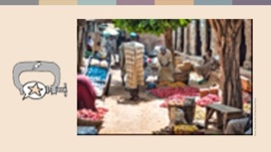 | 2020 j¾Ifha §" W;=re khsÔßhdfõ wd.ñl wêlrKhla kì;=udg wmydi lsÍfï fpdaokdj u; 12 yeúßÈ uqia,sï msßñ <ufhl=g jir 10 l isr o`vqjula kshu l<d' Tyqj jrolre lrñka ,nd ÿka ;Skaÿj 2021 § wd.ñl fkdjk wNshdpkdêlrKhla úiska wj,x.= l< kuq;a" m<s.ekSfï m%ydr fya;=fjka Tyqf.a mjqf,a whg tu m%foaYfha Ôj;a ùu wkdrlaIs; ù ;sfnkjd'
 | cd;Hka;r kS;shg wkqj" ;ykï l< hq;= l:kh jkafka m%pKav;ajh Wis.ekaùuhs' tfy;a" m%pKav;ajh kj;ajkjd fjkqjg" nyq;rhla fokd wlue;s úYajdi iduldój m%ldY lrk mqoa.,hskag o`vqjï ,nd Èh hq;=h hk woyig iydh oelaùu ;=<ska foajdmydi iy wd.u yerhdfï kS;s u.ska m%pKav;ajh Èßu;a lsÍfï keUqrejla ;sfnkjd'
rcfha wëlaIKh iy md,kh
rdcHh úiska wd.ñl m%cdjkaf.a l%shdldrlï iy uQ,H lghq;= mÍlaId lsÍu" wëlaIKh lsÍu iy md,kh lsÍu rdcH l%shdldrlï yryd iSud lsÍï ks¾udKh lrk ;j;a me;slvla jkjd' WodyrKhla yeáhg" Y%S ,xldfõ iuyr foajia:dk" n,OdÍka f.a wëlaIKhg ,la jk nj tu foajia:dk jd¾;d lr ;sfnkjd' fuh isú,a iudc wjldYh yels,Sfï mq¿,a m%jK;djhl fldgila'
ngysr Ökfha isÿ flfrk fidaÈis lsÍï wka ljr ia:dkhlg;a jvd w;sYh ±ä hs' uqia,sï Whs.¾ iq¿;r m%cdfjys idudðlhska y÷kd f.k Tjqka isák ia:dk fmd,Sishg oekqï §ug wdrlaIl leurdj,g yels jk mßÈ uqyqKq y÷kd .ekSfï ;dlaIKh trfÜ jeä jYfhka fhdod f.k ;sfnkjd'

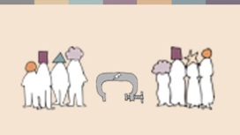 | iudcuh iSud lsÍï  mjq,a" wd.ñl lKavdhï fyda mq¿,a m%cdj ;=< o whs;sjdislï iSud lsÍï isÿ úh yelshs' fuh fndfyda úg mqreIhskag yd ldka;djkag n,mdkafka fjkia wdldrhlghs' ldka;djkag fndfyda úg úúO wjia:d" WodyrKhla f,i foajO¾uh yeoEÍfï wjia:dj jeks wjia:d" wysñ fjkjd' ldka;djkaf.a yeisÍu iy wd.u ms<sme§ï wd.ñl fya;=ka u; mjqf,a fyda m%cdfõ md,khg k;= úh yelshs'  nyq;r iudc fndfyda úg iq¿;r ldka;djkaf.a wd.ñl m%ldYkh o" WodyrKhla yeáhg /lshd ,nd .ekSu i|yd ldka;jkaf.a wd.ñl wkkH;djh ieÕùug Tjqkag n,mEï lsÍu jeks wdldr j,ska" iSud lrkjd'
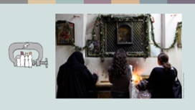 | uhsrd Bðma;=fõ Ôj;a jk l%sia;shdks ;reKshla' weh úYajúoHd,fhka Wmdêh ,nd .;a úg wehg nexl=jl /lshdjla mßkukq ,enqjd' kuq;a weh tu /lshdj Ndr .kafka kï weh yscdnhla me<¢h hq;= nj wehg ±kqï ÿkakd' fjk;a wd.ñl wkkH;djhla we;s nj ujd mEu idOdrK fkdjk nj uhsrd is;+ ksid weh tu /lshdj Ndr .ekSu m%;slafIam l<d'
 | m%pKav;ajh ms<sn| l;kaor
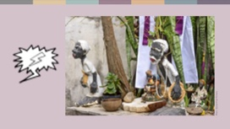 | wms ±ka m%pKav;ajh .ek wjOdkh fhduq lruq' m%pKav;ajfha jvd;a iq,Nj w;a±lSug ,efnk iajrEm w;rg ffjÍ l:dj iy ffjÍ wmrdO we;=<;a fjkjd' jkaokd lrk ia:dk iy tajdg iyNd.S jk mqoa.,hska úfYaIfhka u ffjÍ wmrdOj,g f.dÿreùfï wjodkug uqyqK fokjd'  n%iS,fha idïm%odhsl wm%sldkq-n%iS,shdkq wd.ï woyk msßia" Tjqkaf.a wd.u hlaI wd.ula hehs i,lk kj fmka;fldia; l%sia;shdks wi,ajeishkaf.a m%pKav m%ydrhkag uqyqK fokjd' lekafvdïíf,a wd.fï mQclfhl= jk ud¾isfhda msh;=ud ;u foajia:dkhg isÿjQ myr§ï 20 g wêl ixLHdjla jd¾;d lr ;sfnkjd' kuq;a fmd,sish lsisÿ l%shdud¾.hla f.k keye'
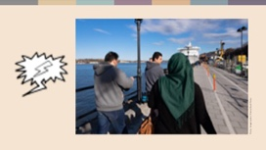 | kej; jrla" ldka;djka iy msßñka fjkia wdldrhlska mSvdjg m;aùfï m%jK;djla ;sfnkjd'  iaùvkfha uqia,sï ldka;djkag" úfYaIfhka yscdí jeks wd.ñl we÷ï w¢k ldka;djkag" m%isoaO ia:dkj,§ wd.ka;=lhska úiska isÿlrkq ,nk ffjÍ wmrdOj,g uqyqK §ug isÿ ùfï jeä wjodkula ;sfnk w;r" uqia,sï msßñka wi,ajeishka fyda i.hka úiska isÿ lrkq ,nk ffjÍ wmrdOj,g f.dÿre ùfï jeä wjodkula ;sfnkjd'
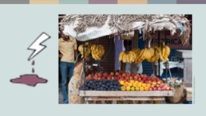 | fndfyda ia:dkj," fldfrdakd ffjria jix.;h u.ska fjkialï lsÍfï rgdjka yd ffjrfha mj;sk rgdjka Yla;su;a lr ;sfnkjd' uqia,sï wd.ñl W;aijhlska miqj ffjrih mq¿,aj me;sÍula isÿùu ksid fldfrdakd ðydvhla isÿ l< njg bkaÈhdfõ uqia,sïjrekag fpdaokd t,a, jqKd' wyuâ Idhsla hkq ;u Ôjfkdamdh ißlr .ekSug fjr ork uqia,sï ùÈ fjf<kafola' 2020 wfm%a,a udifha § yskaÿ cd;sljd§ l,a,shla uqia,sïjreka fldfrdakd me;srùug l=uka;%Kh lrk njg fpdaokd lrñka Tyqf.a fj<| l=áh .,jd f.k msgj hk f,ig Tyqg ±kqï ÿkakd' wyuâ Tjqkag wdhdpkh l< kuq;a Tjqka Tyqg uq.=rej,ska ;Èka myr ÿkakd' wyuâ fmd,sishg meñ‚,a,la bÈßm;a lsÍug W;aidy l<;a ùÈ fj<|du kS;s úfrdaë hehs mjiñka fmd,sish meñKs,a, Ndr.ekSu m%;slafIam l<d'
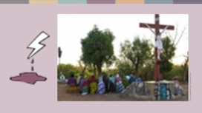 | m%cdj ;=< mj;sk W,a,x>khùï j, jvd;a oreKq;u iajrEmh jkafka cd;sjd§ m%pKav;ajh iy NSIKhhs'  ieuqfj,a foaj.e;s;=ud W;=re nq¾lskd *dfida rfgys wfhla' trg mj;sk wd.ñl bjiSfï iïm%odhg oeka ;%ia; lKavdhï ydkslrñka isákjd' 2019 j¾Ifha § m,a,sj,g myr §u Tjqkaf.a Wmdh ud¾.fha fldgila njg m;ajqKd' ieuqfj,a foaj.e;s;=ud oeka wNHka;rj wj;eka jQjka i|yd jk l|jqrlhs Ôj;a fjkafka'  —fï m%ydr wfma ck;djf.a Ôú; iqkqúiqkq lr oud ;sfnkjd' wms fõokdfjka msÍ,d bkafka'˜ foaj.e;s;=ud lshkjd'  iEu flfkl=gu n,mEï we;s lrñka 2019 isg ;%ia; m%ydr W;aikak ù ;sfnkjd' ñ,shkhlg wêl ck;djla wj;ekaj isákjd'

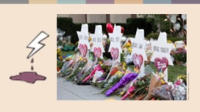 | bia,dï oyu iu. iïnkaO;d we;s ;%ia; lKavdhï f.da,Sh ixLHdf,aLkj, by<skau isák kuq;a" wfkla lKavdhï úiska thg;a jvd úYd, ;¾ckhla t,a, lrkq ,nk fndfyda cd;sl miqìï o ;sfnkjd'  we;eï ngysr rgj, wdrlaIl fiajd" Tjqkag we;s úYd,; u wNHka;r ;%ia; ;¾ckh f,i i,lkafka iqÿ cd;sl wêfY%aIaG;ajjdoSka iy wka; olaIskdxYsl wka;jd§kajhs' fudjqka" iq¿;r lKavdhï b,lal lrkjd' 2018 § weußld tlai;a ckmofha msÜian¾.a kqjr m,a,shl oS tfldf<dia fofkla urd ouk ,o w;r kjiS,ka;fha l%hsiaÜp¾É kqjr m,a,shl § mqoa.,hska 51 fofkla >d;kh lrkq ,enqjd'
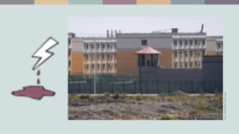 | fmd,Sish" wdrlaIl fiajd fyda yuqodj fyda rch úiska l=,shg .;a uerhka úiska isÿlrkq ,nk m%pKav;ajhg mqoa.,hska fyda iuia; m%cdj u b,lal úh yelshs' rcfha m%pKav;ajh fl;rï oreKq úh yelso hkak ngysr Ökfha Whs.¾jrekaf.a ;;ajh u.ska fmkakqï flfrkjd' Whs.¾ ldka;djka n,y;aldrfhka jkaOHdlrKhg iy .eí.ekSu j<lajkq ,eîug uqyqK § we;s w;r tys m%;sM,hla f,i Wm;a wkqmd;h úYd, jYfhka my; jeà ;sfnkjd' yscdnhla we£u fyda /jq, jeùu jeks fya;= ksid Whs.¾jreka ñ,shk 1'8 la muK fokd kej; wOHdmkh ,ndfok l|jqrej,g hjd ;sfnkjd' fuu l|jqrej,ska jOysxid meñKùï iy ia;%S ¥IK jd¾;d jk w;r" tys§ /|úhkag Tjqkaf.a NdIdj iy wd.u wysñ lr rdcH u;jdoh m%.=K lrjkq ,nkjd' Ök rch lshd isákafka fuu l|jqre iafõÉPd wOHdmk uOHia:dk njhs'
 | rcfha j.lSï iy wiu¾:ùï
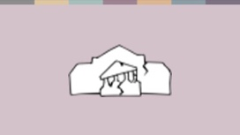 | ñksiqka wdrlaId lsÍug rch wiu;a ùu ms<sn|j wms wjidk jYfhka i,ld n,uq' rchhkag udkj ysñlï wdrlaId lsÍfï j.lSula ;sfnkjd' rchhka tfia lsÍug wfmdfydi;a jk úg" fjkia fldg ie,lSu iy m%pKav;ajh by< hkjd' ;ks isoaëkays § M,odhS f,i fmd,sia l%shdud¾. .ekSu W,a,x>khùï keje;aùug WmldÍ fjkjd'
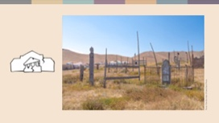 | bia,dï wd.fï isg l%sia;shdks wd.ug yereKq ol=Kq ls¾.sia;dkfha uy¨‍ ldka;djla 2017 j¾Ifha § ñh .shd' wehf.a Èh‚h wehj kd.ßl iqidk N+ñfha N+uodk lsÍug W;aidy l< úg tu m%foaYfha budï;=udf.a kdhl;ajfhka hq;a lKavdhula thg ±ä f,i f,i úfrdaOh oelajQjd' fï ms<sn|j fhduq jQ uyck wjOdkh fya;=fjka n,OdÍka m%;spdr olajk f;la u" j,oeuQ isrer kej; kej;;a ydrd f.dvf.k ;sfnkjd' th isÿ l< jerÈlrejkag tfrysj kvq mjrkq ,enQ w;r" bka miqj" fjk;a wd.ulg yereKq mqoa.,hskag tfrys /äl,a y`v o jeä ù ;sfnkjd'
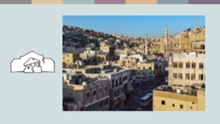 | mjq,a fyda wd.ñl m%cdjka we;=<; isÿjk W,a,x>khùï iïnkaOfhka ueÈy;aùug n,OdÍka fndfyda úg wfmdfydi;a fõ' fcda¾odkfha 22 yeúßÈ l%sia;shdks úYajúoHd, YsIHdjla jk kdÈhd uqia,sïjrfhl= jk wehf.a ñ;=re YsIHfhl= iu. wdorfhka ne÷kdh' wehf.a mjqf,a wh ta nj oek.;a úg" Tjqka wehg ksjiska msgùug bv fkd§ wehg jO ysxid l<d' kdÈhdg ksjfika m,d hdug yels jQ kuq;a udi follg miq wef.a mshd wehj fidhdf.k wehj urd oeuqjd' z.re;ajhZ mokï lr.;a fÉ;kdfjka Tyq fuu l%shdj isÿ l< nj ie,l+ wêlrKh Tyqj isrf.g heõfõ ke;'

 | iudma;sh
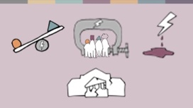 | fuu bÈßm;a lsÍu ;=< wms wdKavq iy m%cdfõ mqoa.,hska úiska lrkq ,nk fjkialï lsÍï" iSud lsÍï iy m%pKav;ajh ms<sn|j fidhd ne¨‍jd' tfuka u" ñksiqka wdrlaId lsÍug rchhka wfmdfydi;a ùu ms<sn|j o wms fidhd ne¨‍jd'  wms ijka ÿka l;d j,ska wmsg ks.uk lsysmhlg t<ôh yelshs(
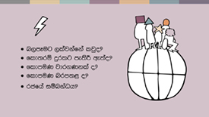 | - iEu j¾.hl u rgj, W,a,x>khùï isÿjk w;r th ish¨‍ wd.ïj,g iy úYajdihkag wh;a mqoa.,hskag n,mdhs' fjkia jkafka n,mEug ,laj we;af;a ljqrekao iy W,a,x>khùï fl;rï mq¿,aj me;sr ;sfío" fl;rï ksr;=rej isÿjkafkao yd fl;rï nrm;, o hkakhs'
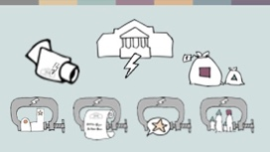 | - úúO wdldrfha kS;s iy rcfha m%;sm;a;s fuu W,a,x>khùï j,g odhl úh yelshs'
 | - idudkHfhka" nyq;rhka ;=< isák" fjkia f,i is;k wh iy iq¿;r lKavdhï jvd;a oeä f,i n,mEug ,lafjkjd' tfy;a nyq;r m%cdjka o" úfYaIfhka NSIK m%pKav;ajfhka" W,a,x>khùï j, n,mEug ,lafjkjd'
 | - wd.u weoySfï fyda úYajdi oeÍfï ksoyi W,a,x>khùï j,g wfkl=;a whs;sjdislï W,a,x>khùï o – WodyrKhla f,i" wOHdmkh ,eîu" újdy ùu iy cSj;a ùu i|yd we;s whs;Ska jeks whs;sjdislï W,a,x>khùï o we;=<;a jk nj wms ijka ÿka l;kaor j,ska meyeos,s fjkjd' msßñka iy ldka;djka ffjÍ wmrdOj, isg" n,y;aldrfhka újdy lsÍu" .re;ajh wdrlaId lr .ekSu i|yd >d;kh lsÍu iy n,y;aldrfhka jkaOHdlrKh lsÍu olajd jQ fl;rï úúO jQ wdldr j,ska n,mEug ,lajkafkao hkak fuu l;d fndfyduhlska fmkakqï flfrkjd'
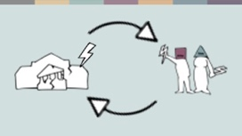 | - ;jo" m%cdj ;=< isÿjk W,a,x>khùï" rcfha wfmdfydi;aùï iy rcfha W,a,x>kh lsÍï úIu pl%hla ks¾udKh lrñka tlsfkl Yla;su;a lrk wdldrh wm ijka ÿka l;kaor .Kkdjlska meyeÈ,s fjkjd'
wd.u weoySfï fyda úYajdi ±Ífï ksoyi W,a,x>khùï isÿùu idudkH ckhdg úYd, jYfhka mqoa.,sl mSvd f.k §ug fya;= fjkjd' tfuka u tajd iudch wia:djr lrkjd' wjidkfha §" iEu flfkl= u wkdrlaIs;Ndjfhka iy wd¾Ól yd iudchSh n,mEfuka mSvd ú¢kjd'
wm ljqreka o hkak fyda wm l=uk wd.ñl m%cdjlg wh;a o hkak fkdi,ld" wfma rfÜ ish¨‍ ñksiqkaf.a wd.u weoySfï fyda úYajdi ±Ífï ksoyig .re lsÍu u.ska wmg fndfyda foa ,nd .; yelshs' wm ish¨‍ fokdgu fjk;a rgj, iq¿ cd;Ska f,i Ôj;ajk iy tu rgj, § iudk whs;sjdislï ,efnk nj ±lSug ±ä f,i wjYHj isák wmf.a ifydaor wd.ñlhska isákjd' iEu ;ekl u isák iEu wfhl=g u iudk whs;sjdislï ,nd §u u.ska wms ish¨ fokdg u wdrlaIs; f,dalhla ks¾udKh fõú'

m%dfoaYSh uQ,dY%
o .d¾ähka, https://www.theguardian.com/world/2013/feb/27/bahai-student-expelled-iranian-university
f*darï 18" https://www.forum18.org/archive.php?article_id=2508
t'c' rdcH fomd¾;fïka;=j" https://www.state.gov/reports/2020-report-on-international-religious-freedom/algeria/
f*darï 18" https://www.forum18.org/archive.php?article_id=2555
o ,S*a,Ü, https://www.theleaflet.in/india-needs-to-overhaul-laws-on-interfaith-marriage-and-religious-conversion/
f*darï taishd" https://www.forum-asia.org/?p=7086
tlai;a rdcOdksfha md¾,sfïka;=j" https://edm.parliament.uk/early-day-motion/57474/maira-shahbaz-and-child-abduction-forced-conversion-and-marriage-in-pakistan
î'î'iS' mqj;a" https://www.bbc.com/news/world-africa-55756834
m%dfoaYSh uQ,dY%
ksõfhda¾la ghsïia, https://www.nytimes.com/2019/04/14/technology/china-surveillance-artificial-intelligence-racial-profiling.html
uQ,dY%h( udßhd" wdrlaIl fya;+ka u; wehf.a ku fjkia lr we;'
RioOnWatch, https://rioonwatch.org/?p=40117
wmrdO je<elaùu i|yd jk iaúÜi¾,ka; cd;sl iNdj" https://www.bra.se/om-bra/nytt-fran-bra/arkiv/press/2021-03-31-islamofobiska-hatbrott-yttrar-sig-i-manga-olika-former.html
ií?ka.a bkaoshd" https://sabrangindia.in/article/stop-targeting-discriminating-against-and-attacking-vendors-and-hawkers-national-hawker
´mka fvd¾ia" tlai;a rdcOdksh" https://www.opendoorsuk.org/persecution/world-watch-list/burkina-faso
tlai;a ckmo fldka.%ih" https://www.congress.gov/116/bills/s894/BILLS-116s894is.xml
o .dähka" https://www.theguardian.com/world/2020/sep/04/muslim-minority-teacher-50-tells-of-forced-sterilisation-in-xinjiang-china
f*darï 18" https://www.forum18.org/archive.php?article_id=2248
m%dfoaYSh uQ,dY%

