mku;T 4
kjk; my;yJ ek;gpf;iff;fhd Rje;jpuj;jpd; kPwy;fsÊ

Kd;itg;GfËfhd vOj;Jg;gpujp

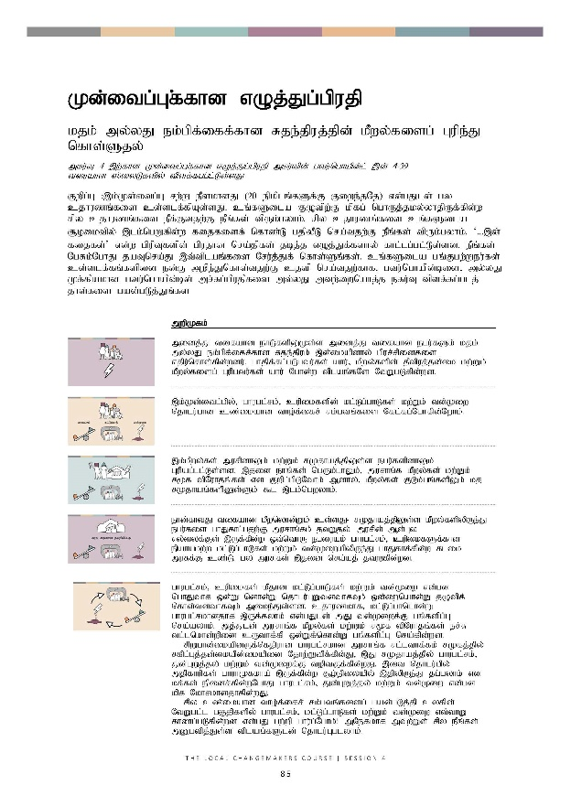
Kd;itg;GfËfhd vOj;Jg;gpujp
kjk; my;yJ ek;gpf;iff;fhd Rje;jpuj;jpd; kPwy;fisg; Gupe;J nfhs;Sjy;
mkuÊT 4 ,wÊfhd Kd;itg;GfËfhd vOjÊJgÊgpujp mkuÊtpdÊÊ gtuÊnghapdÊlÊ ,dÊ 4-39 tiuahd ]ÊiyLfspyÊ tpsfÊfggÊlÊLsÊsJ.

Fwpg;G :,k;Kd;itg;G rw;W ePskhdJ (20 epkplq;fSf;F Fiwe;jNj) vd;gJld; gy cjhuzq;fis cs;slf;fpAs;sJ. cq;fSila FOtpw;F kpfg; nghUj;jky;yhjpUf;fpd;w rpy cjhuzq;fis ePf;Ftjw;F ePq;fs; tpUk;gyhk;. rpy cjhuzq;fis cq;fSila #oiktpy; ,lk;ngWfpd;w fijfisf; nfhz;L gjpyPL nra;tjw;F ePq;fs; tpUk;gyhk;. ‘...,d; fijfs;’ vd;w gpupTfspd; gpujhd nra;jpfs; jbj;j vOj;Jf;fshy; fhl;lg;gl;Ls;sd. ePq;fs; NgRk;NghJ jaTnra;J ,t;tplaq;fis Nru;j;Jf; nfhs;Sq;fs;. cq;fSila gq;Fgw;Weu;fs; cs;slf;fq;fspid ed;F mwpe;Jnfhs;tjw;F cjtp nra;tjw;fhf> gtu;nghapd;bid> myÊyJ KfÊfpakhd gtu;nghapd;bd; mr;Rg;gpujpfis my;yJ mtw;iwnahj;j efu;T tpsf;fg;glj; jhs;fis gad;gLj;Jq;fs.

 | mwpKfk;
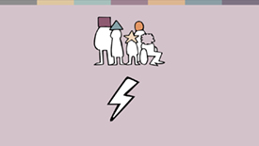 | midj;J tifahd ehLfspYKs;s midj;J tifahd egu;fSk; kjk; my;yJ ek;gpf;iff;fhd Rje;jpuk; ,d;ikapdhy; gpur;rpidfis vjpu;nfhs;fpd;wdu;. ghjpf;fg;gLgtu;fs; ahu;> kPwy;fspd; jPtpuj;jd;ik kw;Wk; kPwy;fisg; Gupgtu;fs; ahu; Nghd;w tplaq;fNs NtWgLfpd;wd.
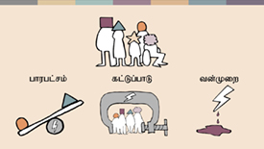 | ,k;Kd;itg;gpy;> ghugl;rk;> cupikfspd; kl;Lg;ghLfs; kw;Wk; td;Kiw njhlu;ghd cz;ikahd tho;f;ifr; rk;gtq;fis Nfl;fg;Nghfpd;Nwhk;.
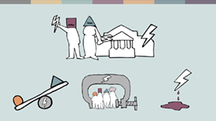 | ,k;kPwy;fs; murpdhYk; kw;Wk; rKjhaj;jpYs;s egu;fspdhYk; Gupag;gl;Ls;sd. ,jid ehq;fs; ngUk;ghYk;> murhq;f kPwy;fs; kw;Wk; r%f tpNuhjq;fs; vd Fwpg;gpLNthk; Mdhy;> kPwy;fs; FLk;gq;fspYk; kj rKjhaq;fspDs;Sk; $l ,lk;ngwyhk;.
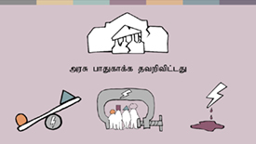 | ehd;fhtJ tifahd kPwnyhd;Wk; cs;sJ- rKjhaj;jpYs;s kPwy;fspypUe;J egu;fis ghJfhg;gjw;F murhq;fk; jtWjy;. murpd; Ms;Gy vy;iyf;Fs; ,Uf;fpd;w xt;nthU egiuAk; ghugl;rk;> cupikfSf;fhd epahakw;w kl;Lg;ghLfs; kw;Wk; td;KiwapypUe;J ghJfhf;fpd;w flik muRf;F cz;L. gy muRfs; ,jid nra;aj; jtWfpd;wd.
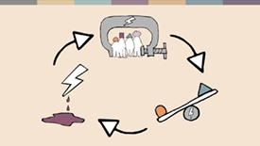 | ghugl;rk;> cupikfs; kPjhd kl;Lg;ghLfs; kw;Wk; td;Kiw vd;gd nghJthf xd;Wlndhd;W njhlu;GWtdthfTk; xd;iwnahd;W jOtpf; nfhs;tdthfTk; mike;Js;sd. cjhuzkhf> kl;Lg;ghnlhd;W ghugl;rkhdjhf ,Uf;fyhk; vd;gJld; mJ td;Kiwf;F gq;fspg;G nra;ayhk;. mj;Jld; murhq;f kPwy;fs; kw;Wk; r%f tpNuhjq;fs; er;R tl;lnkhd;wpid cUthf;fp xd;Wf;nfhd;W gq;fspg;G nra;fpd;wd.  rpWghd;ikapdUf;nfjpuhd ghugl;rkhd murhq;f rl;lthf;fk; r%fj;jpy; rfpg;Gj;jd;ikapd;ikapid NjhwÊWtpfÊfpdÊJ> ,J rKjhaj;jpy; ghugl;rk;> Jd;GWj;jy; kw;Wk; td;Kiwf;F toptFf;fpd;wJ. ,it njhlu;gpy; mjpfhupfs; ghuhKfkha; ,Uf;fpdÊw #oÊepiyapyÊ ,jpypUe;J jgÊgyhkÊ vd kf;fs; epidfÊfpd;wNghJ ghugl;rk;> Jd;GWj;jy; kw;Wk; td;Kiw vd;gd kpf Nkhrkhdjhfpd;wJ.  rpy cz;ikahd tho;f;ifr; rk;gtq;fisg; gad;gLj;jp cyfpd; NtWgl;l gFjpfspy; ghugl;rk;> kl;Lg;ghLfs; kw;Wk; td;Kiw vt;thW fhzg;gLfpd;wd vd;gJ gw;wp ghu;g;Nghk;! mNefkhf mtw;Ws; rpy ePq;fs; mDgtpj;Js;s tplaq;fSld; njhlu;Gglyhk;.
 | ghugl;rj;jpid vLj;Jf;fhl;Lfpd;w fijfs;
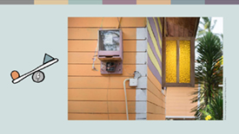 | ghugl;rk; kpfg; nghJthdJ vd;gJld; ,J tho;f;ifapd; midj;;Jg; gFjpfisAk; ghjpf;fpd;wJ.  mUlÊjpU.Fkhu; ,yq;ifapd; fpuhknkhdÊwpdÊ xU Nghjfu; Mthu;. mtUila FLk;gk; mtuJ fpuhkj;jpypUe;j ngsj;j ngUk;ghd;ik rKjhaj;jpdhy; ghugl;rj;jpid vjpu;nfhz;bUe;jJ. Mrpupau;fs; kw;Wk; rfghbfs; mtupd; gps;isfis Jd;GWj;jpdu; vd;gJld; mtupd; tPL rl;ltpNuhj topghl;Lj; jynkhd;W vd;w mbg;gilapy; mf;FLk;gj;jpw;fhd kpd;rhu kw;Wk; ePu; ,izg;Gf;fs; Jz;bf;fg;gl;ld.
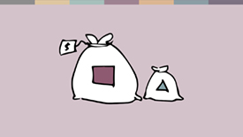 | rpy murhq;fq;fs; nghJ epjpapd; xJf;fPl;by; ghugl;rk; fhl;Lfpd;wJ - cjhuzkhf> rpWghd;ik gFjpfspy; cl;fl;likg;G> Rfhjhuk; my;yJ fy;tpf;fhf kpff; Fiwe;j mstpy; KjyPL nra;jy;. ,J tFg;Gthj Fog;gq;fs; kw;Wk; murpay; ];jpuj;jd;ikapd;ikf;fhd ePz;l fhy mghaq;fis cUthf;Fk;.  epWtdq;fs; njhopw;gLfpd;w topKiwapD}lhfTk; ghugl;rk; Vw;gLj;jg;glyhk;. cjhuzkhf> kj nraw;ghLfspy; gyte;jkhfg; gq;Fngwr; nra;jy; my;yJ jq;fSila rKjhaj;jpid ,opthfg; NgRfpd;w ghlE}y;fs; vd;gtw;wpD}lhf ghlrhiy rpWtu;fs; ghugl;rj;jpid vjpu;nfhs;s KbAk;. mupjhd rpy re;ju;g;gq;fspy;> rpy FOf;fSf;F fy;tp kWf;fg;gLfpd;wJ- <uhdpy; Baha’is rKjhaj;jpdu; gy;fiyf;fofq;fSf;F nry;tjw;F mDkjpf;fg;gLtjpy;iy.
 | kl;Lg;gLj;jy; kw;Wk; ghugl;rj;jpid vLj;Jf;fhl;Lfpd;w fijfs;
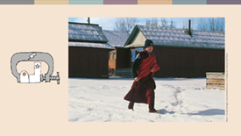 | gy tifahd rl;lq;fs; NeubahfNth my;yJ kiwKfNth ghugl;rj;jpw;F toptFf;fpd;w kl;Lg;ghLfis cUthf;Ffpd;wd. eLepiyahdjhfj; Njhd;wf;$ba jpl;lkply; xOq;Ftpjpfs;> kj topghl;blq;fisf; fl;LtjpypUe;J rpWghd;ikapdiuj; jLf;fpd;w nghJthd jilnahd;whf cs;sJ.  u~;ahtpy; gy;NtWgl;l rpWghd;ikapdu; rpf;fy;fis vjpu;nfhz;Ls;sdu;- cjhuzkhf> mDkjp toq;fg;gLtjpy;iy> fl;Lkhdg; gzpfs; Muk;gpf;fg;gl;lTld; my;yJ jfu;g;gl;lTld; efurig Fj;jiffs; KbTWj;jg;glyÊ.
 | kj rKjhaq;fspd; gjptpid MSif nra;fpd;w rl;lq;fSk; kl;Lg;ghLfisAiladthf kw;Wk; ghugl;rkhditahf ,Uf;fyhk;. my;[Pupad; murhq;fkhdJ kjk; my;yJ NtWtifahd midj;J FOf;fSk; jq;fsJ nraw;ghLfis nra;a Muk;gpg;gjw;F Kd;du; rq;fnkhd;whfg; gjpT nra;a Ntz;Lnkdj; Njitg;gLj;Jfpd;wJ. m`kjp vd;w rpwpanjhU rKjhaj;jpw;F gjpT mspf;fg;gltpy;iy. 2020 Mk; Mz;bd; Kbtpy;> ,r; rKjha cWg;gpdu;fSf;F vjpuhf> mjpfhukspf;fg;glhj ,lq;fspy; gpuhu;j;jidfis elj;Jjy; Nghd;w Fw;wq;fs; njhlu;ghf 220 rl;l tof;Ffs; gjpT nra;ag;gl;bUe;jd.
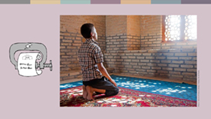 | rpy murhq;fq;fs; ngUk;ghd;ik rKjhaq;fspd; kj eilKiwfisAk; kl;Lg;gLj;Jfpd;wd. 2020 ,y;> JuÊfÊnkdp]ÊjhdÊ ,d; nyggÊ gpuhe;jpaj;jpYs;s mjpfhupfs;> Mrpupau;fs; kw;Wk; jhjpfs; Nghd;w mur Copau;fs; nts;spf;fpoik gpuhu;j;jidfspy; fye;J nfhs;sf;$lhJ vdf; fl;lisapl;lNjhL> mt;thW mtu;fs; me;ehl;fspy; gs;spthry;fspy; fhzg;gl;lhy; mtu;fis gzp ePf;fk; nra;tjhfTk; mr;RWj;jpdu;.
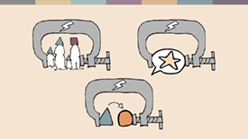 | kl;Lg;ghLfis cUthf;ff;$ba ,d;Dk; ,uz;L tifahd rl;lq;fs; gw;wp ehk; rpe;jpg;Nghk;: FLk;g rl;lk; kw;Wk; ,iw epe;jid my;yJ kj vjpu;g;G rl;lq;fs;.  FLk;g rl;lk;  jpUkzk;> tpthfuj;J> topAupik kw;Wk; gps;isapd; ghJfhty; Nghd;w tplaq;fis MSif nra;fpd;w kjrhu;gw;w kw;Wk; kj rl;lq;fs; cupikfis kl;Lg;gLj;JtJld; ghugl;rg;gLj;Jfpd;wd.
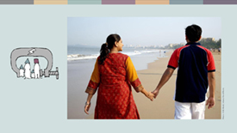 | ,e;jpahtpYs;s> kjrhu;gw;w tpNrl jpUkz rl;lkhdJ NtWgl;l kjq;fspypUe;J jpUkzk; nra;atpUf;fpd;w jpUkz N[hbfs; jq;fs; jpUkzj;jpw;F 30 ehl;fSf;F Kd;du; ePjthd; xUtUf;F mwptpj;jy; toq;f Ntz;Lk; vdj; Njitg;gLj;Jfpd;wJ. ePjthd; mt;tpz;zg;gk; njhlu;ghf tprhuiz nra;J mj;jpUkz N[hbfspd;; FLk;gq;fSf;F mwptpj;jnyhd;wpid mDg;Gthu;. ,J gy jpUkz N[hbfis nfsutj;jpid mbg;gilahff; nfhz;l td;Kiwapid vjpu;nfhs;fpd;w mghaj;jpw;F ,l;Lr; nry;fpd;wJ.
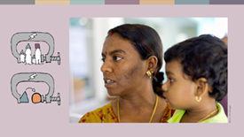 | Revathi Massosai xU kNyrpau;. mts; K];ypk; ngw;NwhUf;F gpwe;jNghjpYk;> jdJ ,e;J ghl;bapdhy; ,e;JnthUtuhfNt tsu;f;fg;gl;lhu;. Revathi ,e;J xUtiuj; jpUkzk; nra;jJld; ,];yhkpw;F kPz;Lk; tu kWj;jikapdhy;> kj ePjpkd;wnkhd;W mtiu MW khj fhyg;gFjpf;F ,];yhk; kPs;-fy;tp epiyaj;jpw;F mDg;gpaJ.
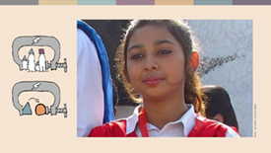 | rpyNeuq;fspy; kjrhu;Gs;s FLk;gr; rl;lk; kw;Wk; kj vjpu;g;G rl;lq;fs; ,yFtpy; ghjpf;fg;glj;jf;f rpWghd;ikapdiu Fw;wtpay; jhf;Fjy;fSf;Fk; Mshf;Ffpd;wd.  xt;nthU tUlKk;> ghfp];jhdpy; E}w;Wf;fzf;fhd ,e;J kw;Wk; fpwp];jt ngz; gps;isfs; flj;jy;> gyte;jkhd kjkhw;wk; kw;Wk; jpUkzj;jpid mDgtpf;fpd;wdu;. ,J> Maira Shahbaz 14 taJ gps;isahf ,Uf;Fk;NghJ mtSf;F ele;jJ. mtsJ ngw;Nwhu;fs; mtisj; jpUk;gg; ngw;Wf; nfhs;tjw;fhf ePjpkd;wj;jpw;F nrd;wdu;. Mdhy;> ,];yhk; kjj;jpid tpl;;L ePq;Fjy; ghfp];jhdpy; jil nra;ag;gl;Ls;sjhYk; fpwp];jt ngw;Nwhu;fs; K];ypk; gps;isnahd;Wf;fhd ghJfhtiyf; nfhz;bUf;f KbahJ vd;gjhYk;> Nky; ePjpkd;wkhdJ mtisf; flj;jpatuplNk mts; kPs nry;y Ntz;Lnkd;W jPu;g;gspj;jJ. ,uz;L thuq;fs; fopj;J Maira jg;gpj;Jtpl;lhs;. jw;NghJ mts; xspe;J tho;fpd;whs; vd;gJld; jd;Dila jpUkzj;jpid typjw;wjhf;fTk;> mtSila rl;l me;j];j;jpid kPz;Lk; fpwp];jtu; vd;w epiyf;F nfhz;L tUtjw;Fk; Nghuhb tUfpd;whs;.
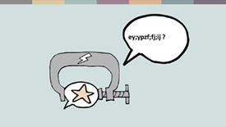 | ,iw epe;jid kw;Wk; kj vjpu;g;G rl;lq;fs;  ,iw epe;jid kw;Wk; kj vjpu;g;G njhlu;ghd rl;lq;fs; (cq;fSila kjj;jpid tpl;L tpyFjy;) ey;ypzf;fj;jpidg; NgZjiyf; fhuzkhf Rl;bf;fhl;b epahag;gLj;jg;gLfpd;wd. vt;thnwdpDk;> ,r;rl;lq;fs; vjpuhd tpisnthd;wpidf; nfhz;bUf;f KbAk;. rpy ehLfspy;> jdpg;gl;l gopthq;fy;fSf;fhf gad;gLj;jg;gLfpd;w ngha;ahd Fw;wr;Rkj;jy;fSld;> ,r;rl;lq;fs; KiwNflhfg; gad;gLj;jg;gLfpd;wd. Mdhy;> ,r;rl;lq;fs; kjk; my;yJ ek;gpf;iff;fhd Rje;jpuj;jpid - Fwpg;ghf> muR my;yJ ngUk;ghd;ik rKjhak; tpUk;ghj kf;fspd; ek;gpf;iffis - tpl;Lf;nfhLf;fpd;w tifapy; Ngr;R kw;Wk; elj;ij Kiwfis kl;Lg;gLj;Jfpd;wd.  m`kjp rKjhaj;jpdu;> nkh`k;kl; ,w;F gpd;du; egp kPJ ek;gpf;if nfhz;ltu;fs;> ehj;jpfu;fs; kw;Wk; muR my;yJ kj mjpfhuKila egu;fis tpku;rpg;gtu;fs; MfpNahu; ngUk;ghYk; Mgj;jpw;F cl;glf;$batu;fshf cs;shu;fs;> Mdhy; ve;jnthU egUk; ghjpf;fg;gl;ltuhf KbAk;.
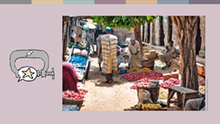 | 2020 ,y;> tl ie[PupahtpYs;s kj ePjpkd;wnkhd;W> egpnahUtiu mtkjpj;jjhf Fw;wk; rhl;lg;gl;l 12 tajhd K];ypk; Mz; gps;isnahUtUf;F 10 tUl rpiwjz;lid mspj;jJ. 2021 ,y; kjrhu;gw;w Nkd;KiwaPl;L ePjpkd;wj;jpdhy; mtuJ jz;lid khw;wg;gl;lJ> Mdhy; gopthq;Ftjw;fhdj; jhf;Fjy;fs; ,lk;ngwyhk; vd;w Mgj;J mtuJ FLk;gk; mg;gFjpapy; tho;tjid ghJfhg;gw;wjhf;fpaJ.
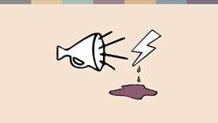 | ru;tNjr rl;lj;jpw;F mika> td;Kiwapidj; J}z;Lfpd;w Ngr;Rf;fNs jil nra;ag;gl Ntz;badthFk;. td;Kiwapid epWj;Jtjw;F gjpyhf> ,iw epe;jid kw;Wk; kj vjpu;g;G rl;lq;fs;> ngUk;ghd;ik kf;fSf;F gpbf;fhj ek;gpf;iffis mikjpahd Kiwapy; ntspg;gLj;Jfpd;w egu;fSk; jz;bf;fg;gl Ntz;Lk; vd;w fUj;jpid Mjupg;gjD}lhf td;Kiwapid Cf;Ftpf;fpd;wd.
mur fz;fhzpg;G kw;Wk; fl;Lg;ghL kl;Lg;ghLfis cUthf;;Ffpd;w kw;WnkhU mur nraw;ghL ahnjdpy;> kj rKjhaq;fspd; nraw;ghLfs; kw;Wk; epjp njhlu;ghd murhq;fj;jpd; Nkw;ghu;it> fz;fhzpg;G kw;Wk; fl;Lg;ghL MFk;. cjhuzkhf> ,yq;ifapYs;s rpy Njthyaq;fs; mur mjpfhupfshy; fz;fhzpf;fg;gLtjhf mwpf;ifapl;Ls;sd. ,J rptpy; r%f mikg;Gf;fs; nraw;gLtjw;F fhzg;gLfpd;w gug;gpid Fiwf;fpd;w gutyhd Nghf;fpd; gFjpnahd;whFk;.
NkwÊF rPdhtpidg; Nghy NtW ve;jnthU ,lj;jpYk; Nkw;ghu;it kpfj; jPtpukhf nraw;gLj;jg;gltpy;iy. ,q;F> ghJfhg;G fkuhf;fs; rpWghd;ik rKjha cWg;gpdu;fis milahsq; fz;L mtu;fs; ,Uf;fpd;w ,lk; njhlu;ghf nghyp]pw;F mwptpf;ff;$ba tifapy; Kfj;jpid milahsq; fhz;fpd;w njhopEl;gk; tpUj;jp nra;ag;gl;Ls;sJ.

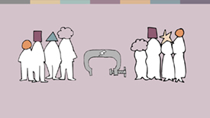 | r%f kl;Lg;ghLfs;  FLk;gq;fspy;> kj FOf;fspy; my;yJ gue;jsthd rKjhaj;jpYk; cupikfs; kl;Lg;gLj;jg;glyhk;. ,J ngUk;ghYk; Mz;fs; kw;Wk; ngz;fis NtWgl;l Kiwfspy; ghjpf;fpd;wJ. ngz;fSf;F ngUk;ghYk; tha;g;Gf;fs; kWf;fg;gLfpd;wd> cjhuzkhf> mtu;fs; ,iwapay; gbf;f KbahJ. mj;Jld; ngz;fspd; elj;ij kw;Wk; rka mDl;lhdk; vd;gd kj mbg;gilfspyhd FLk;g my;yJ rKjha fl;Lg;ghl;bw;F cl;gl;Lf; fhzg;gLfpd;wd.  ngUk;ghd;ik r%fq;fs; ngUk;ghYk; rpWghd;ik ngz;fspd; kj ntspg;gLj;jiy kl;Lg;gLj;Jfpd;wd> cjhuzkhf> njhopiyg; ngw;Wf;nfhs;Sk;nghUl;L jq;fSila kj milahsj;jpid kiwf;FkhW ngz;fSf;F mOj;jk; toq;FtjD}lhf.
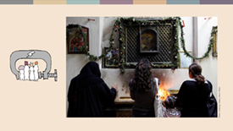 | Maria vfpg;jpy; tho;fpd;w ,sk; fpwp];jtu; Mthu;. mts; gy;fiyf;fofj;jpy; gl;lg;gbg;ig Kbj;jgpd;du;> mtSf;F tq;fpnahd;wpy; Ntiy fpilj;jJ> Mdhy; mt; Ntiyapid mts; ngw;Wf;nfhz;lhy; mts; `p[hg; mzpa Ntz;Lnkd nrhy;yg;gl;lJ. NtWgl;l kj milahsnkhd;wpidf; nfhz;bUg;gjhf ghrhq;F nra;jy; ePjpahdJ vd Maria fUjtpy;iy> MfNt> mts; mt;Ntiyiag; ngw;Wf;nfhs;stpy;iy.
 | td;Kiw njhlu;ghd fijfs;
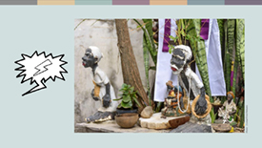 | ,dp ehk; td;Kiwiag; gw;wp rpe;jpg;Nghk;. kpfg; nghJthf mDgtpf;fg;gl;Ls;s td;Kiw tbtq;fshf ntWg;Gg; Ngr;R kw;Wk; ntWg;Gf; Fw;wq;fs; vd;gd fhzg;gLfpd;wd. Fwpg;ghf> kj topghl;blq;fs; kw;Wk; mtw;Wf;F tUif jUfpd;w egu;fs; MfpNahu; ,yFtpy; ntWg;Gf; Fw;wq;fspdhy; ghjpf;fg;gLgtu;fsha; cs;sdu;.  gpNurpypy;> ghuk;gupakhd Afro-Brazilian kjq;fisg; gpd;gw;Wgtu;fs; mtu;fSila kjj;jpid jPa rf;jpahf fUJfpd;w maytu;fshd neo-Pentecostal Christian ,dhy; td;Kiwj; jhf;Fjy;fis vjpu; nfhz;ldu;. Candomblé kj Nghjfuhd mUl;jpU. Marcio jdJ Myak; kPJ 20 ,w;Fk; Nkw;gl;l jhf;Fjy;fs; ,lk;ngw;Ws;sjhf mwpf;ifapl;Ls;shu;. nghyp]; vt;tpj eltbf;ifAk; Nkw;nfhs;stpy;iy.
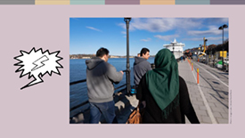 | kPz;LnkhUKiw> ngz;fs; kw;Wk; Mz;fs; NtWgl;l Kiwapy; ghjpf;fg;gLfpd;wdu;.  RtPldpy; cs;s K];ypk; ngz;fs;> Fwpg;ghf `p[hg; Nghd;w kjuPjpahd Milfis mzpfpd;w ngz;fs; nghJ ,lq;fspy; itj;J me;epa egu;fshy; Gupag;gLfpd;w ntWg;Gf; Fw;wq;fis mjpfkhf mDgtpf;fpd;w mNjNtis> K];ypk; Mz;fs; jq;fsJ maytu;fs; my;yJ cld; gzpGupgtu;fshNyNa ntWg;Gf; Fw;wq;fis mDgtpf;fpd;wdu;.
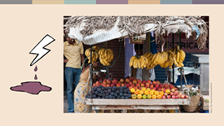 | gy ,lq;fspy;> nfhNuhdh itu]; njhw;whdJ eilKiwapypUe;j ghugl;rk; kw;Wk; ntWg;G fl;likg;Gf;fis gyg;gLj;jpAs;sJ. K];ypk; kj gz;bifnahd;wpidj; njhlu;e;J itu]; njhw;W guty; Vw;gl;lJk; ,e;jpahtpYs;s K];ypk;fs; nfhNuhdh [p`hj;jpid elj;jpajhf Fw;wk; rhl;lg;gl;ldu;. Ahmed Shaikh vd;gtu; jd;Dila tho;f;ifapid nfhz;L elj;j rpukg;gLk; xU K];ypk; tPjp tpahghup Mthu;. 2020 Vg;uy; ,y;> ,e;J Njrpathjf; FOnthd;W> K];ypk;fs; nfhNuhdhtpidg; gug;Gtjw;F rjp nra;fpd;wikapdhy;> mtUila filia fhyp nra;Jtpl;L NghFkhW mtUf;F $wpdu;. Ahmed Shaikh nfQ;rpaNghJk;; mtu;fs; mtiu jbfspdhy; ghuJ}ukhf mbj;jdu;. mtu; nghyp]py; Kiwg;ghL nra;a Kaw;rpj;jhu;> Mdhy;> tPjpapy; tpw;gid nra;jy; rl;l KuzhdJ vd $wp nghyp]hu; Kiwg;ghl;bidg; gjpT nra;a kWj;jdu;.
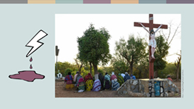 | rKjhaj;jpYs;s kpfj; jPtpukhd td;Kiw tbtq;fshf tFg;Gthj td;Kiw kw;Wk; gaq;futhjj; jhf;Fjy;fs; fhzg;gLfpd;wd.  Nghjfu; Samuel tlf;F Burkina Faso ,Ys;stu; Mthu;. me;ehL kj rfpg;Gj;jd;ikf;fhd ghuk;gupaj;jpidf; nfhz;bUe;jJ. ,jid gaq;futhjf; FOf;fs; mopj;Jf; nfhz;bUe;jd. 2019 ,y;> mtu;fspd; cghaj;jpd; gFjpnahd;whf Njthyaq;fs; kPjhdj; jhf;Fjy;fs; mike;jJ. Nghjfu; Samuel jw;NghJ cs;@upy; ,lk;ngau;e;j egu;fSf;fhd Kfhnkhd;wpy; tho;fpd;whu;.  “,j;jhf;Fjy;fs; vq;fsJ kf;fspd; tho;f;ifapid nehWf;fp tpl;ld. ehq;fs; Ntjidapdhy; epuk;gpapUf;fpd;Nwhk;” vd mtu; $wpdhu;.  2019 ,ypUe;J gaq;futhjj; jhf;Fjy;fs; mjpfupf;fg;gl;ld> ,it xt;nthUtiuAk; ghjpg;gJld;> 1 kpy;ypadpw;Fk; mjpfkhd egu;fs; ,lk;ngau;e;Js;sdu;.

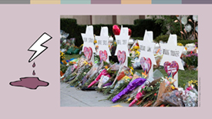 | cyf Gs;sptpguq;fspy; ,];yhj;Jld; njhlu;Gila gaq;futhjf; FOf;fs; Mjpf;fk; nrYj;Jfpd;wNghjpYk;> NtW FOf;fs; caupa mr;RWj;jiy Vw;gLj;Jfpd;w gy Njrpa #oikTfs; fhzg;gLfpd;wd.  rpy Nkw;fj;ija ehLfspd; ghJfhg;G Nritfs; jPtpu cupik kpjthjpfisNa cs;ehl;bYs;s kpfg;ghupa gaq;fu mr;RWj;jyhff; fUJfpd;wd. ,f;FOf;fs; rpWghd;ikapdiu ,yf;F itf;fpd;wd. 2018 ,y;> If;fpa mnkupf;fh> Pittsburgh ,Ys;s; gs;spthrypy; gjpndhU  Ngu; nfhy;yg;gl;ldu; vd;gJld; 2019 ,y; epA+rpyhe;J> Christchurch ,Ys;s gs;spthrypy; itj;J 51 K];ypk;fs; nfhy;yg;gl;ldu;.
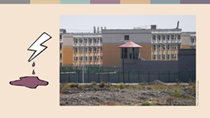 | nghyp];> ghJfhg;G Nritfs; my;yJ ,uhZtk; my;yJ murpdhy; mku;j;jg;gLfpd;w FOf;fspdhy; nra;ag;gLfpd;w td;Kiwapdhy; jdpegu;fis my;yJ nkhj;j rKjhaq;fisAk; ,yf;F itf;f KbAk;. Nkw;F rPdhtpYs;s Uighurs ,d; #o;epiyahdJ murhq;f td;Kiw vt;tsT jPtpukhf nra;ag;glyhk; vd;gjid vLj;Jf;fhl;Lfpd;wJ. Uighur ngz;fs; fl;lha kyl;Lj;jd;ik kw;Wk; fu;g;gj;jil vd;gtw;Wf;F cl;gLj;jg;gl;ldu; vd;gJld; ,J gpwg;G tPjq;fspy; ghupa tPo;r;rpf;F toptFj;jJ. mj;Jld; Rkhu; 1.8 kpy;ypad; Uighur egu;fs; `p[hg; mzpe;jik kw;Wk; jhb itj;jik Nghd;w fhuzq;fSf;fhf kPs;fy;tp Kfhk;fSf;F mDg;gg;gl;ldu;. ,k; Kfhk;fspy;> rpj;jputij kw;Wk; ghypay; td;Gzu;T ,lk;ngw;wjhf mwpf;ifaplg;gl;Ls;sJ. mj;Jld; Kfhkpy; mtu;fspd; nkhop kw;Wk; kjk; kWf;fg;gl;lJld;> mur rpj;jhe;jq;fis tpku;rdkpd;wp Vw;Wf;nfhs;tjw;F mtu;fSf;F fw;gpf;fg;gl;lJ. ,k;Kfhk;fs; jd;dhu;t fy;tp epiyaq;fs; vd rPd murhq;fk; $Wfpd;wJ.
 | murhq;fj;jpd; nghWg;Gf;fs; kw;Wk; murhq;fj;jpd; jtWfs;
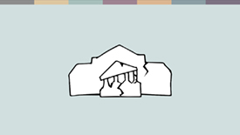 | ,Wjpahf> ehq;fs; kf;fisg; ghJfhg;gjw;F murhq;fk; jtWfpd;wik njhlu;ghf ghu;g;Nghk;. murhq;fq;fSf;F kdpj cupikfisg; ghJfhg;gjw;fhd xU nghWg;G cz;L. mij mit nra;aj;jtWfpd;wNghJ> ghugl;rk; kw;Wk; td;Kiw vd;gd mjpfupf;f Muk;gpf;fpd;wd> Mdhy;> jdpegu; njhlu;ghd tplaq;fspy; tpidj;jpwdhd nghyp]; eltbf;if kPwy;fis epWj;Jtjw;F cjt KbAk;.
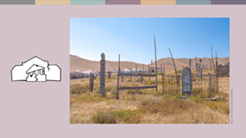 | 2017 ,y;> ,];yhkpypUe;J fpwp];jtj;jpw;F khwpa xU tNahjpg ngz; njw;F fpu;fp];jhdpy; ,we;jhu;. mg;ngz;zpd; kfs; mtiu khefu kahdj;jpy; mlf;fk; nra;a Kaw;rpj;jNghJ> cs;@u; ,khk; xUtuhy; jiyik jhq;fg;gl;l xU FO td;KiwahduPjpapy; vjpu;j;jdu;. kf;fSila ftdkhdJ mjpfhupfis vjpu;tpidahw;wr; nra;fpd;wtiuapy;> mt;Tly; kPz;Lk; kPz;Lk; Njhz;lg;gl;Lf; nfhz;bUe;jJ. Fw;wthspfs; kPJ Fw;wQ;rhl;lg;gl;lJld;> mjd; gpd;du; kj khw;wj;jpw;F vjpuhd jPtpu Fuy;fs; vOtJ Fiwe;jJ.
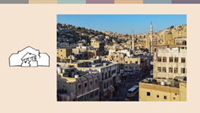 | FLk;gq;fspy; my;yJ kj rKjhaq;fspy; ,lk;ngWfpd;w kPwy;fs; njhlu;ghf jiyaPL nra;tjw;F mjpfhupfs; jtWfpd;wdu;. N[hu;jhdpy; trpf;Fk; Nadia vd;fpw 22 tajhd fpwp];jt> gy;fiyf;fof khztnuhUtu; rf K];yk; khztnuhUtUld; fhjy; nfhz;lhu;. ,jid mtsJ FLk;gk; mwpe;jNghJ> mtu;fs; mtis tPl;bypUe;J ntspNa nry;y mDkjpf;fhjJld; rpj;jputij nra;jdu;. Nadia xUthwhf jg;gpj;J Xbtpl;lhs;> Mdhy; ,uz;L khjq;fSf;F gpwF mtsJ je;ij mtisf; fz;Lgpbj;J nfhiy nra;jhu;. ePjpkd;wkhdJ> mtuJ ‘nfsutj;jpid’ mbg;gilahff; nfhz;l Nehf;fq;fis ‘Fw;wj;jpid jzpg;gjw;fhd re;ju;g;gq;fshf’ fUj Ntz;Lk; vd $wp mtiu rpiwf;F mDg;gtpy;iy.

 | KbT
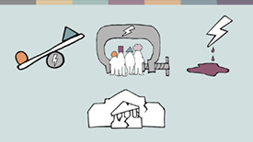 | ,k;Kd;itg;gpyÊ> ehk; murhq;fq;fspdhy; kw;Wk; rKjhaj;jpYs;s egu;fspdhy; Gupag;gLfpd;w ghugl;rk;> kl;Lg;ghLfs; kw;Wk; td;Kiw gw;wpg; ghu;j;Njhk;. mj;Jld;> kf;fisg; ghJfhg;gjw;F muR jtWfpd;wik njhlu;gpYk; ghu;j;Njhk;.  ehq;fs; Nfl;l fijfspypUe;J> ehq;fs; gy KbTfisg; ngw;Wf; nfhs;s KbAk;:
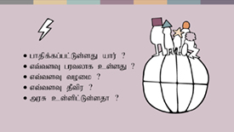 | - kPwy;fs; midj;J tifahd ehLfspYk; ,lk;ngWfpd;wd vd;gJld; mit midj;J kjq;fs; kw;Wk; ek;gpf;iffisr; Nru;e;j kf;fisAk; ghjpf;fpd;wJ. #oikTfSf;fpilapy; NtWgLfpd;wit vitnadpy;> ahu; ghjpf;fg;gl;Ls;shu;> vt;tsT gutyhf cs;sJ> mbf;fb epfOk;jd;ik kw;Wk; ghuJ}ukhdj; jd;ik kw;Wk; mtw;iwg; Guptjpy; murhq;fk; ve;jstpw;F <Lgl;Ls;sJ Nghd;w tplaq;fNs MFk;.
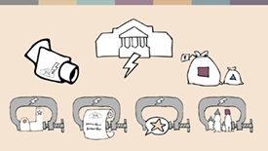 | - NtWgl;l tifahd gy rl;lq;fs; kw;Wk; murhq;ff; nfhs;if vd;gd kPwy;fSf;F gq;fspf;f KbAk;.
 | - nghJthf> rpWghd;ikapdu; kw;Wk; ngUk;ghd;ikapdUs; tpj;jpahrkhf rpe;jpf;fpd;wtu;fs; MfpNahu; ghuJ}ukhfg; ghjpf;fg;gLfpd;wdu;. Mdhy;> ngUk;ghd;ik rKjhaq;fSk; kPwy;fspdhy; ghjpf;fg;glyhk;- Fwpg;ghf gaq;futhj td;Kiwapdhy;.
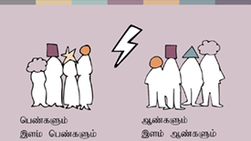 | - gy fijfs; Mz;fs; kw;Wk; ngz;fs; vt;thW NtWgl;l Kiwfspy; ghjpf;fg;gl;ldu; vd;gjid vLj;Jf;fhl;Lfpd;wd- ntWg;Gf; Fw;wq;fspypUe;J gyte;j jpUkzq;fs;> nfsutf; nfhiyfs;> gyte;j fuÊgÊgjÊjil tiuapy;.
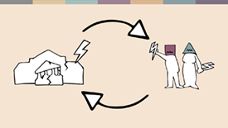 | - mj;Jld;> ehq;fs; Nfl;l gy fijfs; rKjhaj;jpy; cs;s kPwy;fs;> murhq;fj;jpd; jtWiffs; kw;Wk; murhq;f kPwy;fs; vt;thW xd;iwnahd;W kPs;typAWj;jp> er;R tl;lnkhd;wpid cUthf;Ffpd;wd vd;gjid vLj;Jf; fhl;Lfpd;wd.
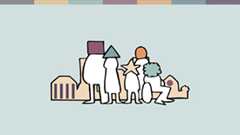 | kjk; my;yJ ek;gpf;iff;fhd Rje;jpuj;jpd; kPwy;fs; rhjhuz kf;fSf;F ghupa jdpg;gl;l Ntjidapid Vw;gLj;Jfpd;wd. mit r%fj;jpidAk;  ];jpukw;wjhf;Ffpd;wd. Kbtpy;> midtUk; ghJfhg;gpd;ik kw;Wk; nghUshjhuk; kw;Wk; r%f ghjpg;Gf;fshy; Jd;GWfpd;whu;fs;.  ehq;fs; ahuhapUg;gpDk;> vk;kjr; rKjhaj;jpw;F cupatuhapUg;gpDk;> vkJ ehl;bYs;s midj;J egu;fs; njhlu;gpYk; kjk; my;yJ ek;gpf;iff;fhd Rje;jpuj;jpw;F kjpg;gspf;fg;gLtjpypUe;J ehk; ngw;wf; nfhs;tjw;F epiwa ,Uf;fpd;wd. mj;Jld;> Vida ehLfspy; rpWghd;ikapduhf tho;fpd;w kw;Wk; mq;Nf rkkhd cupikfis fhz tpUk;Gfpd;w rf tpRthrpfs; vk; midtUf;Fk; ,Uf;fpd;whu;fs;. vq;Fk;> midtUf;Fkhd rk cupikfs;> vk; midtUf;Fkhd re;Njhrkhd> ghJfhg;ghd cyfj;ij cUthf;Fk;.

Local sources/cs;@H juTfs;
The Guardian, https://www.theguardian.com/world/2013/feb/27/bahai-student-expelled-iranian-university
Forum 18, https://www.forum18.org/archive.php?article_id=2508
US State Dept., https://www.state.gov/reports/2020-report-on-international-religious-freedom/algeria/
Forum 18, https://www.forum18.org/archive.php?article_id=2555
The Leaflet, https://www.theleaflet.in/india-needs-to-overhaul-laws-on-interfaith-marriage-and-religious-conversion/
Forum Asia, https://www.forum-asia.org/?p=7086
UK Parliament, https://edm.parliament.uk/early-day-motion/57474/maira-shahbaz-and-child-abduction-forced-conversion-and-marriage-in-pakistan
BBC news, https://www.bbc.com/news/world-africa-55756834
Local sources/cs;@H juTfs;
New York Times, https://www.nytimes.com/2019/04/14/technology/china-surveillance-artificial-intelligence-racial-profiling.html
%yk;: kupah, ghJfhg;G fhuzq;fSf;fhf ,tuJ ngah; khw;wg;gl;Ls;sJ
RioOnWatch, https://rioonwatch.org/?p=40117
The Swedish National Council for Crime Prevention, https://www.bra.se/om-bra/nytt-fran-bra/arkiv/press/2021-03-31-islamofobiska-hatbrott-yttrar-sig-i-manga-olika-former.html
Sabrang India, https://sabrangindia.in/article/stop-targeting-discriminating-against-and-attacking-vendors-and-hawkers-national-hawker
Open Doors UK, https://www.opendoorsuk.org/persecution/world-watch-list/burkina-faso
United States Congress, https://www.congress.gov/116/bills/s894/BILLS-116s894is.xml
The Guardian, https://www.theguardian.com/world/2020/sep/04/muslim-minority-teacher-50-tells-of-forced-sterilisation-in-xinjiang-china
Forum 18, https://www.forum18.org/archive.php?article_id=2248
cs;@hH Mjhu %yk;

