mku;T 5
vkJ efupyÊ kjk; my;yJ ek;gpf;iff;fhd Rje;jpukÊ

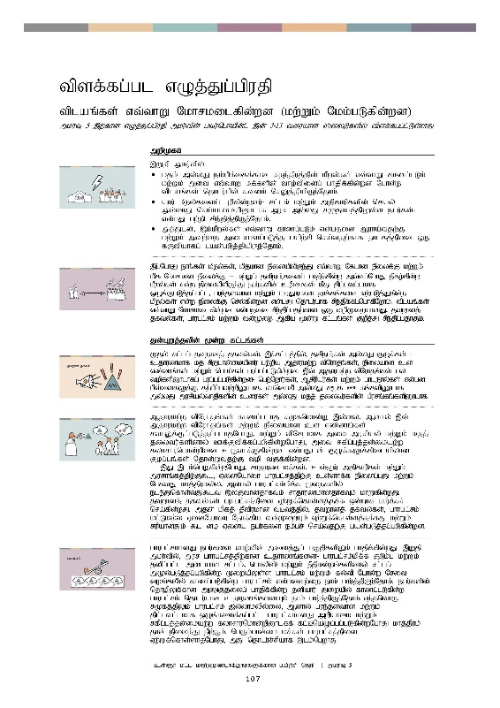
tpsfÊfgÊgl vOjÊJgÊgpujp
tpsfÊfgÊgl vOjÊJgÊgpujp
tplaq;fs; vt;thW Nkhrkilfpd;wd (kwÊWkÊ NkkÊgLfpdÊwd)
mkuÊT 5 ,wÊfhd vOjÊJgÊgpujp mkuÊtpdÊÊ gtuÊnghapdÊlÊ ,dÊ 3-13 tiuahd ]ÊiyLfspyÊ tpsfÊfggÊlÊLsÊsJ.

 | mwpKfkÊ
,Wjp mku;tpy;:
- kjk; my;yJ ek;gpf;iff;fhd Rje;jpuj;jpd; kPwy;fs; vt;thW fhzg;gLk; kw;Wk; mit vt;thW kf;fspd; tho;tpidg; ghjpf;fpd;wd Nghd;w tplaq;fs; njhlu;gpy; ftdk; nrYj;jpapUe;Njhk;.
- ahu; kPwy;fisg; Gupfpd;wdu;- rl;lk; kw;Wk; mjpfhupfspd; nray; my;yhJ nra;ahikapD}lhf muR my;yJ rKjhaj;jpYs;s egu;fs;- vd;gJ gw;wp rpe;jpj;jpUe;Njhk;>
- mj;Jld;> ,k;kPwy;fs; vt;thW fhzg;gLk; vd;gjid Muha;tjw;F kw;Wk; mtw;iw milahsg;gLj;j gapw;rp nra;tjw;fhf ehlfj;jpid xU fUtpahfg; gad;gLj;jpapUe;Njhk;.

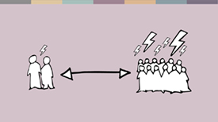 | ,gÊÊNghJ ehqÊfsÊ kPwy;fs;> kpjkhd epiyapypUe;J vt;thW Nflhd epiyf;F kw;Wk; kpf Nkhrkhd epiyf;F – kw;Wk; jdpegu;fisg; ghjpf;fpd;w mt;tg;NghJ epfo;fpd;w kPwy;fs; vd;w epiyapypUe;J egu;fspd; cupikfs; kPJ jpl;ltl;lkhf xOq;FgLj;jg;gl;l> gue;jsthd kw;Wk; ghuJ}ukhd jhf;fq;fis Vw;gLj;Jfpd;w kPwy;fs; vd;w epiyf;F nry;fpd;wd vd;gJ njhlu;ghf rpe;jpfÊfgÊNghfpNwhkÊ. tplaq;fs; vt;thW Nkhrkilfpd;wd vd;gjid rpe;jpg;gjw;fhd xU topKiwahdJ> jtwhdj; jfty;fs;> ghugl;rk; kw;Wk; td;Kiw Mfpa %d;W fl;lq;fs; Fwpj;J rpe;jpg;gjhFk;.
 | JdÊGWjÊjypdÊ %dÊW fl;lq;fs;
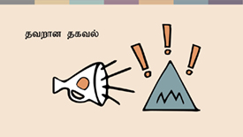 | Kjy; fl;lk; jtwhdj; jfty;fs;. ,f;fl;lj;jpy;> jdpegu;fs; my;yJ FOf;fs; - cjhuzkhf kj rpWghd;ikapdu; gw;wpa Mjhukw;w tpNuhjq;fs;> epiyahd cs vz;zq;fs; kw;Wk; ngha;fs; gug;gg;gLfpd;wd. ,t; Mjhukw;w tpNuhjq;fs; gy topfspD}lhfg; gug;gg;gLfpd;wd- ngw;Nwhu;fs;> Mrpupau;fs; kw;Wk; ghlE}y;fs; vd;gd gps;isfSf;F fw;gpg;gtw;wpD}lhf> thndhyp my;yJ r%f Clfq;fspD}lhf my;yJ murpay;thjpfspd; ciufs; my;yJ kjj; jiytu;fspd; gpurq;fq;fspD}lhf.
Mjhukw;w tpNuhjq;fs; fhzg;glhj r%fnkhd;W ,y;iy> Mdhy; ,t; Mjhukw;w tpNuhjq;fs; kw;Wk; epiyahd cs vz;zq;fs; rthYf;Fl;gLj;jg;glhjNghJ> kw;Wk; tpNrlkhf mit murpay; kw;Wk; kjj; jiytu;fspdhy; Cf;Ftpf;fg;gLfpd;wNghJ> mit rfpg;Gj;jd;ikaw;w fyhrhunkhd;wpid cUthf;Ffpd;wd vd;gJld; FOf;fSf;fpilapyhd Fog;gq;fs; Njhd;Wtjw;F top tFf;fpd;wd.
,J ,lk;ngWfpd;wNghJ> rhjhuz kf;fs;> cs;@u; mjpfhupfs; kw;Wk; murhq;fj;jpw;F$l> VidNahiu ghugl;rj;jpw;F cs;shf;f epidg;gJ kw;Wk; NgRtJ khj;jpuky;y> Mdhy; ghugl;rk;kpf;f Kiwfspy; ele;Jnfhs;tJ $l ,yFthdjhfTk; rhjhuzkhdjhfTk; khWfpd;wJ. jtwhdj; jfty;fs; guhgl;rj;jpid Vw;Wf;nfhs;sj;jf;f xd;whf ghu;f;fr; nra;fpd;wJ. mjd; kpfj; jPtpukhd tbtj;jpy;> jtwhdj; jfty;fs;> ghugl;rk; kl;Lky;y VidNahiu Nehf;fpa td;KiwAk; Vw;Wf;nfhs;sj;jf;fJ kw;Wk; rupahdJk; $l Vida egu;fis ek;gr; nra;tjw;F gad;gLj;jg;gLfpd;wd.

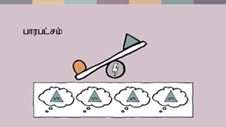 | ghugl;rkhdJ egu;fis tho;tpd; midj;Jg; gFjpfspYk; ghjpf;fpd;wJ. ,Wjp mku;tpy;> mur ghugl;rj;jpw;fhd cjhuzq;fis- ghugl;rk;kpf;f FLk;g kw;Wk; jdpg;gl;l milahs rl;lk;> nghyp]; kw;Wk; ePjpkd;wq;fspdhy; rl;lk; mKy;gLj;jg;gLfpd;w KiwapYs;s ghugl;rk; kw;Wk; fy;tp Nghd;w Nrit toq;fypy; fhzg;gLfpd;w ghugl;rk; vd;gdtw;iw ehk; ghu;j;jpUe;Njhk;. egu;fspd; njhopYf;fhd mZFjiyg; ghjpf;fpd;w jdpahu; Jiwapy; fhzg;gLfpd;w ghugl;rk; njhlu;ghd cjhuzq;fisAk; ehk; ghu;j;jpUe;Njhk;. ve;jnthU r%fj;jpYk; ghugl;rk; ,y;yhkypy;iy> Mdhy; gue;jsthd kw;Wk; jpl;ltl;lkhf xOq;fikf;fg;gl;l ghugl;rkhdJ mwpahik kw;Wk; rfpg;Gj;jd;ikaw;w fyhrhunkhd;wpD}lff; fl;bnaOg;gg;gLfpd;wNghJ khj;jpuk; jhd; epiyj;J epw;Fk;. ngUk;ghd;ik kf;fs; ghugl;rj;jpid Vw;Wf;nfhs;shjNghJ> mJ njhlu;r;rpahf ,lk;ngwhJ.
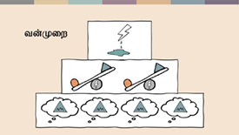 | mj;Jld;> jtwhdj; jfty;fs; ghugl;rj;jpw;fhd mbj;jsj;jpid cUthf;Ftjidg;Nghd;W> jtwhdj; jfty;fs; kw;Wk; ghugl;rk; vd;gd ,ize;J td;Kiwf;fhd mbj;jsnkhd;wpid Mf;Ffpd;wd. rKjhaj;jpy; td;Kiw - nghUl;fis Nrjg;gLj;Jk; fpsu;r;rpfs; > njhe;juT > clw;rhu; td;Kiwf;fhd mr;RWj;jy;fs; tiuapy;- NtWgl;l tbtq;fisf; nfhz;bUf;fyhk;. mj;Jld;> mur td;Kiw> vNjr;rhjpfhukhd rpiwj;jz;lid> rpj;jputij kw;Wk; ghypd mbg;gilapyhd td;Kiw vd;gtw;wpid cs;slf;Fk;.
 | msT jlitfs; kw;Wk; jhf;fk;
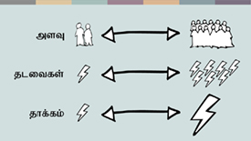 | gpur;rpidapd; %d;W tbtq;fSk; - jtwhdj; jfty;fs;> ghugl;rk; kw;Wk; td;Kiw - gy;NtWgl;l msTfspYk; jlitfspYk; ,lk;ngwyhk;> kw;Wk; NtWgl;l msTfspyhdj; jhf;fq;fisf; nfhz;bUf;fyhk;. xU kPwyhdJ rpy jdpegu;fis my;yJ ghupaf; FOf;fisg; ghjpf;f KbAk;. mit mt;tg;NghJ ,lk;ngwyhk;> tof;fkhf ,lk;ngwyhk; my;yJ jpl;ltl;lkhf xOq;fikf;fg;gl;ljhf ,Uf;fyhk;- mjhtJ mJ r%f Kiwikfs; kw;Wk; fl;likg;Gf;fspDs; fl;bnaOg;gg;gl;l xd;whf ,Uf;fyhk;. mj;Jld;> mJ ghjpf;fg;gLfpd;w egu;fs; kPJ kl;Lg;gLj;jg;gl;lj; jhf;fq;fis my;yJ Nguopthdj; jhf;fq;fisf; nfhz;bUf;fyhk;.
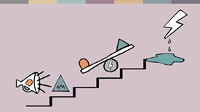 | gy ehLfspd; mDgtq;fspdbg;gilapy; kpfg; gue;jsthd kw;Wk; ghuJ}ukhd Mjhukw;w tpNuhjq;fs; kw;Wk; jtwhdj; jfty;fs; vd;gd kpfg; gue;jsthd kw;Wk; ghuJ}ukhd ghugl;rkha; cUthf tha;g;gspg;gjhf vkf;F nrhy;fpd;wd. NkYk; ,it ,uz;Lk; vt;tsT gutyhf ,Uf;fpwNjh> me;j msTf;F gutyhdJk; fLikahdJkhd td;Kiwf;fhd tha;g;Gfs; mjpfk;. xd;W kw;nwhd;wpw;F toptFf;fpd;wJ. ,J vk;ik Nrhu;thf czur; nra;jhYk;> tplaq;fs; vt;thW Nkhrkhd epiyapid milfpd;wd vd;gJ gw;wpa Gupe;Jzu;T> mit vt;thW rup nra;ag;glyhk; vd;gJ gw;wp ehk; rpe;jpg;gjw;F cjTk;.
 | ,Wjpahf
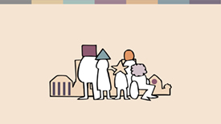 | ehk; rpe;jpf;fpd;w KiwapYk;> xUtiug;gw;wpnahUtu; Ngrpf;nfhs;fpd;w kw;Wk; elj;Jfpd;w KiwapYNk midj;Jk; Muk;gkhfpd;wJ. mj;Jld;> ,J vkJ FLk;gq;fspy; kw;Wk; jdpg;gl;l tiyaikg;Gf;fspy; ,J Fwpj;J vk; xt;nthUtuhYk; nra;a Kbe;j tplankhd;whf ,Uf;fpd;wJ. ehq;fs; ,J njhlu;ghf rKjha kl;lj;jpy; vijNaDk; nra;jYk; rhj;jpakhdNj- cjhuzkhf> vq;fSila kj rKjhaq;fs;> ghlrhiyfs; kw;Wk; njhopyplq;fspy;.  Mdhy;>,J kl;Lk; NghjhJ. ehk;> egu;fis ghugl;rg;gLj;Jfpd;w kw;Wk; jPq;F tpistpf;fpd;w cj;jpNahf KiwfisAk;- Nflhd rl;lq;fspypUe;J ghlrhiy Mrupau;fs; my;yJ nghyp]; mjpfhupfs; Nghd;w mjpfhupfspd; elj;ij tiuapy;- khw;w Ntz;Lk;.
 | mj;jifa xU khw;wj;jpid rhj;jpakhdjhf;Ftjw;F> jq;fSila cupikfs; gw;wp mwpe;Js;s kw;Wk; mtw;Wf;fhf Nghuhlf;$ba MW;wy;gilj;j rpWghd;ikapdu;> kw;Wk; kdpj cupikfis kjpg;gjw;fhd> ghJfhg;gjw;fhd kw;Wk; Nkk;gLj;Jtjw;fhd jq;fsJ nghWg;Gf;fisg; Gupe;Jnfhz;Ls;s murpay; kw;Wk; kjj; jiytu;fs; vkf;F Njit.
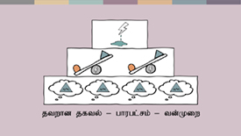 | ,jid eilKiw rhj;jpakhdjhf;fy; nkJthd kw;Wk; fbdkhd nrad;Kiw xd;whFk;. mr;nrad;KiwahdJ> vq;fsJ #oiktpid ehq;fs; gFg;gha;T nra;fpd;wNghJ kw;Wk; gpur;rpidfis milahsk; fhz;fpd;wNghJ Muk;gpf;fpd;wJ. ehk; mjid nra;tjw;F vkf;F cjTtjw;fhf ehk; ,t; jtwhdj; jfty;fs;- ghugl;rk;- td;Kiw vd;w ,k;%d;W fl;l gbkj;jpidg; gad;gLj;j KbAk;.

mq;fPfupg;G:
,t; vOj;Jg;gpujpahdJ> Johan Candelin ,dhy; Mf;fg;gl;Ls;s Jd;GWj;jypd; %d;W fl;lq;fs; gbkj;jpidj; jOtpAs;sJ.

