mku;T 6
fijfspdhy; <u;f;fg;gly;
- cj;jpfspdhy; tYT+l;lg;gly;

Kd;itg;gpw;fhd vOj;Jg;gpujp
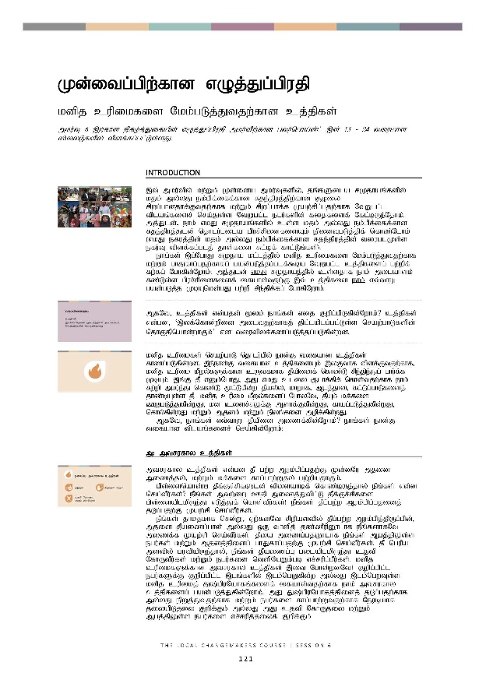
Kd;itg;gpw;fhd vOj;Jg;gpujp
kdpj cupikfis Nkk;gLj;Jtjw;fhd cj;jpfs;
mku;T 6 ,w;fhd epfo;j;Jifapd; vOj;Jg;gpujp mku;tpw;fhd gtu;ngha;d;l; ,d; 13 - 24 tiuahd ];iyLfspy; tpsf;fg;gl;Ls;sJ.

 | mwpKfk;
,t; mku;tpy; kw;Wk; Kd;ida mku;Tfspy;> jq;fSila rKjhaq;fspy; kjk; my;yJ ek;gpf;iff;fhd Rje;jpuj;jpw;fhd #oiy rpwg;ghdjhf;Ftjw;fhf kw;Wk; rpwg;ghf;f Kaw;rpg;gjw;fhf NtWgl;l tplaq;fisr; nra;Js;s NtWgl;l egu;fspd; fijfisf; Nfl;bUe;Njhk;. mj;Jld;> ehk; vkJ rKjhaq;fspy; cs;s kjk; my;yJ ek;gpf;iff;fhd Rje;jpuj;Jld; njhlu;Gila gpur;rpidfisAk; epidTgLj;jpf; nfhz;Nlhk; (vkJ efuj;jpd; kjk; my;yJ ek;gpf;iff;fhd Rje;jpuj;jpd; tiuglKs;s efu;T tpsf;fg;glj; jhs;fis Rl;bf; fhl;Lq;fs;).
ehq;fs; ,g;NghJ rKjha kl;lj;jpy; kdpj cupikfis Nkk;gLj;Jtjw;fhf kw;Wk; ghJfhg;gjw;fhfg; gad;gLj;jg;glf;$ba NtWgl;l cj;jpfisg; gw;wpf; fw;fg; Nghfpd;Nwhk;. mj;Jld; vkJ rKjhaj;jpy; cs;sjhf ehk; milahsk; fz;Ls;s gpur;rpidfisf; ifahs;tjw;F ,t; cj;jpfis ehk; vt;thW gad;gLj;j KbAnkd;gJ gw;wp rpe;jpf;fg; NghfpNwhk;.

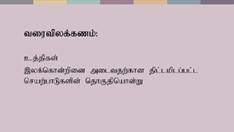 | MfNt> cj;jpfs; vd;gjd; %yk; ehq;fs; vij Fwpg;gpLfpd;Nwhk;? cj;jpfs; vd;gd> ‘,yf;nfhd;wpid miltjw;fhfj; jpl;lkplg;gl;Ls;s nraw;ghLfspd; njhFjpnahd;whFk;’ vd tiutpyf;fzg;gLj;jg;gLfpd;wd.
kdpj cupikfs; nraw;ghL njhlu;gpy; ehd;F tifahd cj;jpfs; fhzg;gLfpd;wd. ,e;ehd;F tifahd cj;jpfisAk; ,yFthf tpsf;Ftjw;fhf> kdpj cupik kPwy;fSf;fhd cUtfkhf jPapidf; nfhz;L rpe;jpe;Jg; ghu;f;f KbAk;. ,q;F jP vDk;NghJ> mJ vkJ cliy #lhf;fpf; nfhs;tjw;fhf ehk; Rw;wp mku;e;J nfhz;L %l;Lfpd;w jPay;y> khwhf> Mgj;jhd> fl;Lg;ghLfisj; jhz;bAs;s jP. kdpj cupik kPwy;fisg; NghyNt> jPAk; kf;fis CWgLj;Jfpd;wJ> kd cisr;rYf;F Mshf;Ffpd;wJ> fhag;gLj;Jfpd;wJ> nfhy;fpd;wJ kw;Wk; Mjdk; kw;Wk; epyq;fis mopf;fpd;wJ.
MfNt> ehq;fs; vt;thW jPapid mizf;fpd;Nwhk;? ehq;fs; ehd;F tifahd tplaq;fisr; nra;fpd;Nwhk;:

 | m. mtrufhy cj;jpfs;
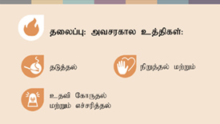 | mtrufhy cj;jpfs; vd;gd jP gw;w Muk;gpg;gjw;F Kd;dNu mjid mizj;jy;> kw;Wk; kf;fis fhg;ghw;Wjy; gw;wpajhFk;.  gps;isnahd;W jPf;Fr;rpfSld; tpisahbf; nfhz;bUe;jhy; ePq;fs; vd;d nra;tPu;fs;? ePq;fs; mtw;iw Cjp mizj;Jtpl;L jPf;Fr;rpfis gps;isaplkpUe;J vLj;Jf; nfhs;tPu;fs;! ePq;fs; jPg;gw;w Muk;gpg;gjidj; jLg;gjw;F Kaw;rp nra;tPu;fs;.  ePq;fs; jhkjkhf nrd;W> Vw;fdNt rpwpastpy; jPg;gw;w Muk;gpj;jpUg;gpd;> mjid jPaizg;ghd; my;yJ xU thspj; jz;zPupD}lhf ePq;fshfNt mizf;f Kaw;rp nra;tPu;fs;. jPia mizg;gjD}lhf ePq;fs; Mgj;jpYs;s egu;fs; kw;Wk; Mjdj;jpidg; ghJfhg;gjw;F Kaw;rp nra;tPu;fs;. jP ngupa mstpy; gutpapUe;jhy;> ePq;fs; jPaizg;G gilaplkpUe;J cjtp NfhUtPu;fs; kw;Wk; egu;fis ntspNaWk;gb vr;rupg;gPu;fs;.  kdpj cupikfSf;fhd mtrufhy cj;jpfs; ,it Nghd;wdNt! Fwpg;gpl;l egu;fSf;F Fwpg;gpl;l ,lq;fspy; ,lk;ngWfpd;w my;yJ ,lk;ngwTs;s kdpj cupikj; J~;gpuNahfq;fisf; ifahs;tjw;fhf ehk; mtrufhy cj;jpfisg; gad;gLj;Jfpd;Nwhk;. mJ J~;gpuNahfj;jpidj; jLg;gjw;fhf my;yJ epWj;Jtjw;fhf kw;Wk; egu;fis fhg;ghw;Wtjw;fhf Neubahf jiyapLjiy Fwpf;Fk; my;yJ mJ cjtp NfhUjiy kw;Wk; Mgj;jpYs;s egu;fis vr;rupj;jiyf; Fwpf;Fk;.
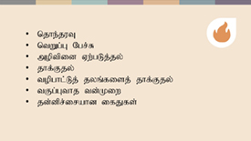 | MfNt> vt;tifahd kjk; my;yJ ek;gpf;iff;fhd Rje;jpuj;jpd; kPwy;fs; njhlu;gpy; mtrufhy cj;jpfisg; gad;gLj;jyhk;? njhe;juT> ntWg;G Ngr;R> jhf;Fjy;fs;> Mjdj;jpid Nrjg;gLj;jy;> topghl;Lj; jyq;fs; kPjhd jhf;Fjy;> tFg;Gthj td;Kiw kw;Wk; jd;dpr;irahd ifJ vd;;gd Fwpg;gpl;l egu;fSf;F my;yJ FOf;fSf;F> Fwpg;gpl;l ,lq;fspy;> Fwpg;gpl;l Neuq;fspy; elf;ff;$ba kPwy;fSf;fhd cjhuzq;fshFk;.  mtrufhy cj;jpfs; ,JNghd;w cldbahd epfo;TfSf;fhd Jyq;fy;fis nra;fpd;wNghJk;> mtw;Wf;fhf ehk; jahuhapUf;f Ntz;baJk; mtrpakhFk;. vd;d nra;a Ntz;Lnkd njupe;jpUf;f Ntz;Lk;. jPaizg;G gilapd; njhiyNgrp ,yf;fj;ij njupe;J itj;jpUj;jy;> jPaizg;ghid vt;thW gad;gLj;Jtnjd njupe;J itj;jpUj;jy; NghyNt> kdpj cupik kPwy;fs; ,lk;ngWfpd;wNghJ> mtw;iwj; jLg;gjw;fhd> epWj;Jtjw;fhd> cjtp NfhUtjw;fhd topKiwfisj; njupe;J itj;jpUf;f KbAk;.
 | M. khw;wj;jpw;fhd cj;jpfs;
rpy fhuzq;fspdhy;jhd; jP gw;Wk; kw;Wk; guTk; - cjhuzkhf> Mgj;jhd kpd;tpepNahf Rw;wpdhy;. khw;wj;jpw;fhd cj;jpfs; vd;gd jP gw;Wtjw;F fhuzkha; mikfpd;w re;ju;g;gq;fis khw;WtJ njhlu;ghdjhFk; - cjhuzkhf> kpd;tpepNahf Rw;W ghJfhg;ghdJ vd;gjid cWjpg;gLj;Jtjw;fhd fl;bl xOq;Ftpjpfs; fhzg;gLfpd;wd vd;gjid cWjpg;gLj;jpf; nfhs;sy;.
kdpj cupik kPwy;fSk; rpy fhuzq;fspdhy;jhd; ,lk;ngWfpd;wd- cjhuzkhf> egu;fis ghJfhg;gjw;F Njitahd tpjpfis r%fk; nfhz;bUf;fhikapdhy; my;yJ mt;tpjpfs; gpd;gw;wg;gLfpd;wd vd;gjid cWjpg;gLj;jNtz;ba egu;fs; mjid nra;aj; jtWfpd;wikapdhy;. Vnddpy;> r%fk; jtwhd Kiwapy; gpizf;fg;gl;Ls;sJ.

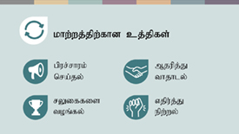 | tpjpfis my;yJ tplaq;fs; nra;ag;gLfpd;w topKiwfis khw;WtJ Fwpj;J egu;fis ,zq;fr;nra;tjD}lhf kl;LNk gy kdpj cupik kPwy;fisj; jPu;f;f KbAk;. ehq;fs; mjid 4 NtWgl;l topfspy; nra;a KbAk;:  - gpur;rpidapid mbf;Nfhbl;Lf; fhl;Ltjw;fhf gpur;rhuk; kw;Wk; Mu;g;ghl;lk; nra;tjD}lhf  - ,g;gpur;rpid njhlu;ghf vijNaDk; nra;af;$ba tplaq;fis khw;WtJ njhlu;gpy; mjpfhuj;jpidf; nfhz;Ls;s egu;fis ,zq;f itg;gjD}lhf- ehq;fs; ,jid Mjupj;J thjhly; vd miog;Nghk;.  - egu;fs; tpj;jpahrkhf ele;Jnfhs;tjw;fhf mtu;fSf;F rYiffis mspg;gjD}lhf  - my;yJ jPa rl;lq;fs; my;yJ r%f epakq;fis ehk; Vw;Wf; nfhs;tjpy;iy vd fhz;gpg;gjw;fhf mtw;iw mikjpahdKiwapy; vjpu;g;gjD}lhf.  ,itNa khw;wj;jpw;fhd cj;jpfshFk;. ,it gy ,lq;fspy; mjpfkhd egu;fisg; ghjpf;fpd;w ePz;l - fhy> jpl;ltl;lkhff; fl;likf;fg;gl;Ls;s gpur;rpidfis ikag;gLj;Jfpd;wd.
 | ,. fl;bnaOg;Gfpd;w cj;jpfs;
jP gutiy epWj;Jtjw;fhf ehk; nra;af;$ba NtW topKiwnahd;W ahnjdpy;> nghJ kf;fs; tpopg;Gzu;tpid Vw;gLj;jy; kw;Wk; elj;ijg;ghq;Ffis khw;WjyhFk;> cjhuzkhf> fha;e;j jiuapy; rpfnul; jPf;fe;jiy tPRtjdhy; Vw;gLk; Mgj;J Fwpj;J tpopg;Gzu;tpid Vw;gLj;jy;. ehq;fs; nghJ kf;fspd; <Lghl;bidAk; fl;bnaOg;g KbAk;- jPapidj; jLg;gjw;fhd jpwd;fis fl;bnaOg;Gtjpy; mjpfkhd egu;fis jd;dhu;t mbg;gilapy; ,izj;Jf; nfhs;sy;- cjhuzkhf egu;fSf;F jPaizg;ghid gad;gLj;Jk; Kiw njupe;jpUf;fpd;wJ vd;gjid cWjpg;gLj;jy;.
kdpj cupikfs; njhlu;gpy;> fl;bnaOg;Gfpd;w cj;jpfshdit> kdpj cupikfs; fyhrunkhd;iwf; fl;bnaOg;Gtjw;fhd ePz;lfhy gzpahFk;. r%fj;jpYs;s midtUk; jq;fsJ kw;Wk; VidNahupd; cupikfis Gupe;Jnfhsfpd;w> kdpj cupikfSf;fhd kjpg;gpid rhjhuzkhdnjhd;whf kw;Wk; cupiknahd;whf ghu;f;fpd;w> Vida egu;fSila cupikfis vg;gb kjpg;gJ kw;Wk; mtw;Wf;fhf vg;gb NghuhLtJ kw;Wk; cupikfs; kPwg;gl;lhy; vd;d nra;tJ vd;gjid mwpe;jpUf;fpd;w r%fnkhd;wpidf; fl;bnaOg;Gtjw;fhf gzpahw;WjiyNa ,J Fwpf;fpd;wJ.
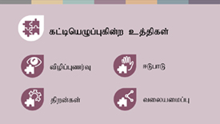 | ,j;jifa r%fnkhd;wpidf; fl;bnaOg;GjyhdJ 4 tplaq;fs; nra;ag;gLtjid cs;slf;Ffpd;wJ:  - kdpj cupikfspd; Kf;fpaj;Jtk; njhlu;ghd tpopg;Gzu;T kw;Wk; ,lk;ngWfpd;w kdpj cupik kPwy;fs; kw;Wk; mit Vw;gLj;Jfpd;w Nrjq;fs; njhlu;ghd tpopg;Gzu;tpidf; fl;bnaOg;gy;.  - <Lghl;bidf; fl;bnaOg;gy;- kdpj cupikfis Nkk;gLj;Jtjw;fhd eltbf;iffis Kd;ndLf;ff;$ba mu;g;gzpg;gpidf; nfhz;bUf;ff;$ba mjpfsthd egu;fis cUthf;fy;.  - jpwd;fisf; fl;bnaOg;Gjy;- MfNt> egu;fSf;F kdpj cupikfis vt;thW Nkk;gLj;Jtnjd;gJ njupAk;.  - kw;Wk; NtWgl;l ,lq;fspy; NtWgl;l tplaq;fisr; nra;fpd;w> Mdhy; nghJthd ,yf;FfSf;fhf xUq;fpizf;fg;gl;l Kiwapy; nraw;gLfpd;w egu;fs; kw;Wk; mikg;Gf;fspd; tiyaikg;Gf;fisf; fl;bnaOg;gy;.  ,it khw;wj;jpw;fhd Kd;-epge;jidfis cUthf;Ffpd;w ePz;l-fhy cj;jpfshFk;. ehq;fs; Vida cj;jpfisg; gad;gLj;Jfpd;wNghJ epw;gjw;fhd xU mbj;jsj;jpid ,t; cj;jpfs; fl;bnaOg;Gfpd;wd.
 | <. ,Wjpahf> vq;fsplk; Njw;Wfpd;w cj;jpfs; ,Uf;fpd;wd.
 | jPiag; NghyNt> kdpj cupik kPwy;fSk; kf;fs;> Mjdk; kw;Wk; rKjhaq;fis Nrjg;gLj;Jfpd;wJ. Njw;Wfpd;w cj;jpfshdit> kdpj cupik kPwy;fs; ,lk;ngw;w gpd;du; mtw;why; ghjpf;fg;gl;ltu;fisg; guhkupg;gjw;F ehk; vd;d nra;fpd;Nwhk; vd;gJ njhlu;ghdJ.
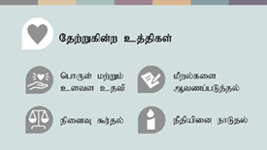 | ,J gFjpastpy;> egu;fs; kPz;L tUtjw;F Njitahd kUj;Jt> %yg;nghUs; kw;Wk; csts Mjutpidg; ngw;Wf; nfhs;fpd;wdu; vd;gjid cWjpg;gLj;JtJ njhlu;ghdjhFk;. Mdhy;> ,J nfsutk; kw;Wk; ePjp njhlu;ghdJk; MFk;.  - ele;jtw;iw %b kiwf;f KbahJ vd;gjid cWjpg;gLj;Jtjw;fhf mtw;iw Mtzg;gLj;JtJ njhlu;ghdJ  - vd;d ele;jJ vd;gjidg; gw;wp NgrTk; mtw;iw epidT $uTk; egu;fSf;F tha;g;gpid toq;FtJ njhlu;ghdJ  - egu;fs; ePjp kw;Wk; e~;l <l;bidg; ngw;Wf; nfhs;fpd;whu;fs; vd;gjid cWjpg;gLj;JtJ njhlu;ghdJ.
 | KbT
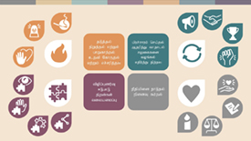 | nrayhw;Wtjw;fhd ,t;NtWgl;l topfsidj;Jk; kdpj cupikfis Nkk;gLj;Jtjw;F Kf;fpakhditahFk;. mit xd;iwnahd;W Fiw KOikahf;Ffpd;wd> xd;Wlndhd;W nghUe;Jfpd;wd vd;gJld; mtw;iw xNu Neuj;jpy; gad;gLj;jTk; KbAk;.  ve;jnthU egNuh my;yJ xU mikg;Ngh> ,t; midj;J cj;jpfisAk; gad;gLj;j KbahJ- vkf;F fhzg;gLfpd;w NtWgl;l tfpghfq;fs;> jpwd;fs; kw;Wk; tha;g;Gf;fs; vd;gd vt; cj;jpapidg; gad;gLj;JtJ vd;w vkJ njuptpy; rupahd Kiwapy; jhf;fk; nrYj;Jfpd;wd. Kf;fpakhd tplak; ahnjdpy; xt;nthUtUk; VNjDnkhd;iw nra;a KbAk; vd;gJld; vq;fSf;fpilapy; xNu jpiria Nehf;fp ,Of;fg;gLfpd;w egu;fs; kw;Wk; mikg;Gf;fspd; tiyaikg;Gf;fspD}lhf ehq;fs; khw;wj;jpid Vw;gLj;j KbAk;.  ehk; midtUk; jP Nghd;w kdpj cupik kPwy;fs; ,lk;ngWtjid epWj;Jtjw;F kw;Wk; vq;fSila tPLfspy; kw;Wk; rKjhaq;fspy; kw;Wk; vq;fSila murhq;fq;fshy; kdpj cupikfSf;F kjpg;gspf;fg;gLfpd;w r%fnkhd;wpidf; fl;bnaOg;Gtjw;F gq;fspf;f KbAk;.

mq;fPfupg;G:
,k;Kd;itg;ghdJ> Center for Victims of Torture ,dhy; elj;jg;gLfpd;w kdpj cupikfspy; Gjpa cj;jpfs; vd;w nraw;jpl;lj;jpdhy; Mf;fg;gl;Ls;s cj;jpfSf;fhd Kiwapay; fl;likg;gpd; khw;wpaikf;fg;gl;l tbtj;jpdhy; <u;f;fg;gl;Ls;sJ kw;Wk; mjid gad;gLj;jpAs;sJ. www.newtactics.org

