mku;T 8
khw;wj;jpw;fhd vkJ gazk;

Kd;itg;gpw;fhd vOj;Jg;gpujp
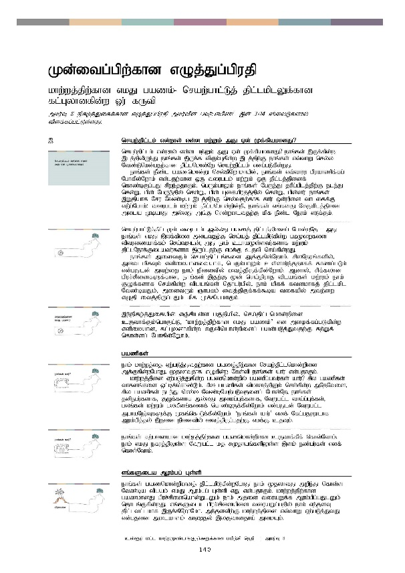
Kd;itg;gpw;fhd vOj;Jg;gpujp

khw;wj;jpw;fhd vkJ gazk;- nraw;ghl;Lj; jpl;lkplYf;fhd fl;Gyhdfpd;w Xu; fUtp

mku;T 8 epfo;j;JiffÊfhd vOj;Jg;gpujp mku;tpd; gtu;ghapz;l; ,dÊ 3-24 ];iyLfshy; tpsf;fg;gl;Ls;sJ.

 | nraw;jpl;lk; vd;why; vd;d kw;Wk; mJ Vd; Kf;fpakhdJ?
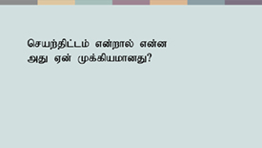 | nraw;jpl;lk; vd;why; vd;d kw;Wk; mJ Vd; Kf;fpakhdJ? ehq;fs; ,Uf;fpd;w ,lj;jpypUe;J ehq;fs; ,Uf;f tpUk;Gfpd;w ,lj;jpw;F ehq;fs; vt;thW nry;y Ntz;Lnkd;gjw;fhd jpl;lnkhd;Nw nraw;jpl;lk; vdg;gLfpd;wJ.  ehq;fs; ePz;l gaznkhd;W nry;fpNwhkhapd;> ehq;fs; vt;thW gpuahzpf;fg; Nghfpd;Nwhk; vd;gjw;fhd xU tiuglk; kw;Wk; xU jpl;lj;jpidf; nfhz;bUg;gJ rpwe;jjhFk;. ngUk;ghYk; ehq;fs; NgUe;J jupg;gplj;jpw;F ele;J nrd;W> gpd; NgUe;jpy; nrd;W> gpd; Gifapujj;jpy; nrd;W> gpd;du; ehq;fs; ,Wjpahf Nru Ntz;ba ,lj;jpw;F nry;tjw;fhf fhu; xd;wpid thliff;F vLg;Nghk;! tiuglk; kw;Wk; jpl;lnkhd;wpd;wp> ehq;fs; vq;fsJ NrUkplj;jpid mila KbahJ my;yJ mq;F nrd;wiltjw;F kpf ePz;l Neuk; vLf;Fk;.
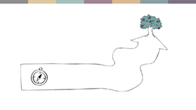 | nraw;ghl;Lj;jpl;lKk; tiuglk; my;yJ gazj; jpl;lj;jpidg; Nghd;wNj - mJ ehq;fs; vkJ ,yf;fpid miltjw;F nra;aj; jpl;lkpLfpd;w gbKiwfis tptuizahf;fk; nra;tJld;> mJ ehk; cghaKs;stu;fshf kw;Wk; jpl;lNehf;Filatu;fshf ,Ug;gjw;F vkf;F cjtp nra;fpd;wJ.  ehq;fs; midtUk; nraw;jpl;lq;fis Mf;Ffpd;Nwhk;. rpyNeuq;fspy;> mit kpfTk; vspikahditahf> ngUk;ghYk; cs;shu;e;jjhff; fhzg;gLk; vd;gJld; mtw;iw ehk; epidtpy; itj;jpUf;fpd;Nwhk;. Mdhy;> rpf;fyhd gpur;rpidfSf;fhd> ehq;fs; ,jw;F Kd; nra;jpuhj tplaq;fs; kw;Wk; ehk; FOf;fshf nra;fpd;w tplaq;fs; njhlu;gpy;> ehk; kpff; ftdkhfj; jpl;lkpl Ntz;baJk;> midtUk; Qhgfk; itj;jpUf;ff;$ba tifapy; mtw;iw vOjp itj;jpUg;gJk; kpf Kf;fpakhFk;.
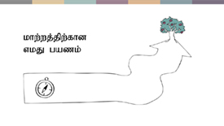 | ,k;Kd;itg;gpdÊ vQ;rpAs;s gFjpapy;> nra;jpl;lnkhd;wpid cUthf;Fk;nghUl;L> ‘khw;wj;jpw;fhd vkJ gazk;’ vd miof;fg;gLfpd;w vspikahd> fl;Gydhfpd;w fUtpnahd;wpidg; gad;gLj;Jtjw;F fw;Wf; nfhs;sg; Nghfpd;NWhk;.
 | gazpfs;
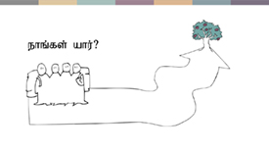 | ehk; khw;wj;ij Vw;gLj;Jtjw;fhd gazj;jpw;fhd nraw;jpl;lnkhd;wpid Mf;Ffpd;wNghJ> Kjyhtjhf vOfpd;w Nfs;tp ehq;fs; ahu; vd;gjhFk;.  khw;wj;jpid Vw;gLj;Jfpd;w gaznkhd;wpy; gazpg;gtu;fs; ahu;? rpy gazpfs; thfdq;fis Xl;bf;nfhz;Lk;> rpy gazpfs; tpkhdj;jpYk; nry;fpd;w mNjNtis> rpy gazpfs; ele;J nry;y Ntz;bNaw;gLtjidg; Nghd;Nw> ehq;fs; jdpegu;fshf> FOf;fshf my;yJ mikg;Gf;fshf> NtWgl;l tha;g;Gf;fs;> gyq;fs; kw;Wk; gytPdq;fisf; nfhz;bUf;fpd;Nwhk; vd;gJld; NtWgl;l mghaNeu;TfSf;F Kfq;nfhLf;fpd;Nwhk;. ‘ehq;fs; ahu;’ vdf; Nfl;gjD}lhf Muk;gpj;jy; ,jid epidtpy; itj;jpUg;gjw;F vkf;F cjTk;.
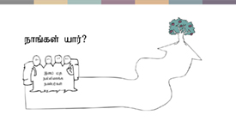 | ehq;fs; fw;gidahd khw;wj;jpw;fhd gaznkhd;wpid cUthf;fpf; nfhs;Nthk;. ehk; vkJ efuj;jpYs;s NtWgl;l kj rKjhaq;fspYs;s ,sk; ez;gu;fs; vdf; nfhs;Nthk;.
 | vq;fSila Muk;gg; Gs;sp
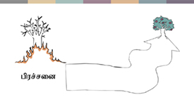 | ehq;fs; gaznkhd;wpidj; jpl;lkpLfpd;wNghJ ehk; KjyhtJ mwpe;J nfhs;s Ntz;ba tplak; vkJ Muk;gg; Gs;sp vJ vd;gjhFk;. khw;wj;jpw;fhd gazkhdJ gpur;rpidnahd;WlDk; ehk; mjid tiuaWf;f Muk;gpg;gJlDk; njhlq;Ffpd;wJ. vq;fSila gpur;rpidapid tiuaWg;gjpy; ehk; ve;jsT jpl;ltl;lkhf ,Uf;fpNwhNkh> me;jstpw;F khw;wj;jpid vt;thW Vw;gLj;JtJ vd;gjid milahsk; fhZjy; ,yFthdjha; mikAk;.
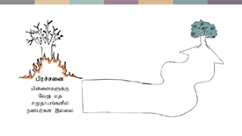 | MfNt> “rfpg;Gj;jd;ikapd;ik” jhd; gpur;rpidnad nrhy;tjw;F gjpyhf> “gps;isfSf;F NtW kj rKjhaq;fspy; ez;gu;fs; ,y;iy” vd nrhy;y Ntz;Lk;. ,J njhlu;r;rpahd rfpg;Gj;jd;ikapd;ikapd; tpisnthd;whfTk; kw;Wk; fhuznkhd;whfTk; mikfpd;wJ.
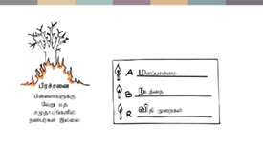 | ,JNghd;w gpur;rpidfs; mtw;Wf;F gq;fspf;fpd;w gy;NtW mbg;gil fhuzpfisf; nfhz;bUf;Fk;. ,t; mbg;gilf; fhuzpfshf gpd;tUtd mikayhk;:  - egu;fs; nfhz;Ls;s gpur;rpidf;Fupa kdg;ghq;Ffs;  - gpur;rpidf;Fupa elj;ijfs;- egu;fs; nra;fpd;w tplaq;fs;  - my;yJ gpur;rpidf;Fupa rl;lq;fs;> tpjpfs; my;yJ nfhs;iffs;.  kdg;ghq;Ffs;> elj;ijfs; kw;Wk; tpjpfs; xd;wpize;J gpur;rpidapid cUthf;Ffpd;wd. MfNt> ehq;fs; milahsg;gLj;jpAs;s gpur;rpid njhlu;ghf> ehq;fs; khw;w tpUk;Gfpd;w Fwpg;ghd elj;ijg; ghq;Ffs;> elj;ijfs; kw;Wk; tpjpfs; ahit?
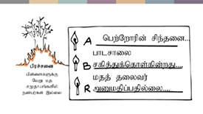 | vq;fSila cjhuzj;ij Fwpj;J ghu;f;fpd;wNghJ> ‘ngw;Nwhu;fs; jkJ gps;isfSf;F NtW rKjhaq;fspy; ez;gu;fs; cs;sik njhlu;ghf vjpu;kiwahd kdg;ghq;Ffs; nfhz;Ls;sdu;’ my;yJ ‘NtWgl;l kj rKjhaq;fSf;fpilapYs;s khztu;fSf;fpilapy; Jd;GWj;jy; ,lk;ngWtjid ghlrhiy rfpj;Jf; nfhs;fpd;wJ’ my;yJ ‘NtWgl;l rKjhaq;fspYs;s gps;isfSf;fpilapyhd el;G mDkjpf;fg;glf;$lhJ vd cs;@u; kjj; jiytu; xUtu; nrhy;fpwhu;’ vd Fwpg;gpl Ntz;Lk;. vq;fSila gpur;rpidf;F gq;fspg;G nra;fpd;w kdg;ghq;Ffs; elj;ijfs; kw;Wk; tpjpfs; ,itNa.
 | vq;fsJ NrUkplk;
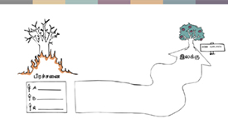 | ehq;fs; khw;wj;ij Vw;gLj;Jfpd;w gaznkhd;wpid Nkw;nfhs;fpd;wNghJ> ehq;fs; vq;F nry;y Ntz;Lk; vd;gjid mwpe;jpUj;jy; Kf;fpakhdjhFk;! vkJ NrUkplj;jpid tiuaWj;jy; je;jpuk; kpf;fjhFk;. vk; midtUf;Fk; rkhjhdk;> ePjp kw;Wk; ghugl;rkpd;ik vd;gdtw;iw mile;Jf; nfhs;s Ntz;Lk;! Mdhy;> Fwpg;gpl;l fhy tiuaiwf;Fs; vk;khy; vjid mile;Jf; nfhs;s KbAk; vd;gJ njhlu;ghf ehk; jpl;ltl;lkhfTk; ajhu;j;jG+u;tkhfTk; ,Uf;f Ntz;Lk;.
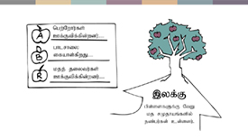 | cjhuzkhf> ‘gps;isfSf;F NtW kj rKjhaq;fspy; ez;gu;fs; cs;sdu;’ vd;gJ vkf;F ,yf;fhf ,Uf;fyhk;. mj;Jld;> mt; ,yf;fpw;fhf> gioa> Nflhd elj;ijg; ghq;Ffs;> elj;ijfs; my;yJ tpjpfs; fhzg;gl;l ,lj;jpy; ehk; fhz tpUk;Gfpd;w Fwpg;ghd kdg;ghq;Ffs; elj;ijfs; my;yJ tpjpfs; ahit vd;gJ gw;wp ehk; rpe;jpf;f KbAk;.  cjhuzkhf: “ngw;Nwhu;fs; gps;isfSf;F NtW kj rKjhaq;fspy; ez;gu;fs; ,Uf;fpd;wikapid” my;yJ “ghlrhiy Jd;GWj;jiy Kidg;Gld; ifahs;fpd;wJ” my;yJ “rKjhaq;fSf;fpilapyhd el;gpid kjj; jiytu;fs; Cf;Ftpf;fpd;wdu;”.
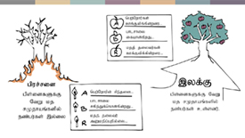 | ePq;fs; ghu;f;fpd;wjw;fika> vq;fSila gpur;rpidfs; kw;Wk; ,yf;Ffs; vd;gd xt;nthd;wpdJk; fz;zhbg; gpujpgypg;Gf;fs; Nghd;wdthFk;.  gpur;rpid kw;Wk; ,yf;F vd;gd khw;wj;jpw;fhd vkJ gazj;jpd; fl;likg;gpid tiuaWf;fpd;wd. khw;wj;jpw;fhd nrad;Kiw vq;F Muk;gkhfpd;wJ kw;Wk; mJ vq;F nry;y Ntz;Lnkd ehk; tpUk;Gfpd;Nwhk;?
 | vq;fSila topapy; ehk; re;jpf;Fk; egu;fs;
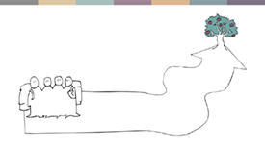 | ePz;lnjhU gazj;jpy; ehk; gy egu;fis re;jpf;f NeupLk; - mNj jpirapy; gazpf;fpd;w rf gazpfs;> vq;fis Nrhjid nra;fpd;w bf;nfl; mjpfhupfs; my;yJ vq;fis epWj;Jfpd;w my;yJ NtW jpirf;F khw;Wfpd;w tPjpj; jilfis cUthf;Ffpd;w egu;fs;. MfNt> vq;fsJ gazj;jpy; ehk; ahiu re;jpf;fg; Nghfpd;Nwhk;?
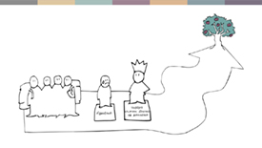 | mq;F:  - gpur;rpidapdhy; ghjpf;fg;gl;l egu;fs;> (vkJ cjhuzj;jpd;gb> gps;isfs;)  - gpur;rpid njhlu;ghf vijNaDk; nra;af;$ba mjpfhuk; cs;s egu;fs; (cjhuzkhf> ghlrhiy rig kw;Wk; gzpahsu;fs;> ngw;Nwhu;fs; kw;Wk; kjj; jiytu;fs;) MfpNahu; ,Ug;ghu;fs;.
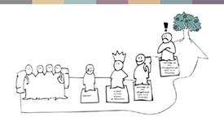 | mj;Jld; mq;F:  - vq;fSila ,yf;fpidg; gfpu;e;Jf; nfhs;fpd;w kw;Wk; vq;fSf;F ghijapy; cjtj;jf;f rf gazpfs; ,Ug;ghu;fs;. vq;fsJ cjhuzj;jpy;> cs;@u; kj ey;ypzf;f FO vkJ $l;lzpahf ,Uf;fyhk;.  - my;yJ vk;Kila ,yf;fpid vjpu;f;fpd;w kw;Wk; vq;fSila ghijapid ,ilkwpf;f Kaw;rpf;fpd;w egu;fs; ,Uf;fyhk;. ngUk;ghYk;> vkJ rKjhaj;jpYs;s rfpg;Gj;jd;ikaw;w> r%f Clf nry;thf;F kpf;f xU egu;.
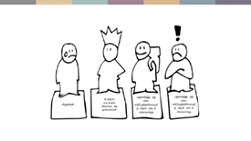 | ehq;fs; nraw;jpl;lnkhd;wpid vOJfpd;wNghJ> ,j;jifa egu;fs;> mikg;Gf;fs; kw;Wk; epWtdq;fis ahitnad rpe;jpj;jy; rpwe;jjhFk;> MfNt> ehq;fs; cj;jpfisj; njupT nra;fpd;wNghJ kw;Wk; vq;fSila nraw;ghLfisj; jpl;lkpLfpd;wNghJ mtu;fisAk; fUj;jpw; nfhs;syhk;.  khw;wj;ij Vw;gLj;Jtjw;F vq;fSld; ,ize;J cjtp nra;af; $batu;fs; ahu;? ,zq;fitg;gjw;F vkf;F ahu; Njit kw;Wk; vijf; Fwpj;J ,zq;fitf;f Ntz;Lk;? mj;Jld;> khw;wj;jpw;fhd vkJ topapid ,ilkwpf;ff; $batu;fs; ahu;?
 | ghijapidj; njupT nra;jy;
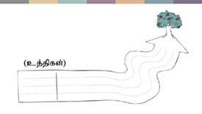 | m ,ypUe;J M ,w;F nry;tjw;F nghJthf mjpfsthd topfs; fhzg;gLk;- NtWgl;l ghijfs; kw;Wk; Nghf;Ftuj;J Kiwfs;. MfNt> ehq;fs; nry;yg; Nghfpd;w ghij vJ?  ehq;fs; gad;gLj;Jfpd;w cj;jpfspdhy; vq;fsJ ghij jPu;khdpf;fg;gLfpd;wJ. tpopg;Gzu;tpidf; fl;bnaOg;GjypypUe;J> Mjupj;Jthjhly; kw;Wk; kPwy;fis Mtzg;gLj;jy; tiu> ehq;fs; njupT nra;tjw;F 15 NtWgl;l cj;jpfs; cz;nld;gjid epidtpw; nfhs;Sq;fs;. ,t; cj;jpfisg; gad;gLj;Jtjw;fhd gy nraw;ghl;L Nahridfs; njhlu;ghf ehk; Vw;fdNt ghu;j;jpUf;fpd;Nwhk;! ePq;fs; ,tw;iwg; gad;gLj;jf;$ba ,lk; ,JNt!
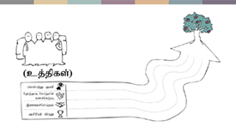 | vq;fSila cjhuzj;jpid vLj;Jf; nfhz;Nlhkhdhy;: kj ey;ypzf;f cijg;ge;jhl;lf; FOnthd;wpid mikg;gjD}lhf ehk; gps;isfspd; vz;zj;jpid khw;WtJ njhlu;gpy; ftdk; nrYj;jg; Nghfpd;Nwhkh my;yJ Jd;GWj;jy; rk;gtq;fis Mtzg;gLj;jp> mJ njhlu;ghf ghlrhiy rigia eltbf;if vLf;fr; nra;tjw;fhf mt; Mtzg;gLj;jiy ghtpj;J Mjupj;J thjhl Nghfpd;Nwhkh my;yJ ey;y cwTepiyfis Nkk;gLj;Jtjw;fhf tFg;giwapy; gd;ikj;jd;ikapid rpwg;ghf Nkk;gLj;jp> kjpg;gspj;jiy cWjpg;gLj;Jfpd;w MrpupaUf;fhd tpUnjhd;wpid cUthf;FtjD}lhf Mrupau;fSf;F rYifaspf;fg; Nghfpd;Nwhkh my;yJ kjq;fSf;fpilapyhd el;gpid Cf;Ftpg;gjw;F kjj; jiytu;fis ,zq;fr; nra;ag; Nghfpd;Nwhkh my;yJ ,it midj;jpdJk; njhFg;gpidr; nra;ag; Nghfpd;Nwhkh?  ehq;fs; nra;af;$ba NtWgl;l tplaq;fs; gy fhzg;gLfpd;wd. vk;khy; mit midj;ijAk; nra;a KbahJ> Mdhy;> ehq;fs; ntw;wp ngw Ntz;Lkhapd;> xd;wpw;F Nkw;gl;l tplaq;fisr; nra;jy; Ntz;Lk;. cjhuzkhf> gpujhd kjq;fspd; jiytu;fs; vjpu;f;fpd;wNghJ kw;Wk; ahUk; ,ize;Jf; nfhs;tjw;F tpUg;gk; fhl;lhjNghJ> cijg;ge;jhl;lf; FOnthd;wpid Muk;gpj;jypy; vt;tpj gaDk; ,y;iy. ntw;wpfukhd nraw;jpl;lq;fs; nghJthf NtWgl;l rpy cj;jpfisf; nfhz;bUf;Fk;> Mdhy; mt; cj;jpfs; xd;iwnahd;W Fiw epug;Gtdthf/KOikahf;Ffpd;wdthff; fhzg;gLk;.
 | gazj;jpd; gbKiwfs;
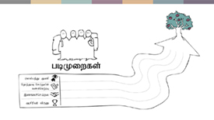 | vt; cj;jpfis ehk; gad;gLj;jg;Nghfpd;Nwhk; vd;gjid ehk; jPu;khdpj;jTld;> mtw;iw vt;thW gad;gLj;jg;Nghfpd;Nwhk; vd;gJ njhlu;ghf rpe;jpf;f Ntz;Lk;. ehq;fs; Nkw;nfhs;s Ntz;ba jpl;ltl;lkhd gbKiwfs; vd;d kw;Wk; mtw;iw vt; xOq;fpy; Nkw;nfhs;s Ntz;Lk;. ehq;fs; njupT nra;Js;s xt;nthU cj;jp njhlu;ghfTk;> ahu;> vg;NghJ> vd;d nra;a Ntz;Lk;? eilKiwapy;> cijg;ge;jhl;lf; FOnthd;wpid xOq;fikg;gjw;F kw;Wk; Nkk;gLj;Jtjw;F my;yJ Ma;nthd;wpid Kd;ndLg;gjw;F ehk; vt;thW nraw;gl Ntz;Lk;? ahu;> ve;j kjj; jiytu;fSld; NgRthu;fs;?
 | nra;jp
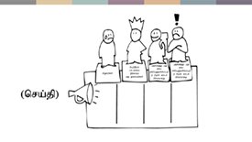 | ehq;fs; egu;fSld; NgRfpd;wNghJ> ehq;fs; vd;d nrhy;yg; Nghfpd;Nwhk; vd;gJ njhlu;ghf rpe;jpf;f Ntz;Lk;. vt;tifahdj; jfty;fs; my;yJ thjq;fs;> vq;fSld; ,iztjw;fhd rhj;jpag;ghl;bidAila $l;lzpfs; vk;Kld; ,iztJ Fwpj;J mtu;fis ,zq;f itf;Fk; my;yJ jq;fSila kdg;ghq;Ffs;; my;yJ elj;ijapid khw;WtJ Fwpj;J egu;fis ,zq;f itf;Fk;? mjpfhuj;jpidf; nfhz;Ls;stu;fis vd;d tplaq;fisf; $wp nraw;gl itf;fyhk;? mj;Jld;> vjpu;g;gpidj; jtpu;f;ff;$ba tifapy; ehq;fs; $w tUfpd;w tplaj;jpidf; fl;likj;Jf; nfhs;tjw;F VNjDk; topKiwfs; cs;sdth?  cjhuzkhf: rKjhaq;fSf;fpilapyhd cwtpidf; fl;bnaOg;Gtjdhy; gps;isfspd; vjpu;fhyj;jpw;F fpilf;ff;$ba ed;ikfs; gw;wpa jfty;fs; kw;Wk; cijg;ge;jhl;lf;FOtpy; gps;isfs; ghJfhg;ghf ,Ug;ghu;fs; kw;Wk; ed;whfg; guhkupj;Jf; nfhs;sg;gLthu;fs; Nghd;w tplaq;fis ngw;Nwhu;fs; Nfl;f Ntz;Lk;.  mj;Jld;> cijg;ge;jhl;lf; FOtpid topelj;Jtjpy; NtWgl;l rKjhaq;fisr; Nru;e;j taJ te;jtu;fis ehk; vt;thW cs;thq;fpf; nfhs;sg; Nghfpd;Nwhk; vd;gJ gw;wp njupe;Jf; nfhs;tjw;F cs;@u; kj ey;ypzf;f rig Mu;tkhf ,Uf;fyhk;.  NkYk; njhe;juT nfhLj;jypd; -vjpu;g;Gf; nfhs;ifia nraw;gLj;Jtjdhy; vt;thW gs;spapd; Ratptuj;ij mjpfupj;J nfhs;syhk; vd;gijf; mwpe;Jnfhs;s ghlrhiy epu;thfk; Cf;Ftpf;fg;glyhk;.
 | jilfs; kw;Wk; mgha Neu;Tfs;
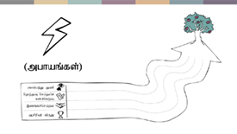 | ePz;lJk; rpf;fyhdJkhd xU gazj;jpy;> gazpfs; jilfs;> Mgj;Jf;fs; kw;Wk; Gay;fis re;jpf;f NeupLk;. mtu;fSila NrUkplj;jpid mile;Jf; nfhs;Sk;nghUl;L mtu;fs; ,tw;iwj; jtpu;f;f Ntz;Lk; my;yJ ntw;wpf; nfhs;s Ntz;Lk;. khw;wj;jpw;fhd midj;J nrad;KiwfspYk; jilfSk; mghaNeu;TfSk; cs;sd. ehq;fs; Kd;Ndhf;fp rpe;jpj;jy;> rhj;jpakhdsT ghJfhg;ghd ghijapidj; njupT nra;jy; kw;Wk; Njhd;wf;$ba rpf;fyhd #o;epiyfis vt;thW ifahs;tJ vd;gJ njhlu;ghd jpl;lnkhd;wpidf; nfhz;bUj;jy; vd;gd cjtpahf mikAk;.  MfNt> ehq;fs; fw;gid nra;Js;s nraw;ghLfis Kd;ndLf;fpd;wNghJ ehq;fs; vjpu;nfhs;sf;$ba jilfs; kw;Wk; mgha Neu;Tfs; vit? mr;nraw;ghLfSs; vitNaDk; mghak; kpf;fjhf cs;sjh kw;Wk; mghaq;fisf; Fiwj;Jf; nfhs;tjw;fhd VNjDk; topfs; cs;sdth?  cjhuzkhf: rpy #oikTfspy;> cs;@u; thndhyp miytupirnahd;wpD}lhf< kj ey;ypzf;f cijg;ge;jhl;lf;FO gw;wp tpsk;guk; nra;jy; rfpg;Gj;jd;ikaw;w FOf;fspd; ftdj;jpid mtrpakw;wKiwapy; <u;f;Fk; vd;gJld; ,tu;fs; vjpu;g;gpidj; jpul;lf;$Lk;. ehq;fs; mjid mikjpahf Muk;gpj;Jtpl;L> mjw;fhd rKjha Mjutpidf; fl;bnaOg;g Ntz;Lk;.
 | KbT
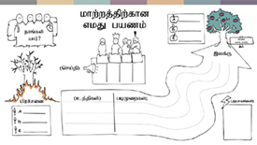 | nraw;jpl;lnkhd;wpid Mf;Ffpd;w nrad;Kiwapid ehk; ,g;NghJ nra;Js;Nshk;. khw;wj;jpw;fhd vkJ gazj;jpw;fhf ehk; fPo;tUtdtw;iw milahsg;gLj;jpAs;Nshk;:  - vkJ Muk;gg; Gs;sp- gpur;rpid  - vkJ NrUkplk;- ,yf;F  - ehk; vkJ topapy; re;jpf;fpd;w egu;fs;- ez;gu;fs;> vjpupfs;> VNjh xU topapy; ehk; nry;thf;F nrYj;j tpUk;Gfpd;w egu;fs;.  - ghij- ehq;fs; gad;gLj;jtpUf;fpd;w cj;jpfs; kw;Wk; ehq;fs; Kd;Ndhf;fp nry;tjw;F Nkw;nfhs;sNtz;ba jpl;ltl;lkhd gbKiwfs;.  mj;Jld; ehq;fs; vkJ nra;jp kw;Wk; vkJ topapy; ehk; vjpu;nfhs;sf;$ba mgha Neu;Tfs; gw;wpAk; rpe;jpj;Js;Nshk;. ePq;fs; gad;gLj;j tpUk;Gfpd;w ve;jnthU cj;jp njhlu;ghfTk; vspikahd my;yJ Mokhd nraw;jpl;lnkhd;wpid cUthf;fpf; nfhs;tjw;F ,r;nrad;Kiwapid gad;gLj;j KbAk;.  MfNt> ,J ePq;fs; ifahs tpUk;Gfpd;w gpur;rpidnahd;W njhlu;ghf> cq;fSila khw;wj;jpw;fhd gazj;jpw;Fupa nraw;jpl;lnkhd;wpid Mf;fpf;nfhs;tjw;F ePq;fNs Kaw;rpf;f Ntz;ba NeukhFk;!

